Lab No. 05 - Databases and Network Protocols

# Objective

Continue learning the installation of basic software and the operation of network protocols.

# Tools to be used

Computers

Internet access

Virtualization software

Wireshark

# Introduction

We are continuing to work within a company’s infrastructure, which typically includes various IT services. This infrastructure features both wired and wireless user workstations and servers (both physical and virtual- ized), all connected through switches (Layer 2 and Layer 3), wireless equipment, and routers connecting them to the Internet. Cloud infrastructures are also common, provisioning resources as needed by the organization. The servers may host services such as web, DNS, email, databases, storage, and applications, among others.

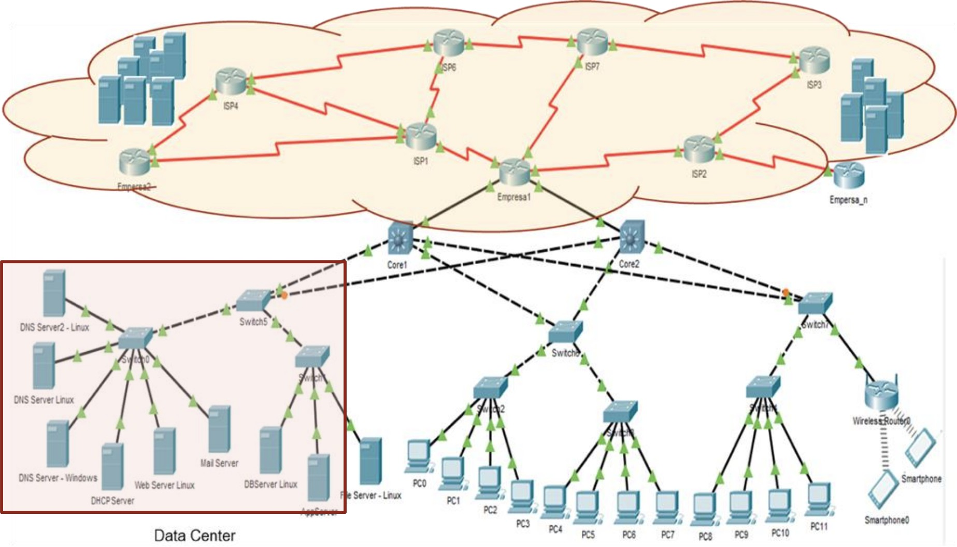

In this part of the lab, we will focus on continuing to set up our servers.

# Review of Network Protocols

## Review of DNS Messages

**[For groups of 1, 2, and 3 students]**

Using **Wireshark**, make a query to the webpage <http://www.google.com/>, filter DNS messages, and examine the name resolution. Identify the fields and explain each part.

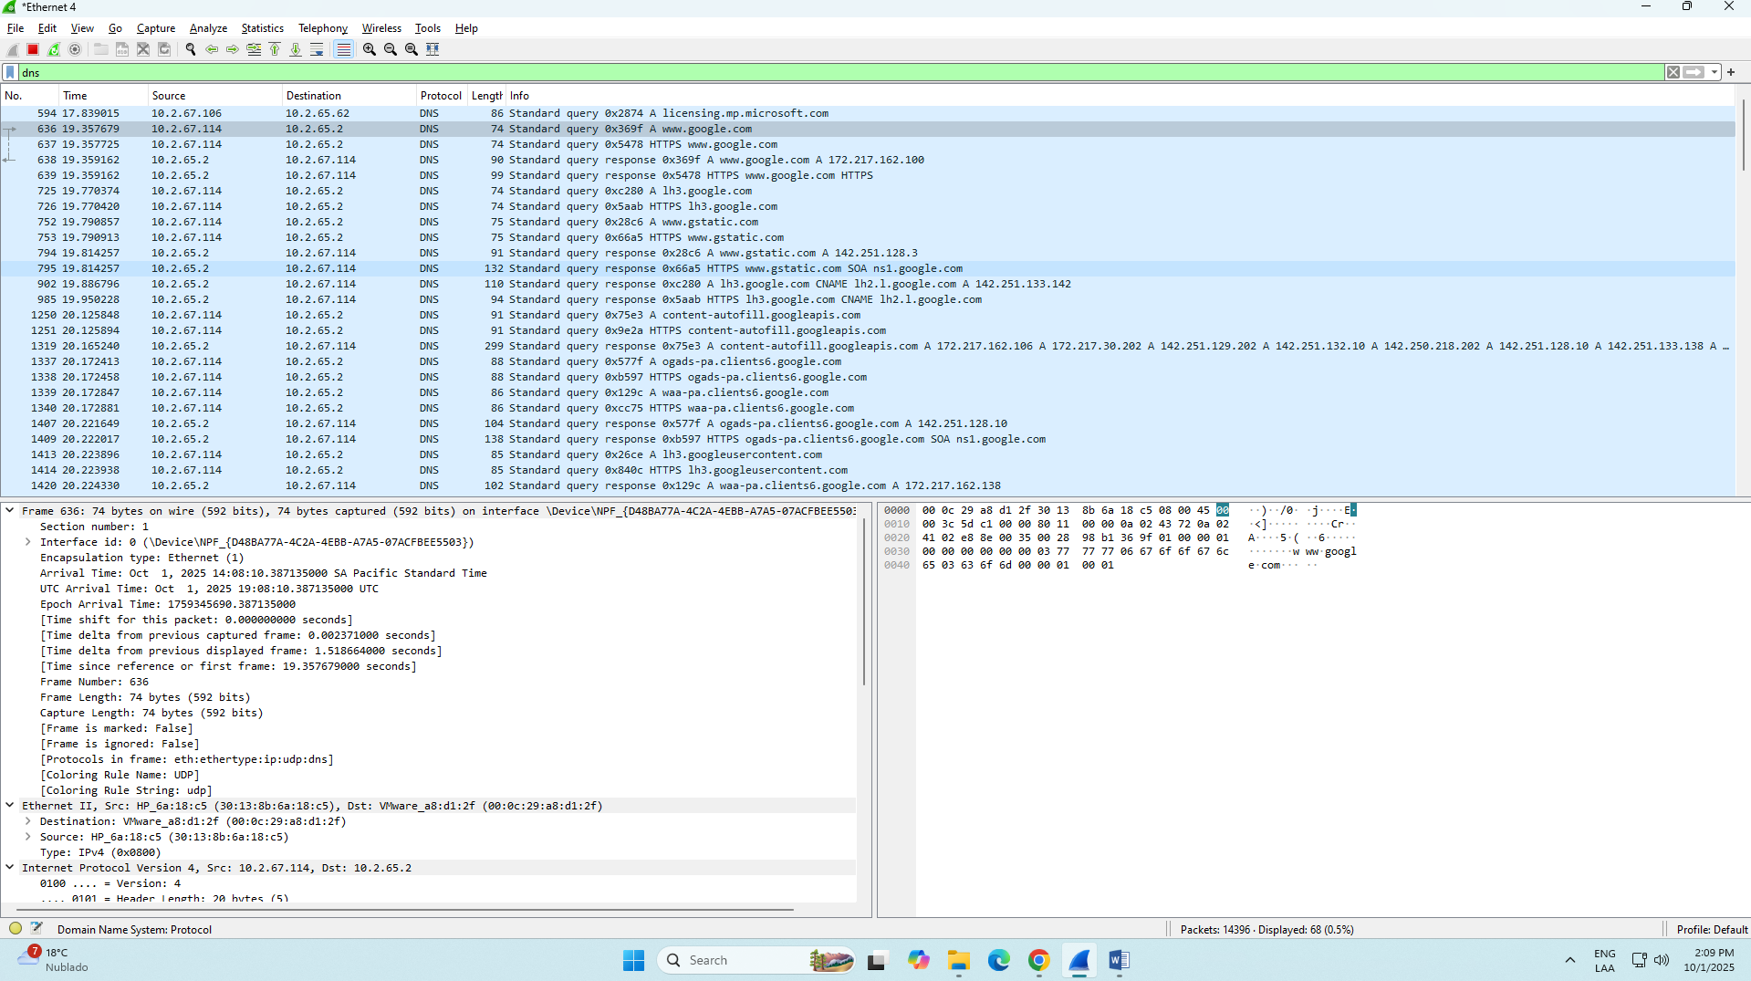

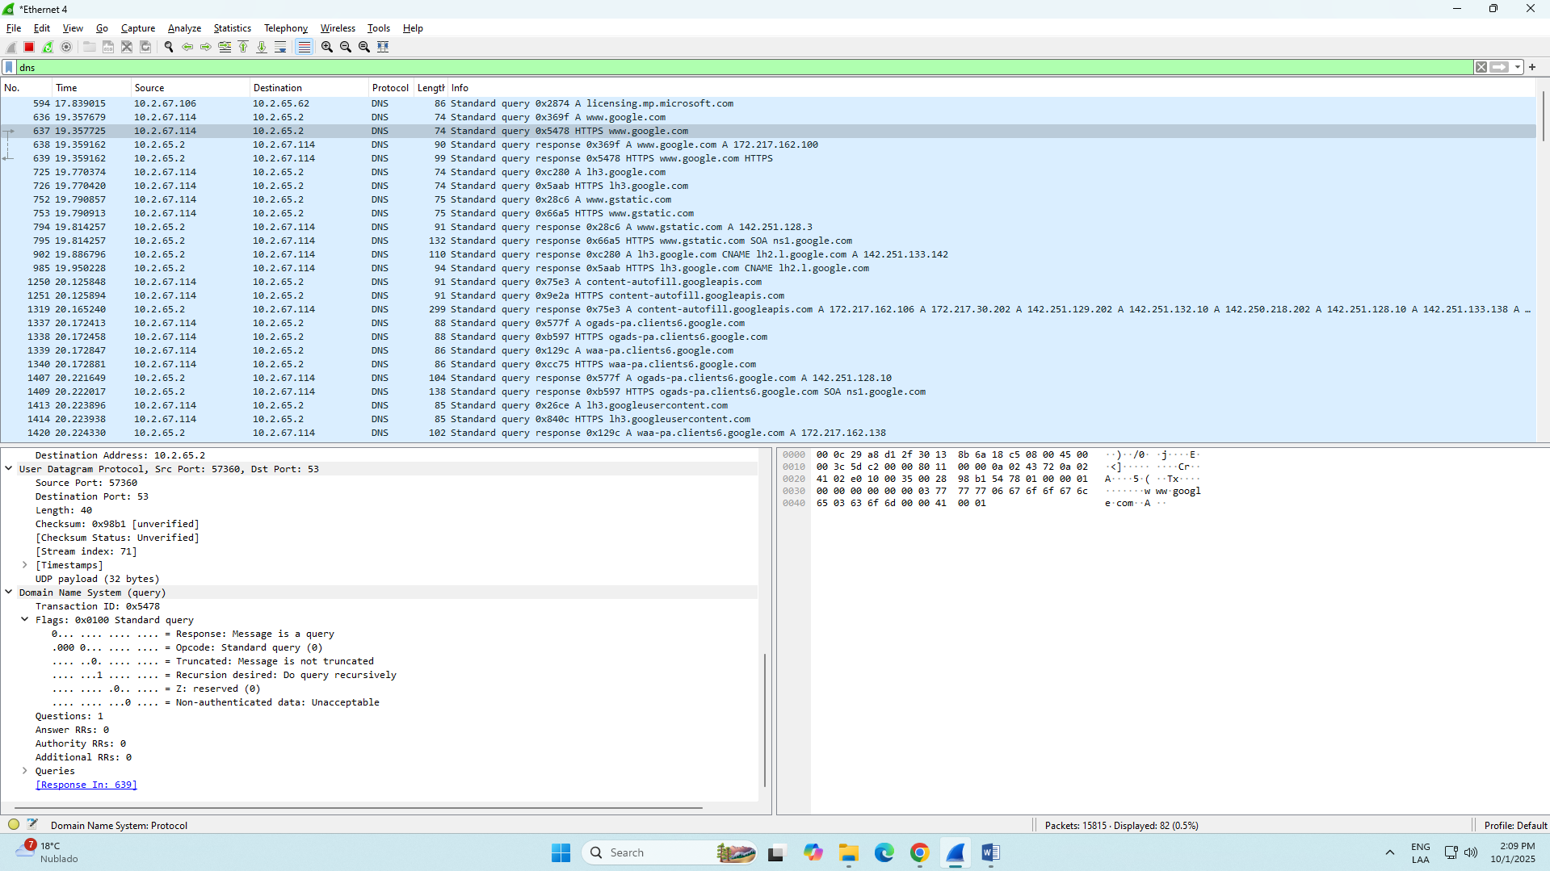

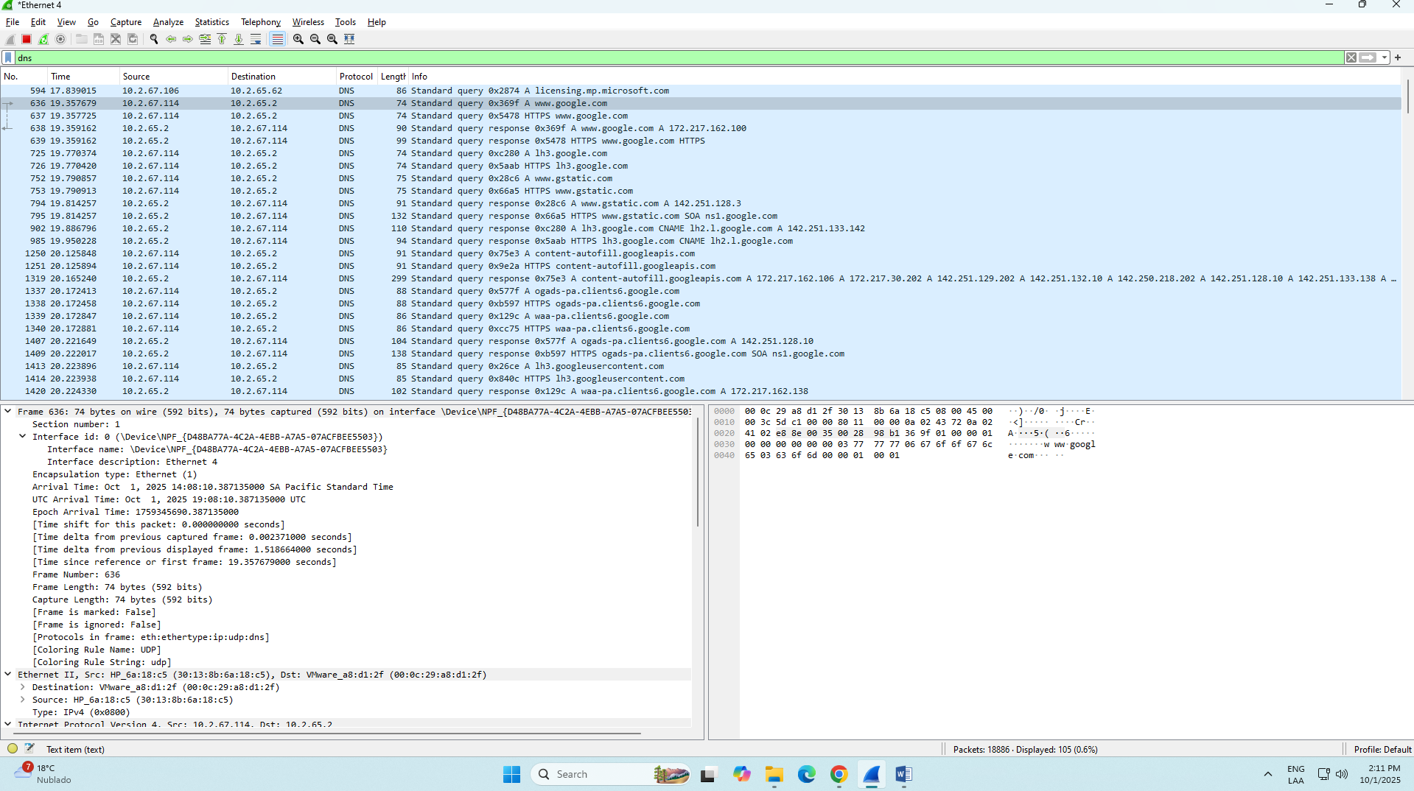

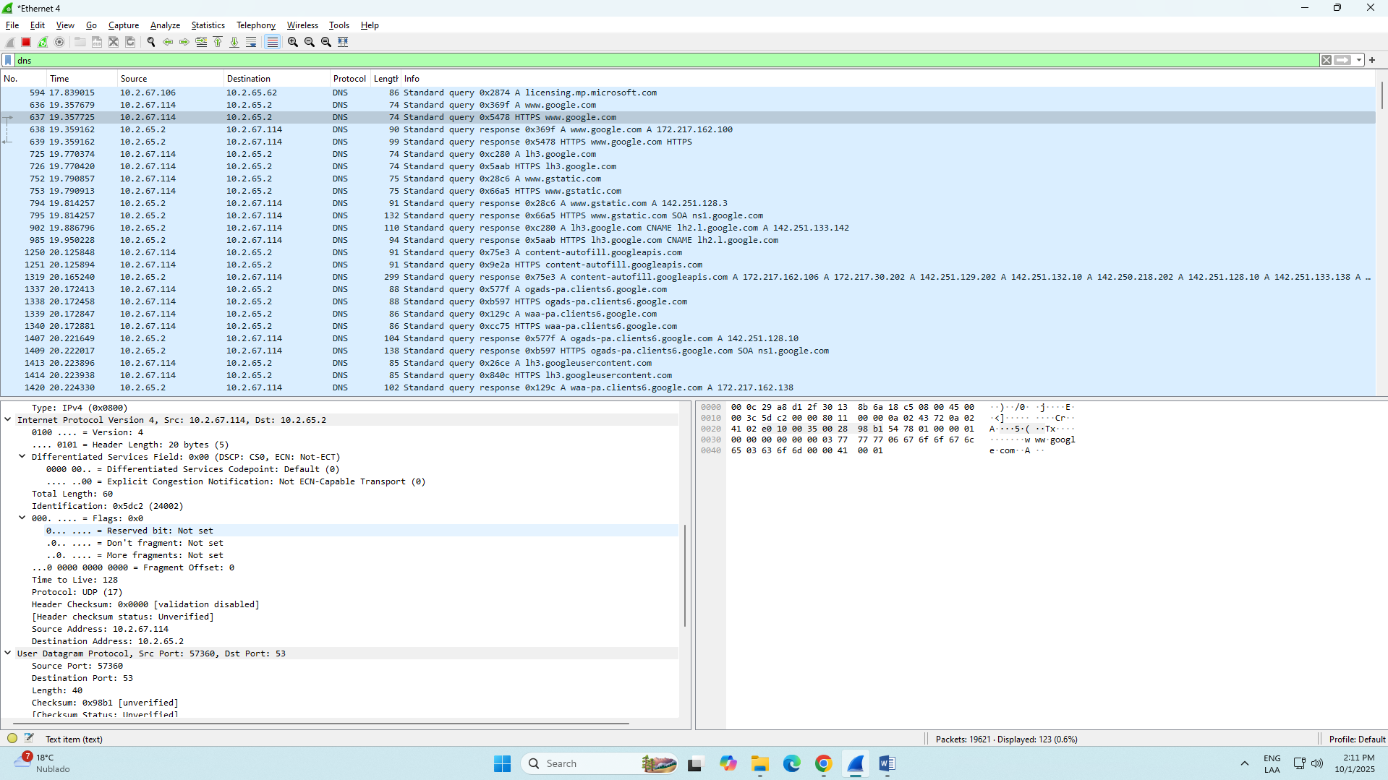

## Review of HTTP Messages

**[For groups of 1, 2, and 3 students]**

Using **Wireshark**, make a query to the webpage [http://profesores.is.escuelaing.edu.co/˜csantiago](http://profesores.is.escuelaing.edu.co/~csantiago/)/ , fil- ter the messages, and examine the HTTP message header. Identify the fields and explain each part.

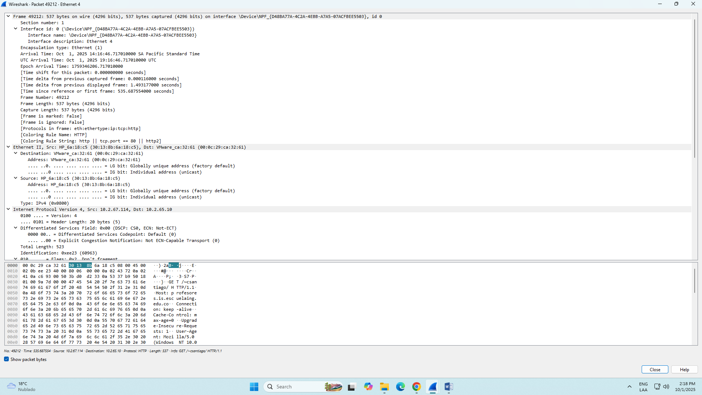

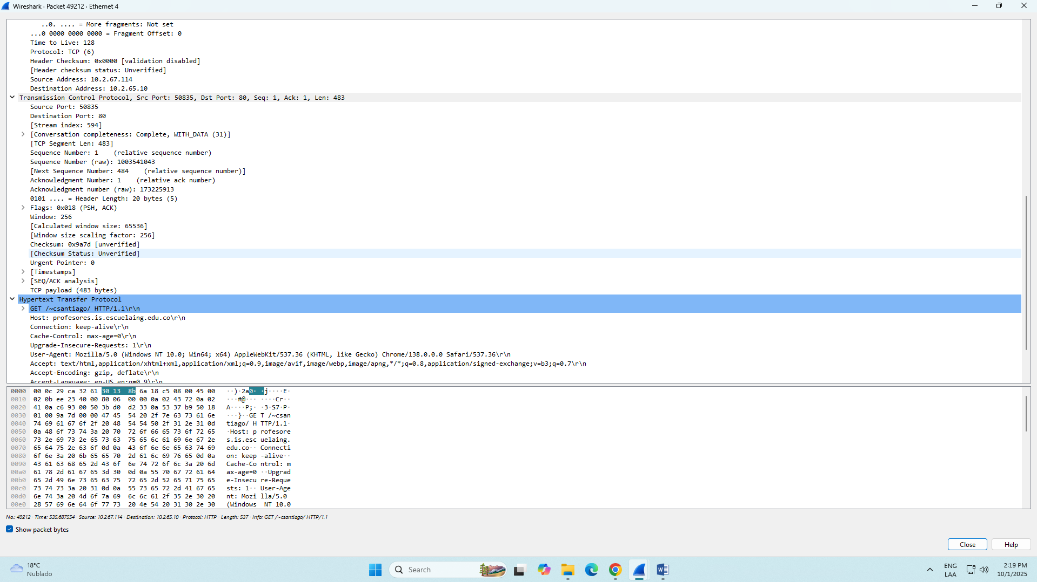

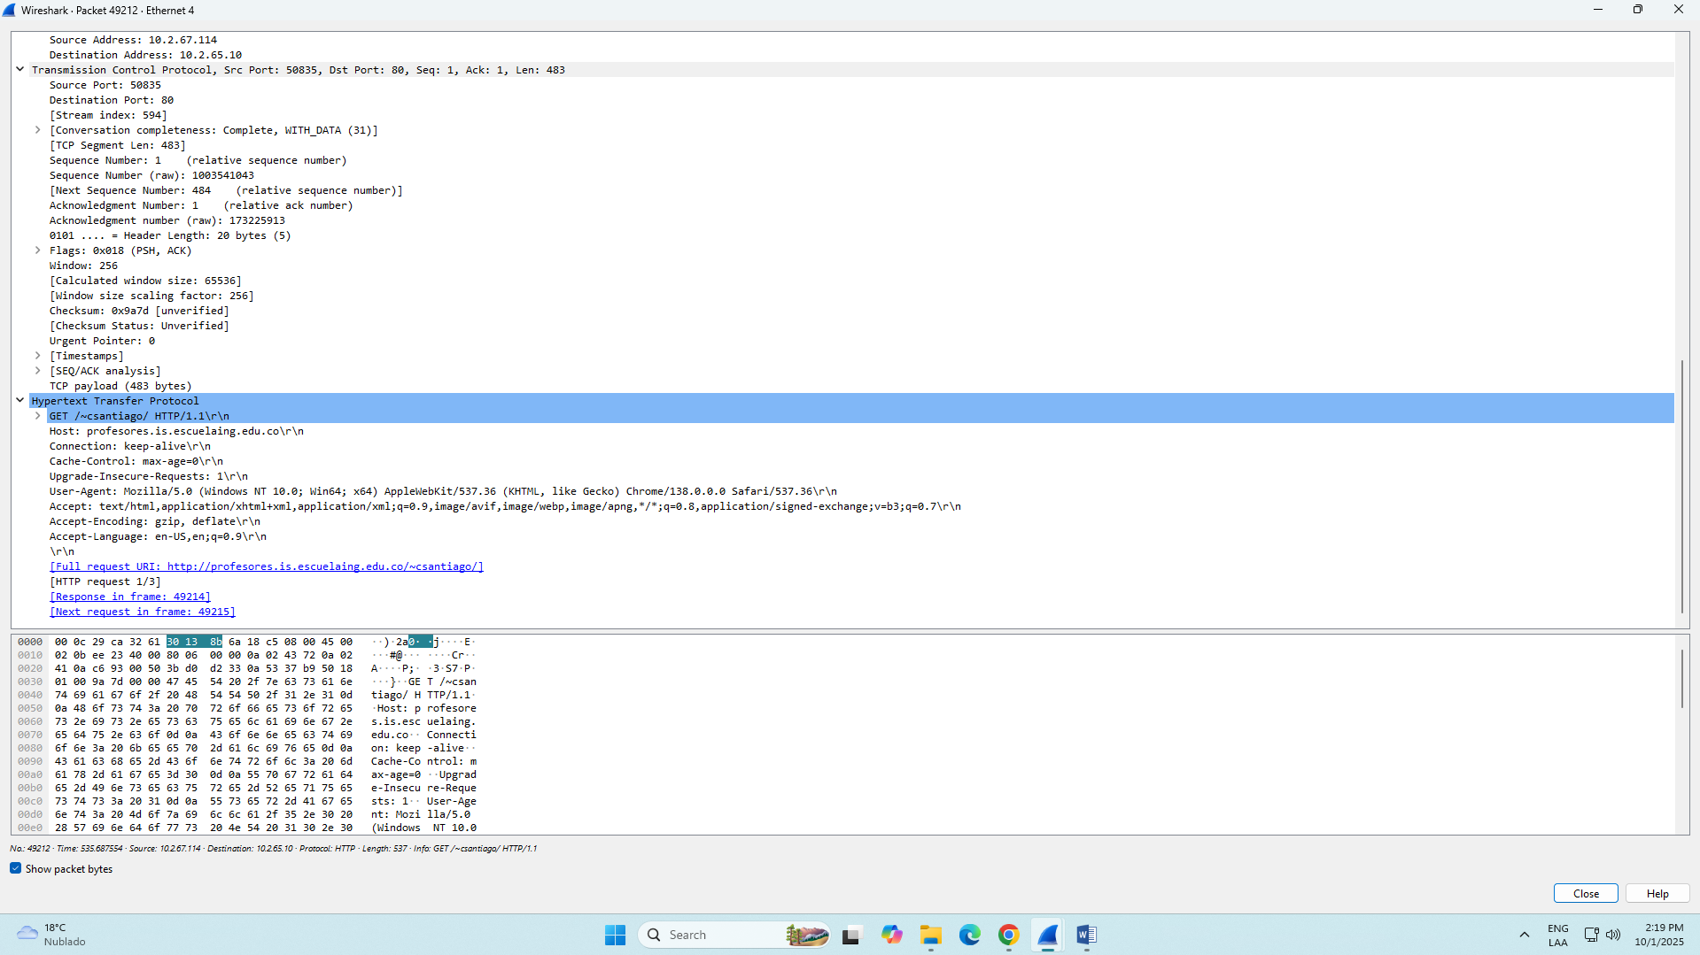

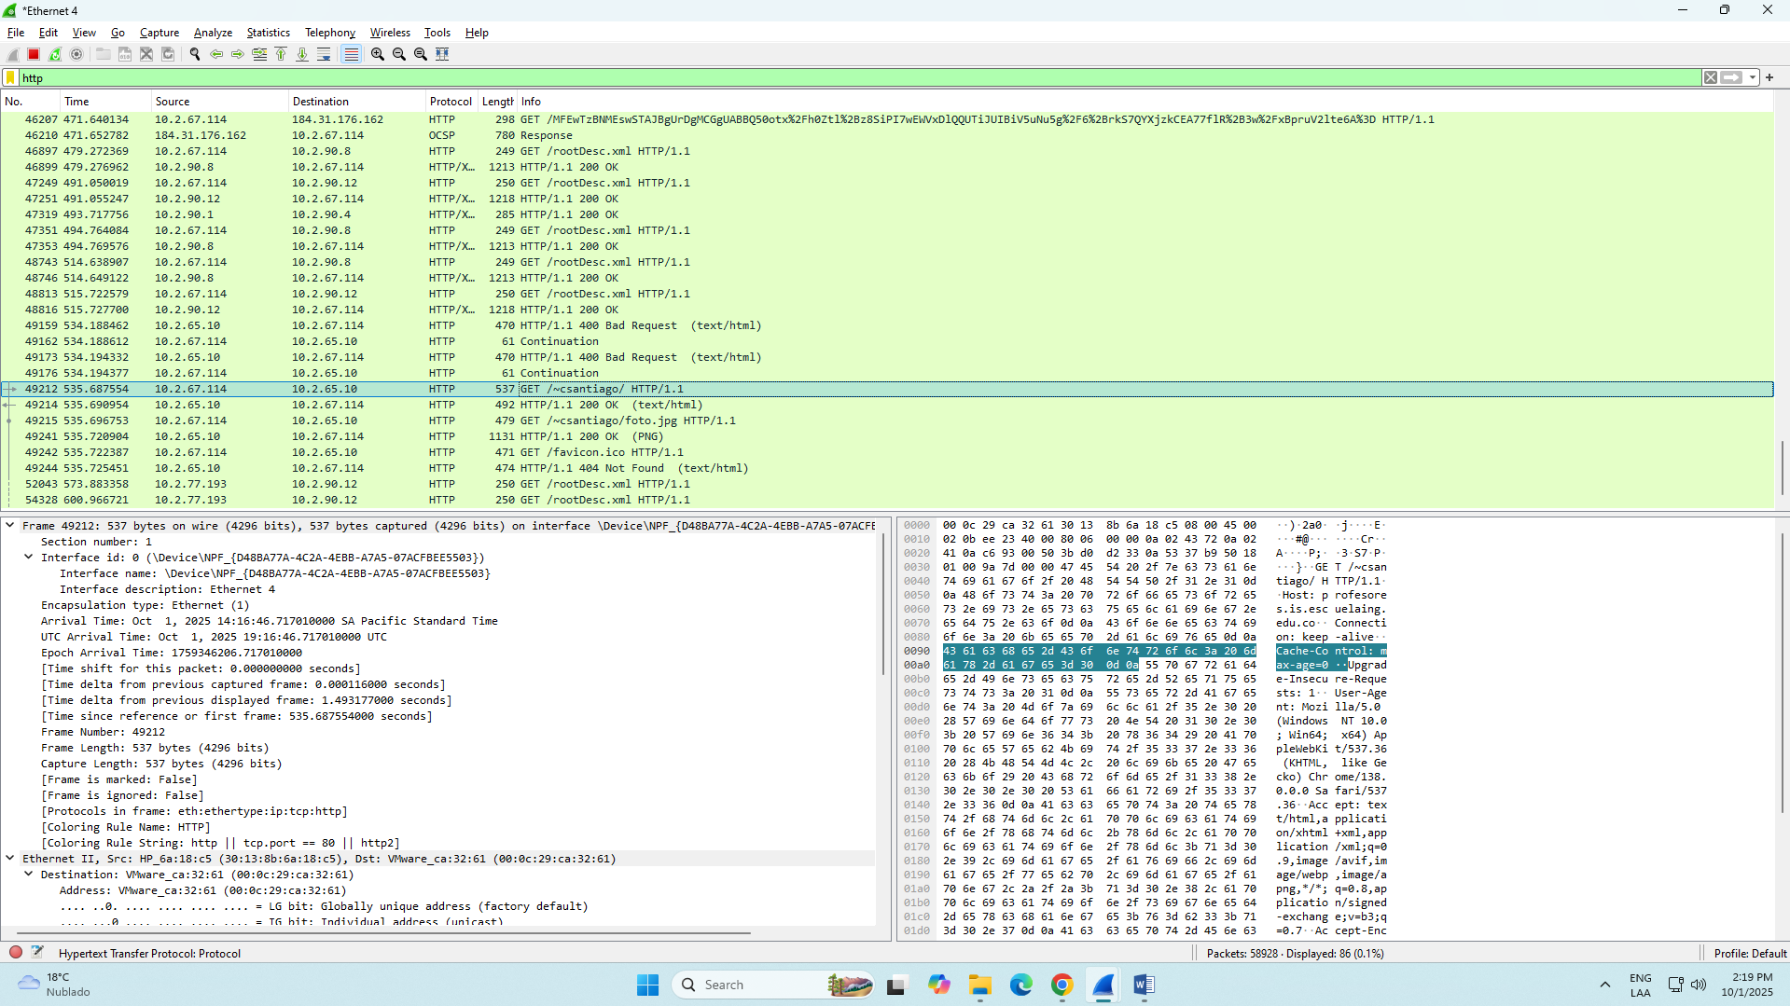

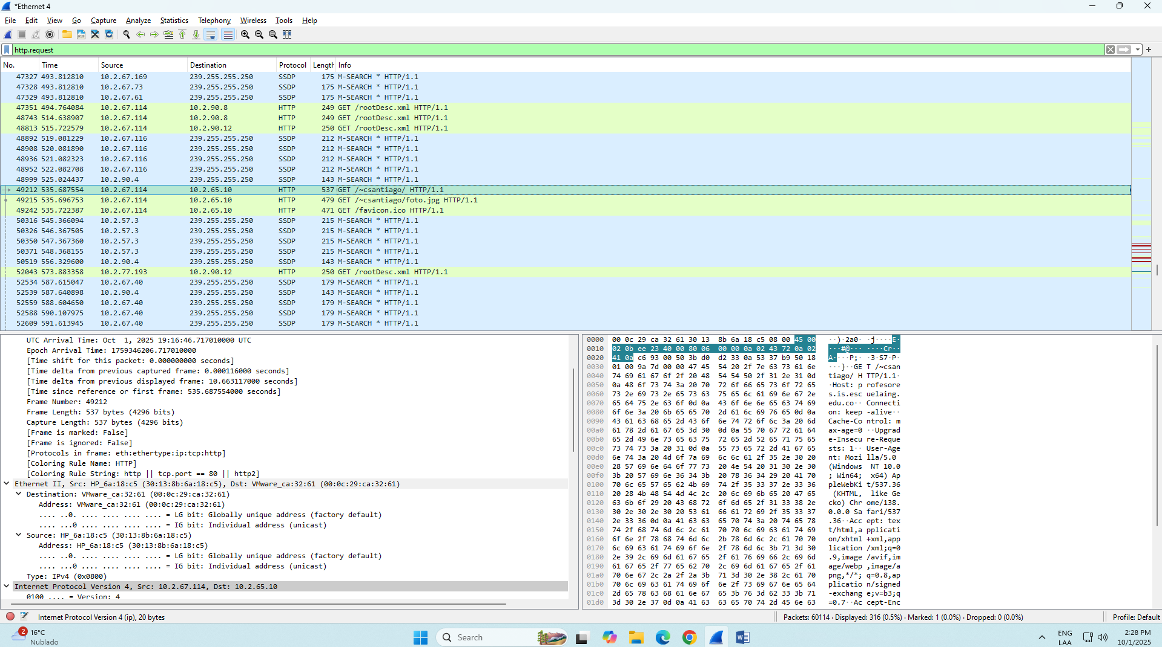

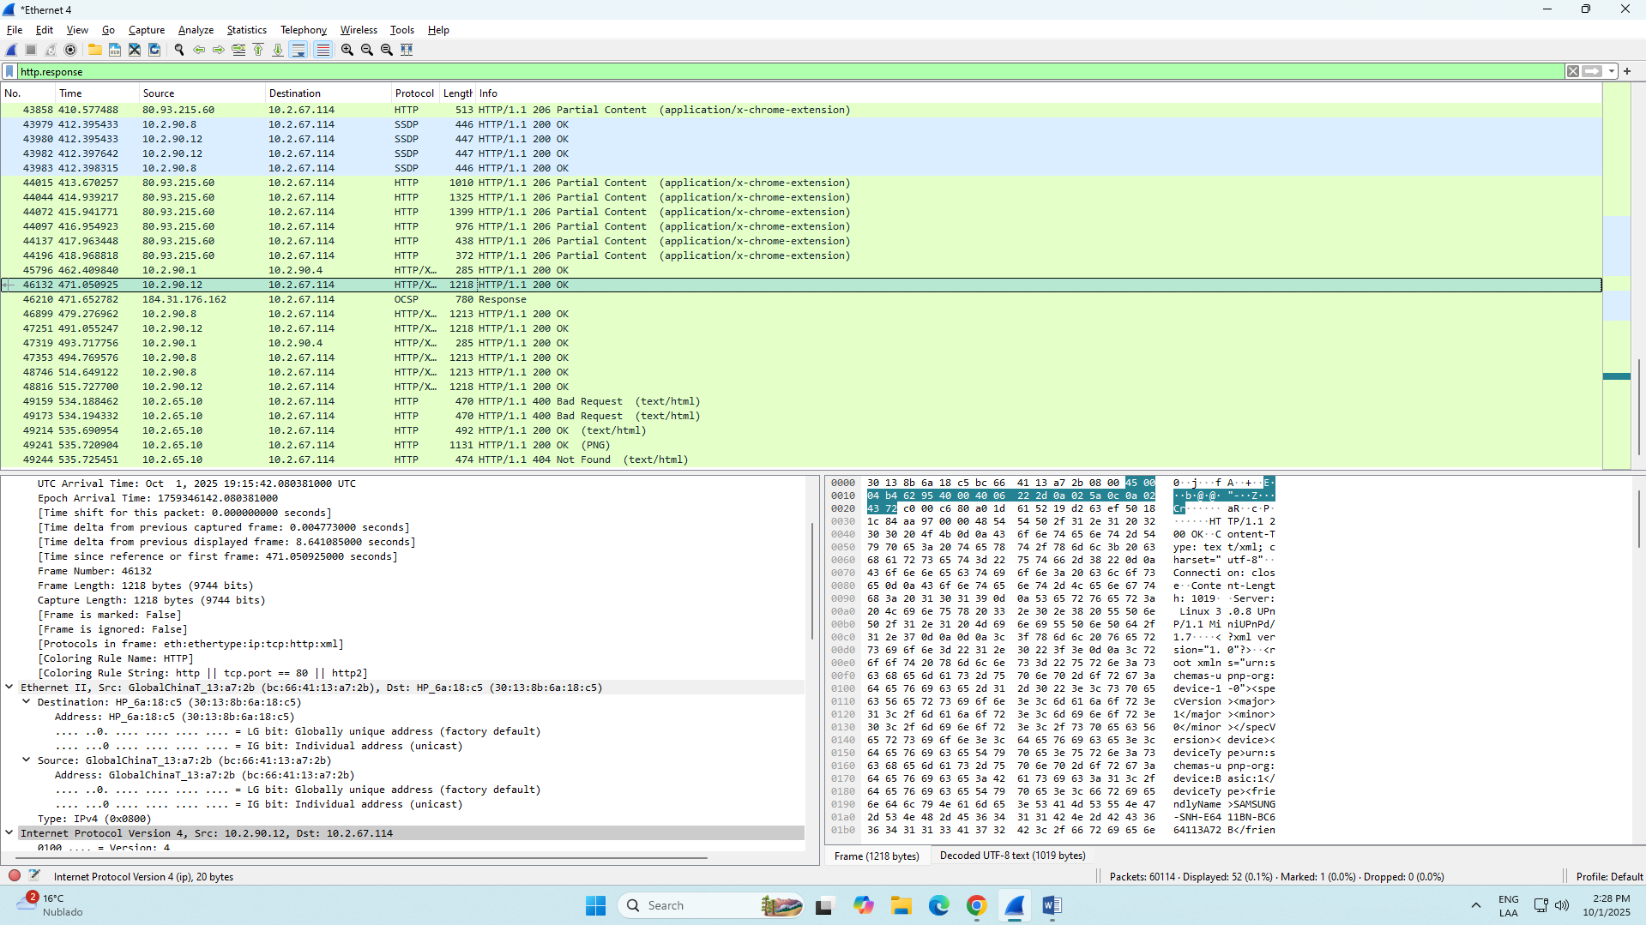

## Review of Ethernet Frames

**[For groups of 1, 2, and 3 students]**

Using **Wireshark**, make a query to the webpage [http://profesores.is.escuelaing.edu.co/˜csantiago/](http://profesores.is.escuelaing.edu.co/~csantiago/) , filter the GET messages and examine the Ethernet frame header. Identify the fields and explain each part.

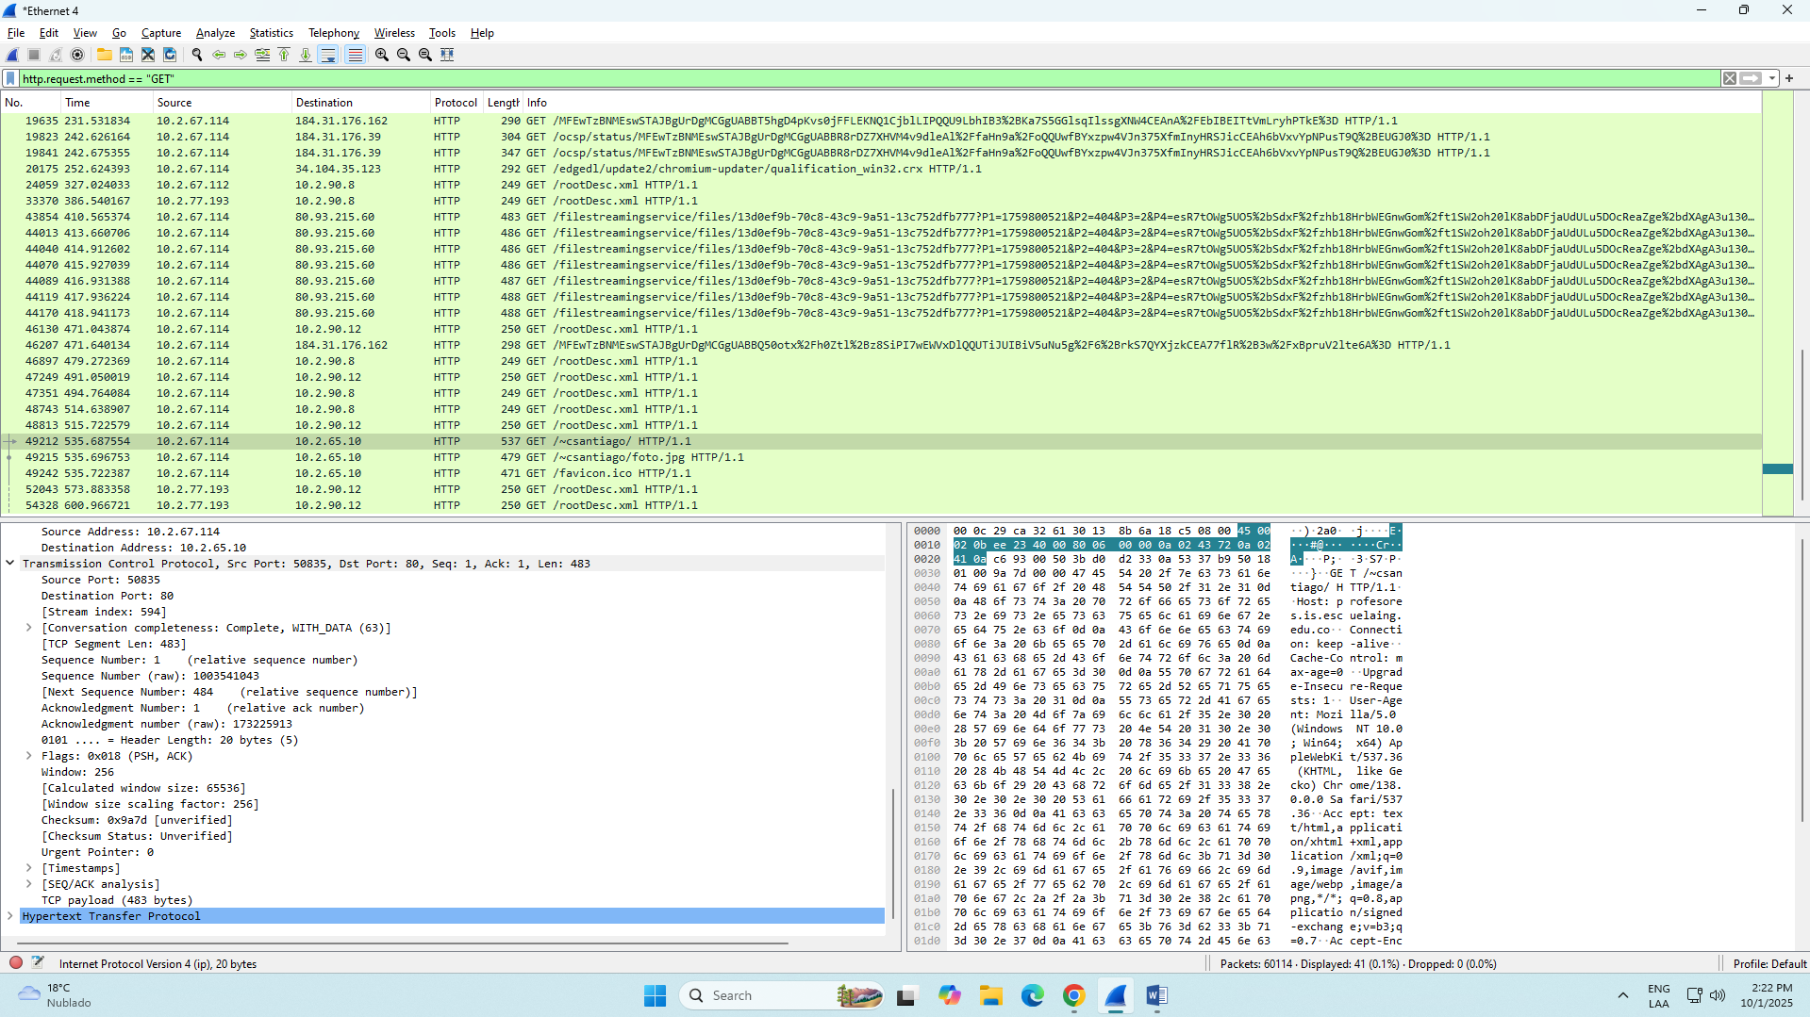

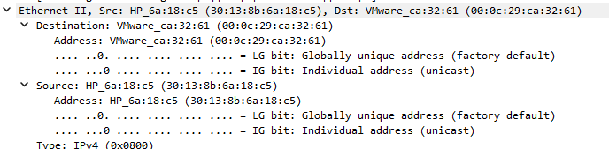

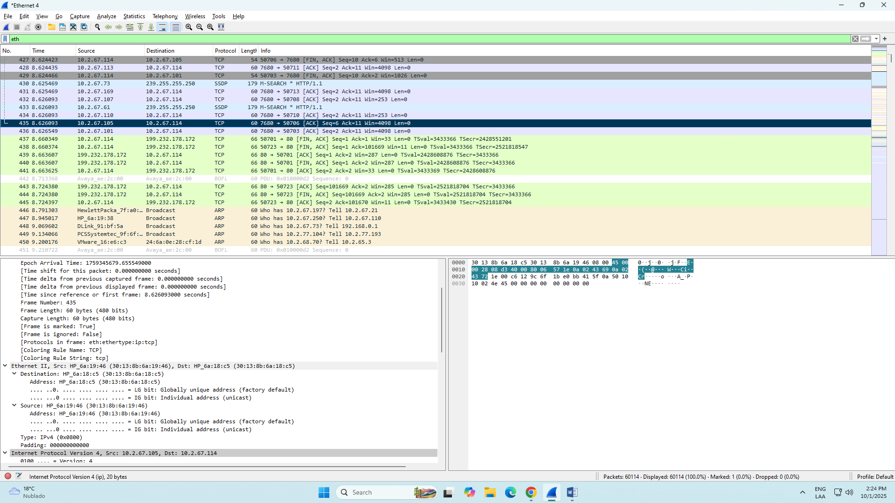

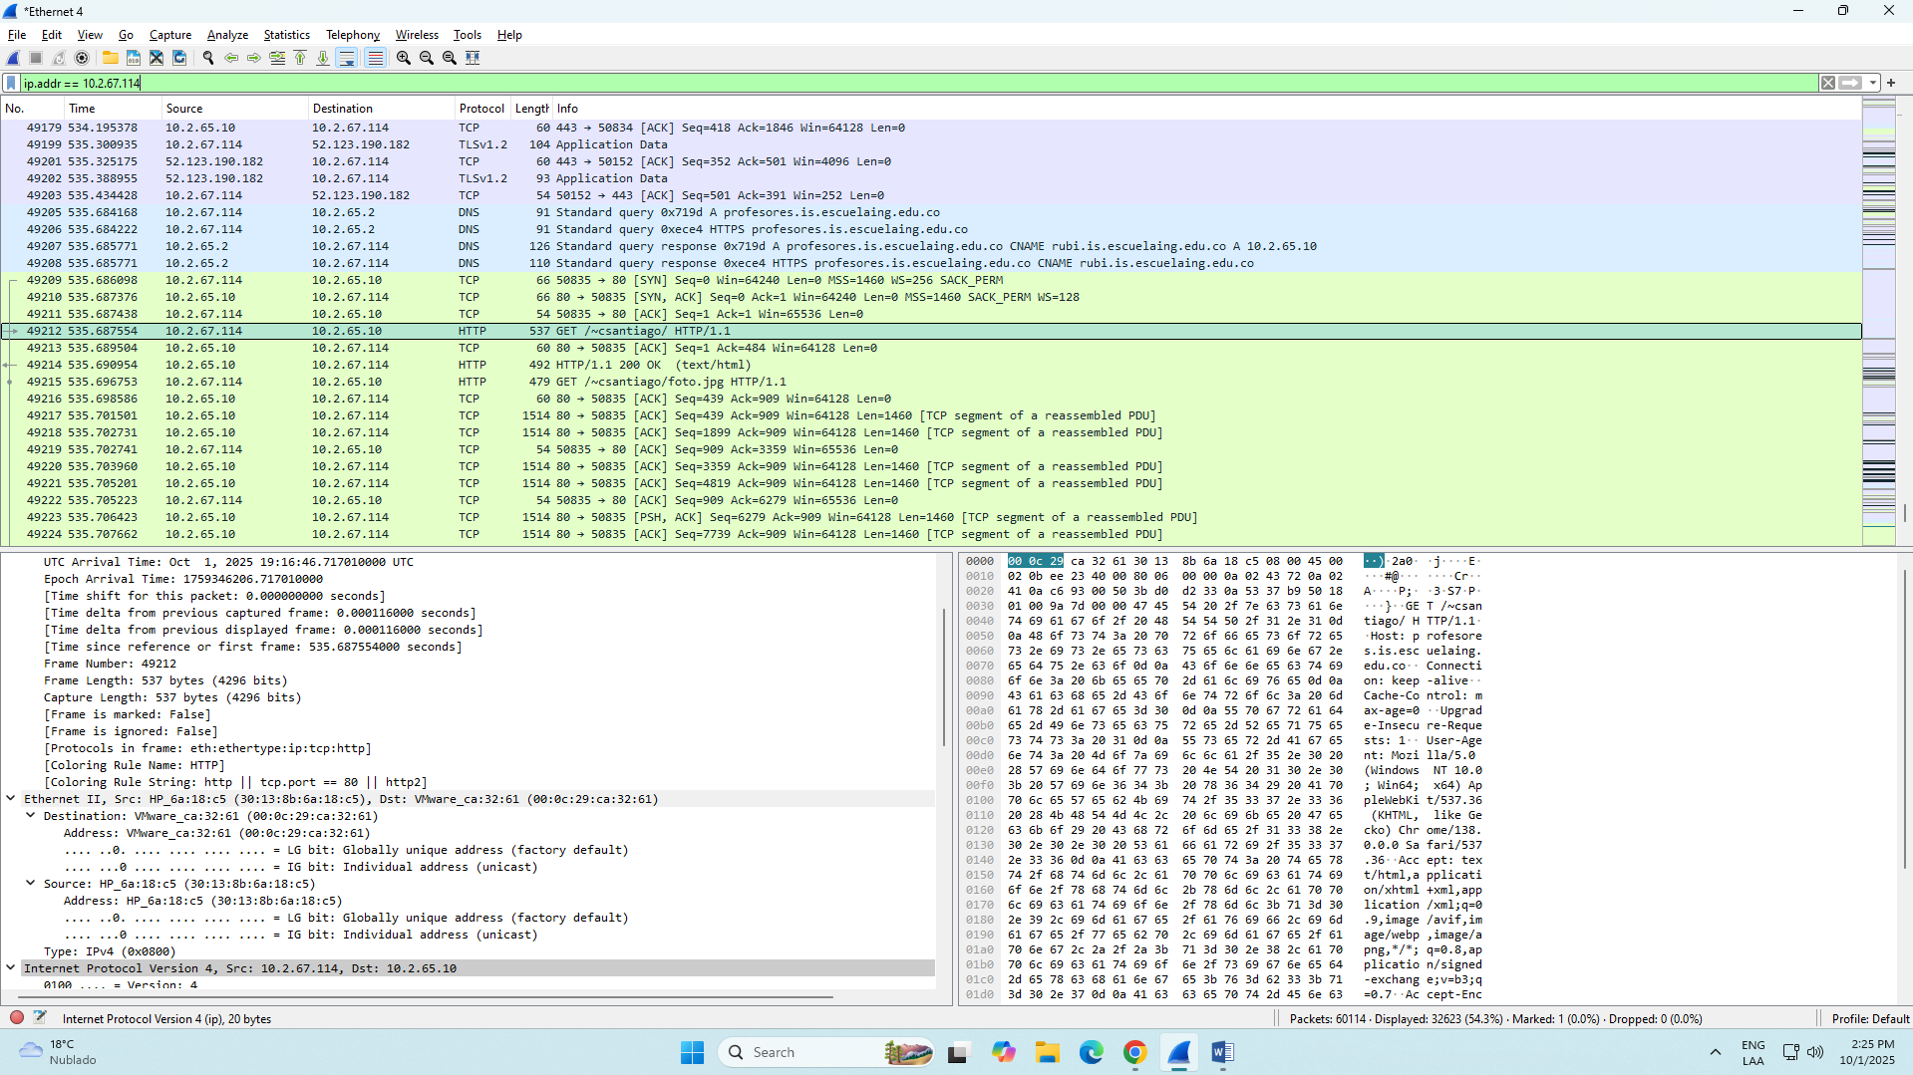

# Base Software Installation

Another key component of basic IT infrastructure is database management systems (DBMS). These DBMS can be hosted either in a company’s datacenter or on a cloud server. They store structured data for the organization and are used by different applications supporting business operations.

## PostgreSQL - Linux Slackware

**[For groups of 1, 2, and 3 students]**

* 1. Install the PostgreSQL DBMS on a virtual machine running Linux Slackware.

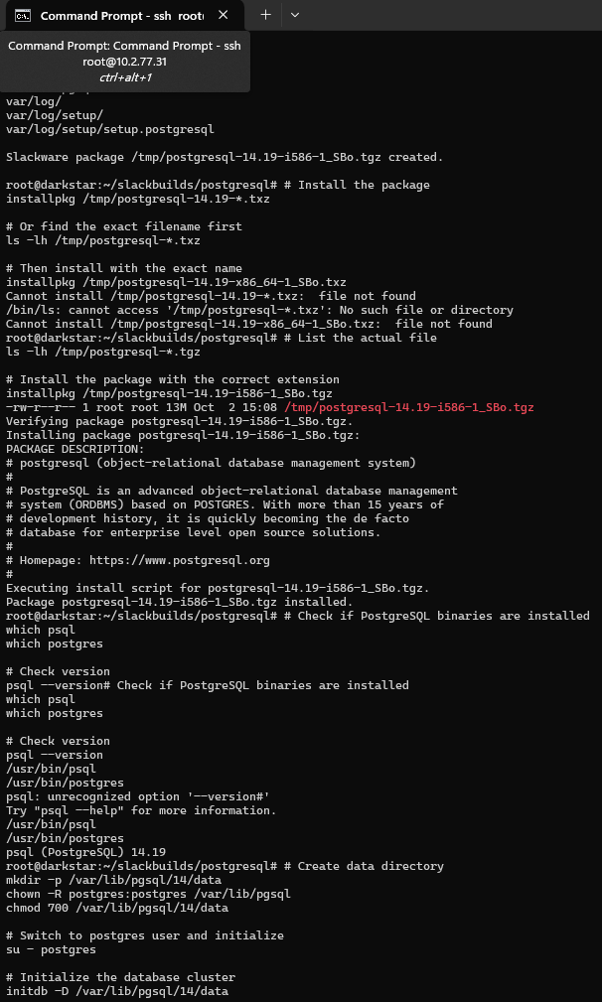

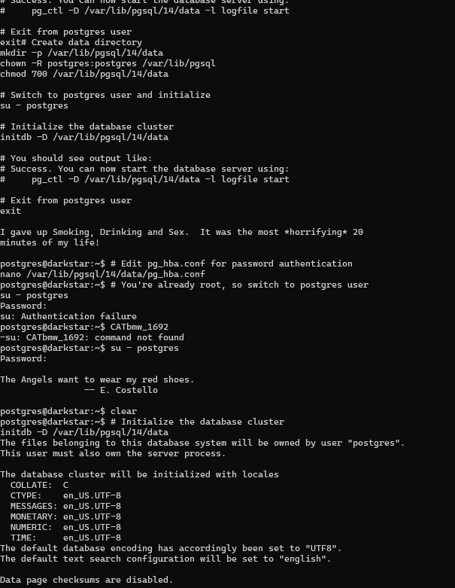

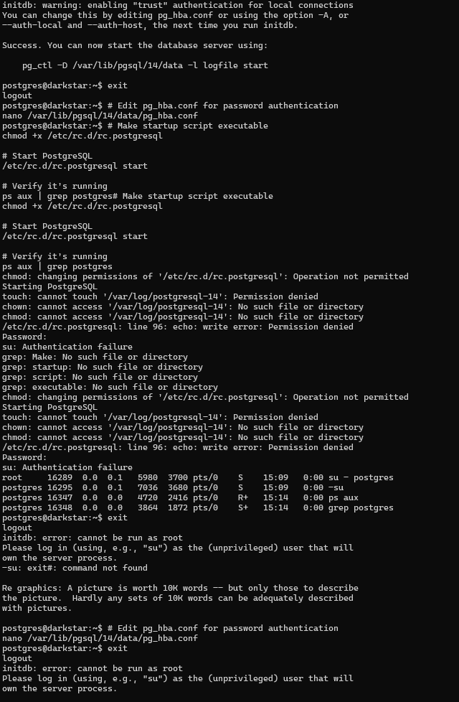

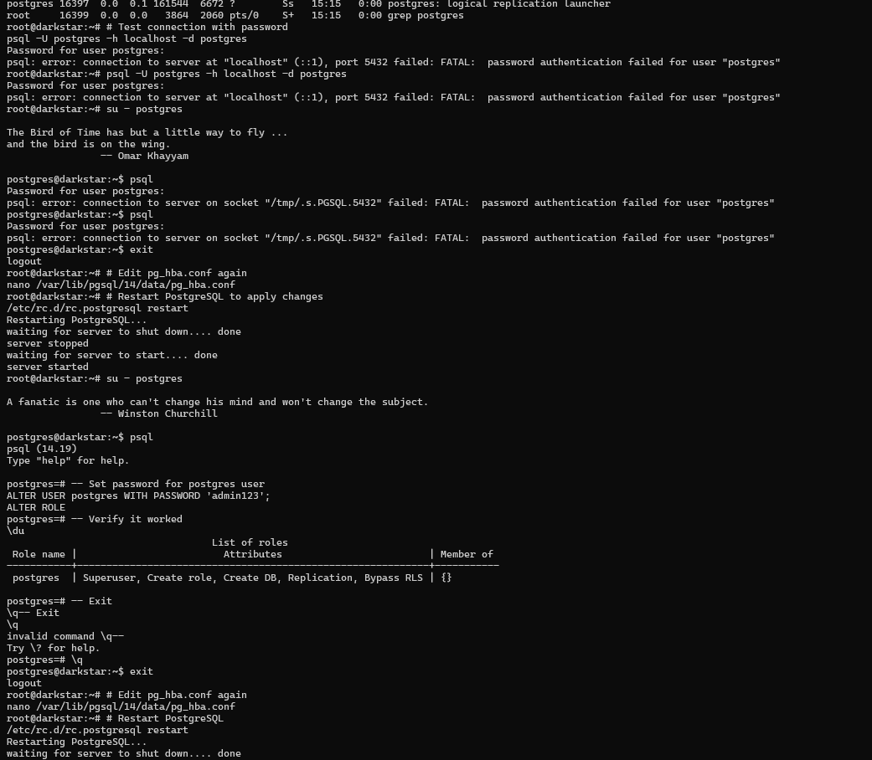

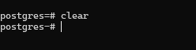

PostgreSQL catBMW_1692

postgreSQLUser admin123

* 1. Create a user for each group member. Use the students’ names as the username.

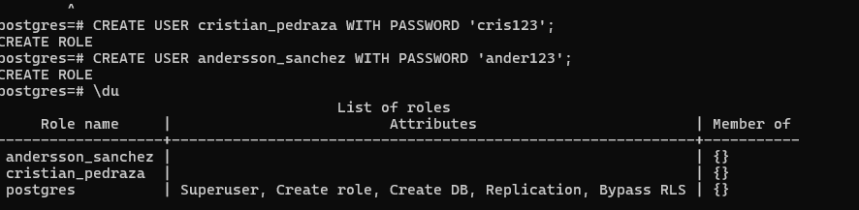

*-- Create user for Cristian Santiago Pedraza Rodriguez*

CREATE USER cristian_pedraza WITH PASSWORD 'cris123';

*-- Create user for Andersson David Sánchez Méndez*

CREATE USER andersson_sanchez WITH PASSWORD 'ander123';

*-- Verify users were created*

\du

* 1. Create a database to store information about tourist sites in Colombia you wish to visit. The database must have at least 3 tables. Each student should have access only to their own database.

-- Create database for Cristian

CREATE DATABASE cristian_tourism OWNER cristian_pedraza;

-- Create database for Andersson

CREATE DATABASE andersson_tourism OWNER andersson_sanchez;

-- Revoke public access to ensure isolation

REVOKE ALL ON DATABASE cristian_tourism FROM PUBLIC;

REVOKE ALL ON DATABASE andersson_tourism FROM PUBLIC;

-- Grant access only to respective owners

GRANT ALL PRIVILEGES ON DATABASE cristian_tourism TO cristian_pedraza;

GRANT ALL PRIVILEGES ON DATABASE andersson_tourism TO andersson_sanchez;

-- List all databases to verify

\l

-- Exit

\q

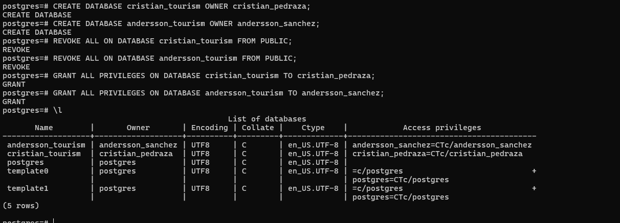

* 1. Insert data into the databases.

### For Cristian Santiago Pedraza Rodriguez:

bash

*# Connect as cristian_pedraza*

psql -U cristian_pedraza -h localhost -d cristian_tourism

Enter password: cris123

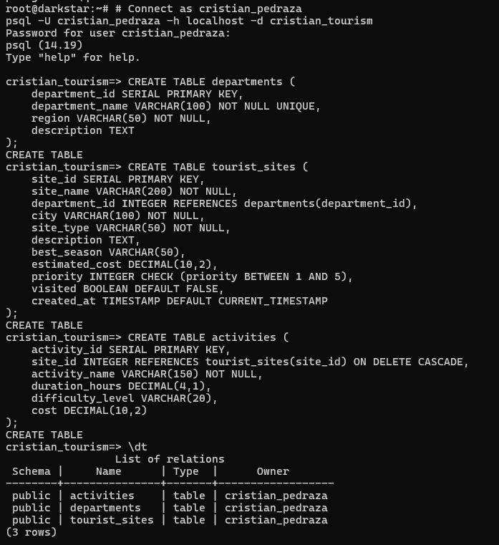

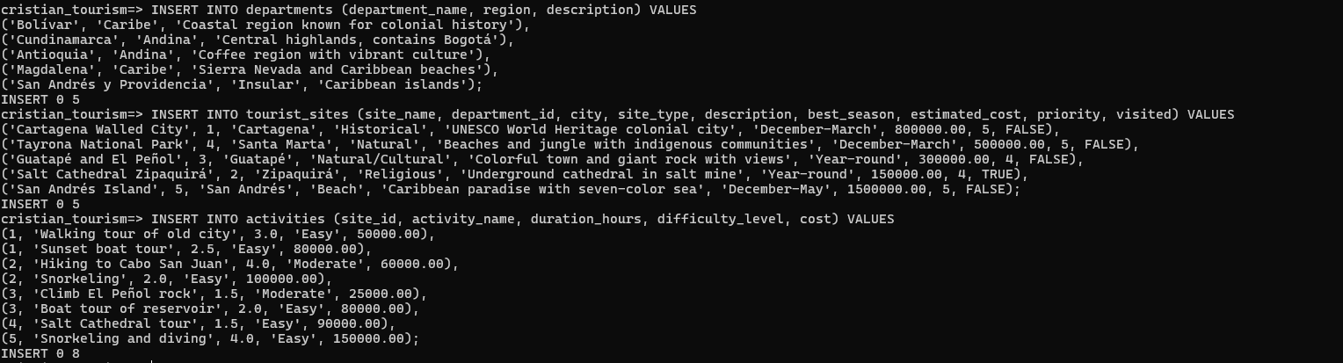

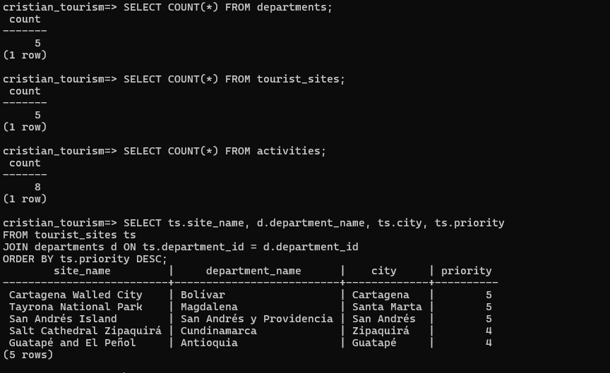

### For Andersson David Sánchez Méndez:

bash

*# Connect as andersson_sanchez*

psql -U andersson_sanchez -h localhost -d andersson_tourism

Enter password: ander123

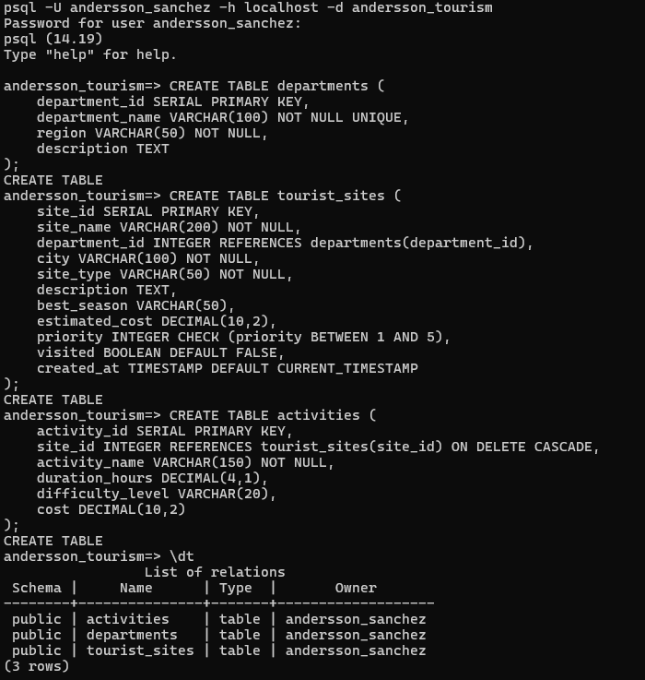

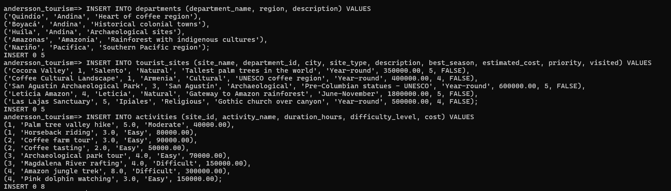

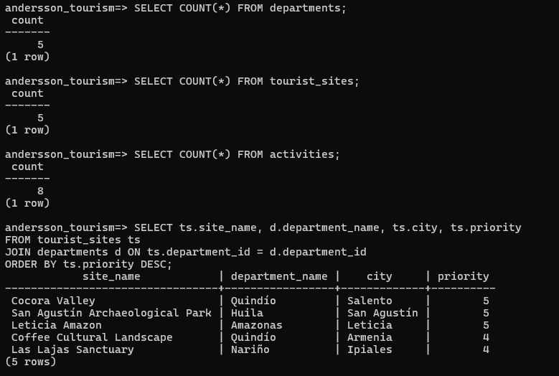

## SQL Server - Windows Server

**[For groups of 1, 2, and 3 students]**

* 1. Install the SQL Server DBMS on a virtual machine running Windows Server.

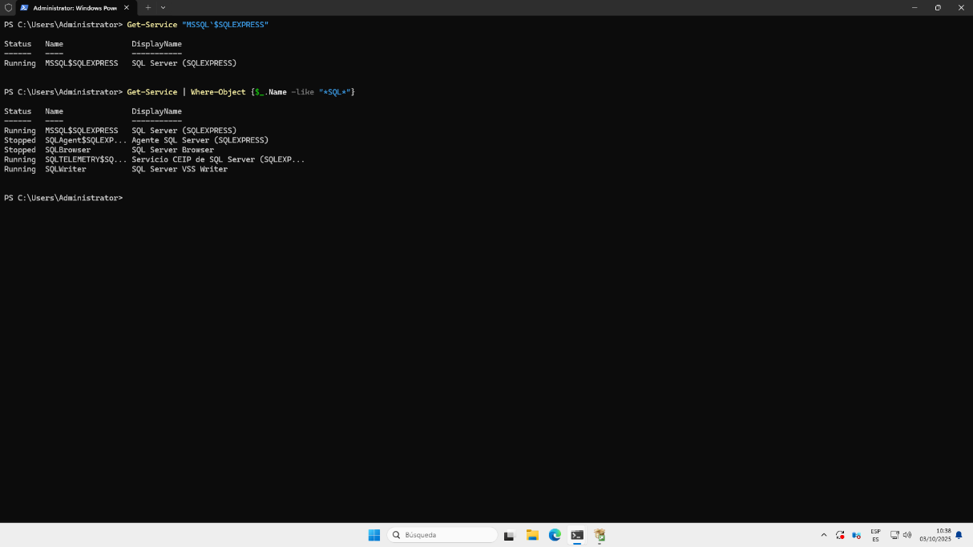

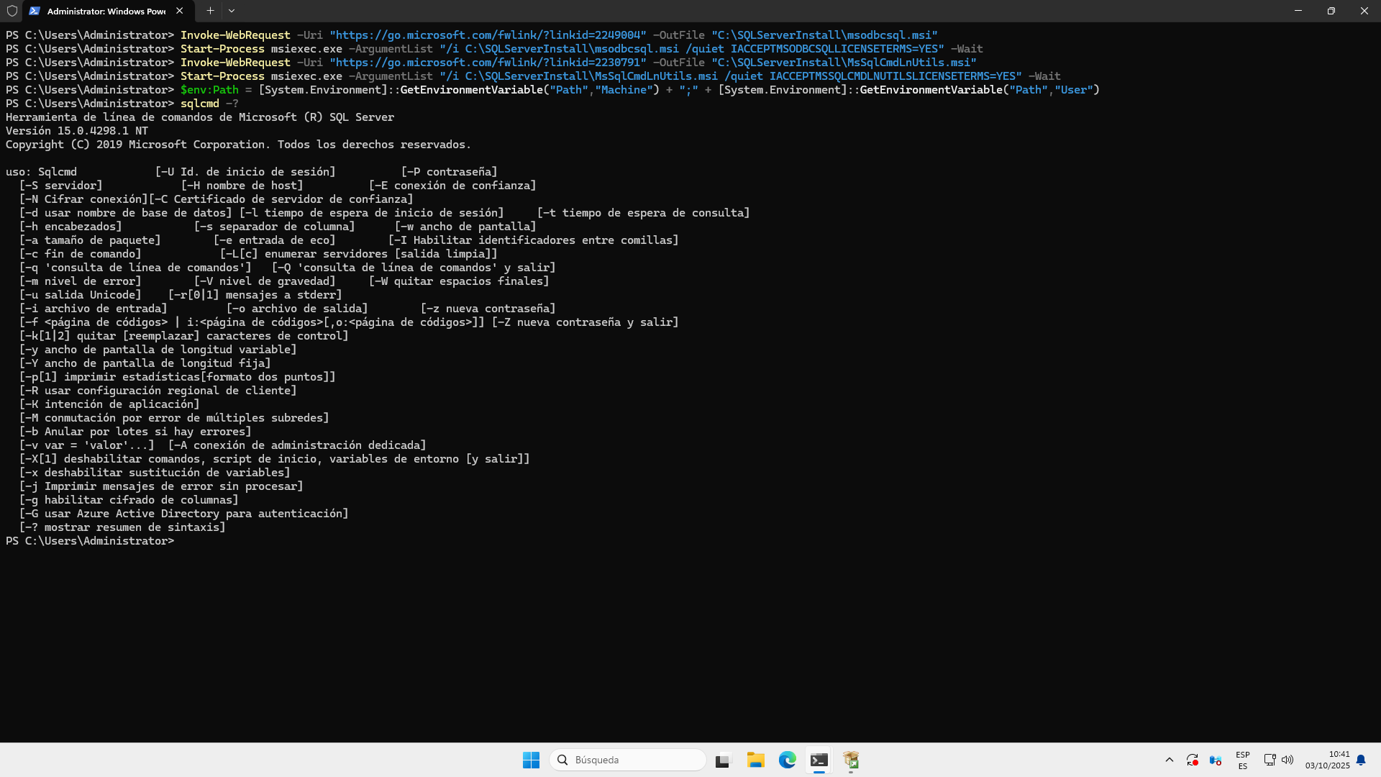

* 1. Create a user for each group member. Use the students’ names as the username.

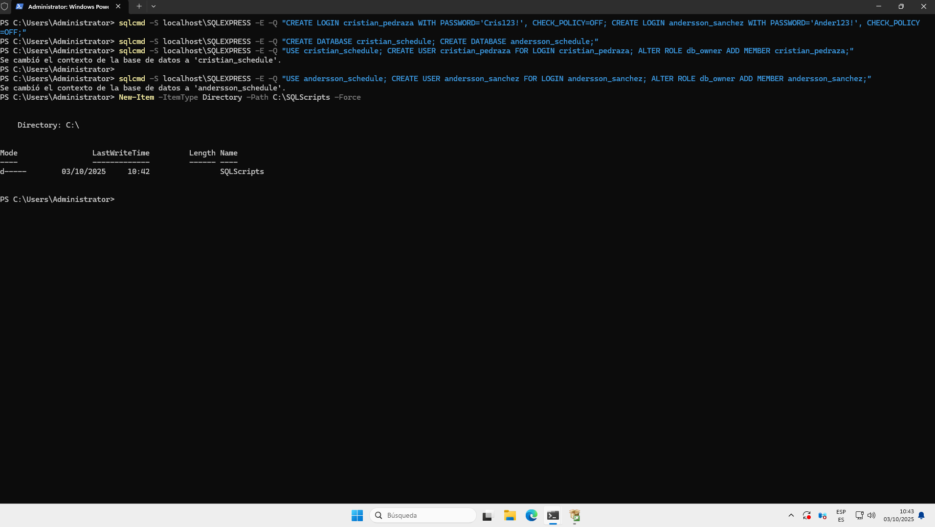

* 1. Create a database to organize your monthly activity schedule. The database must have at least 3 tables. Each student should have access only to their own database.

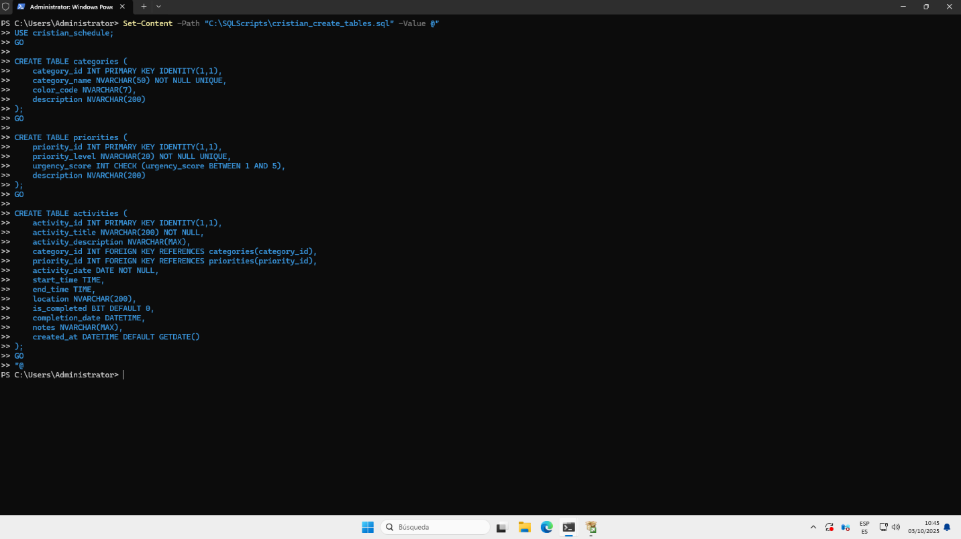

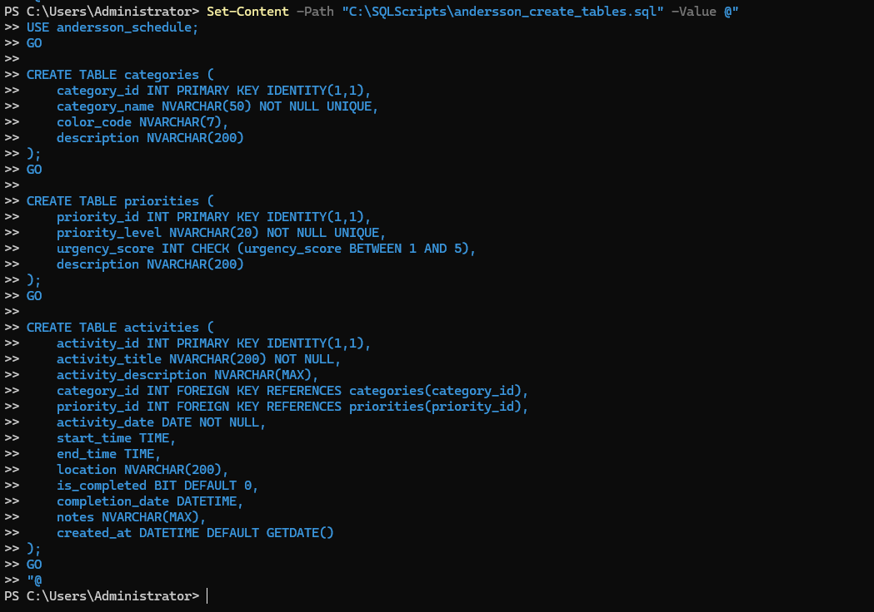

* 1. Insert data into the databases.

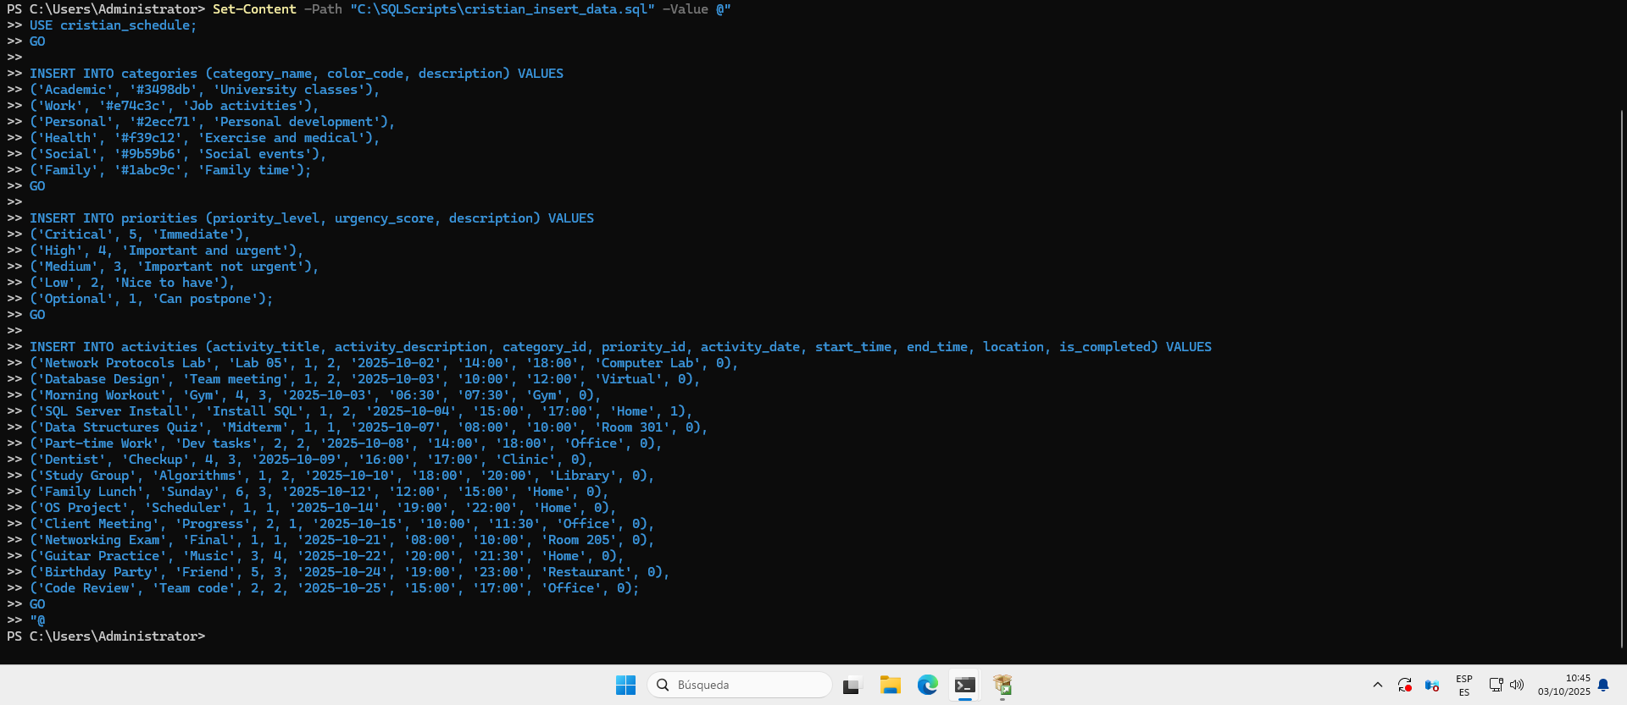

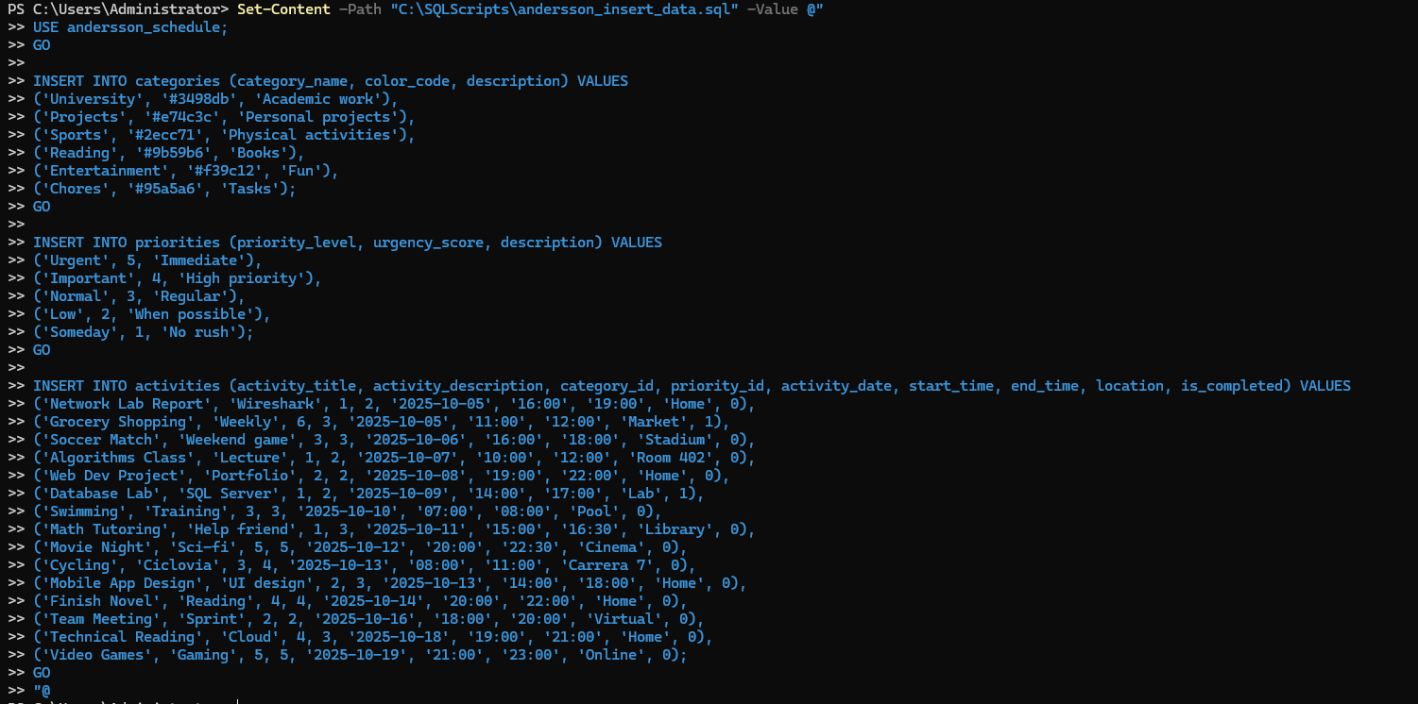

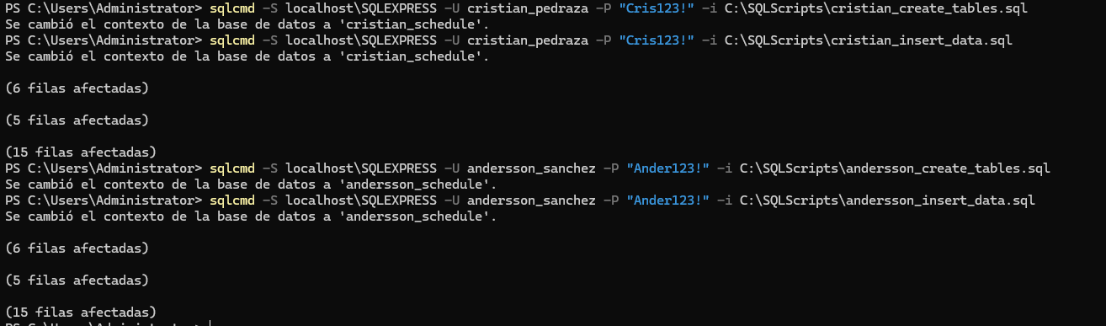

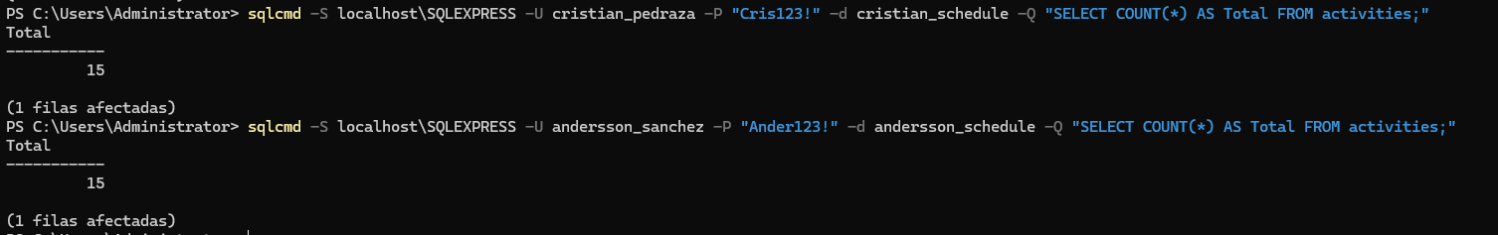

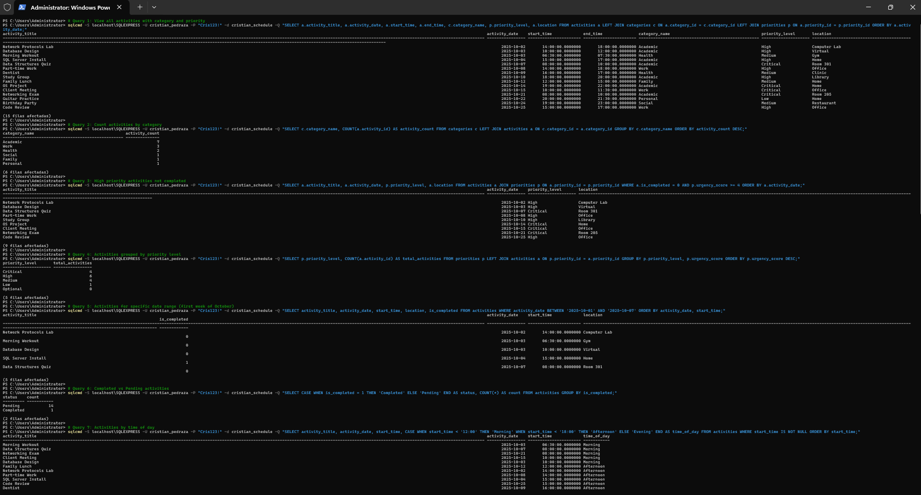

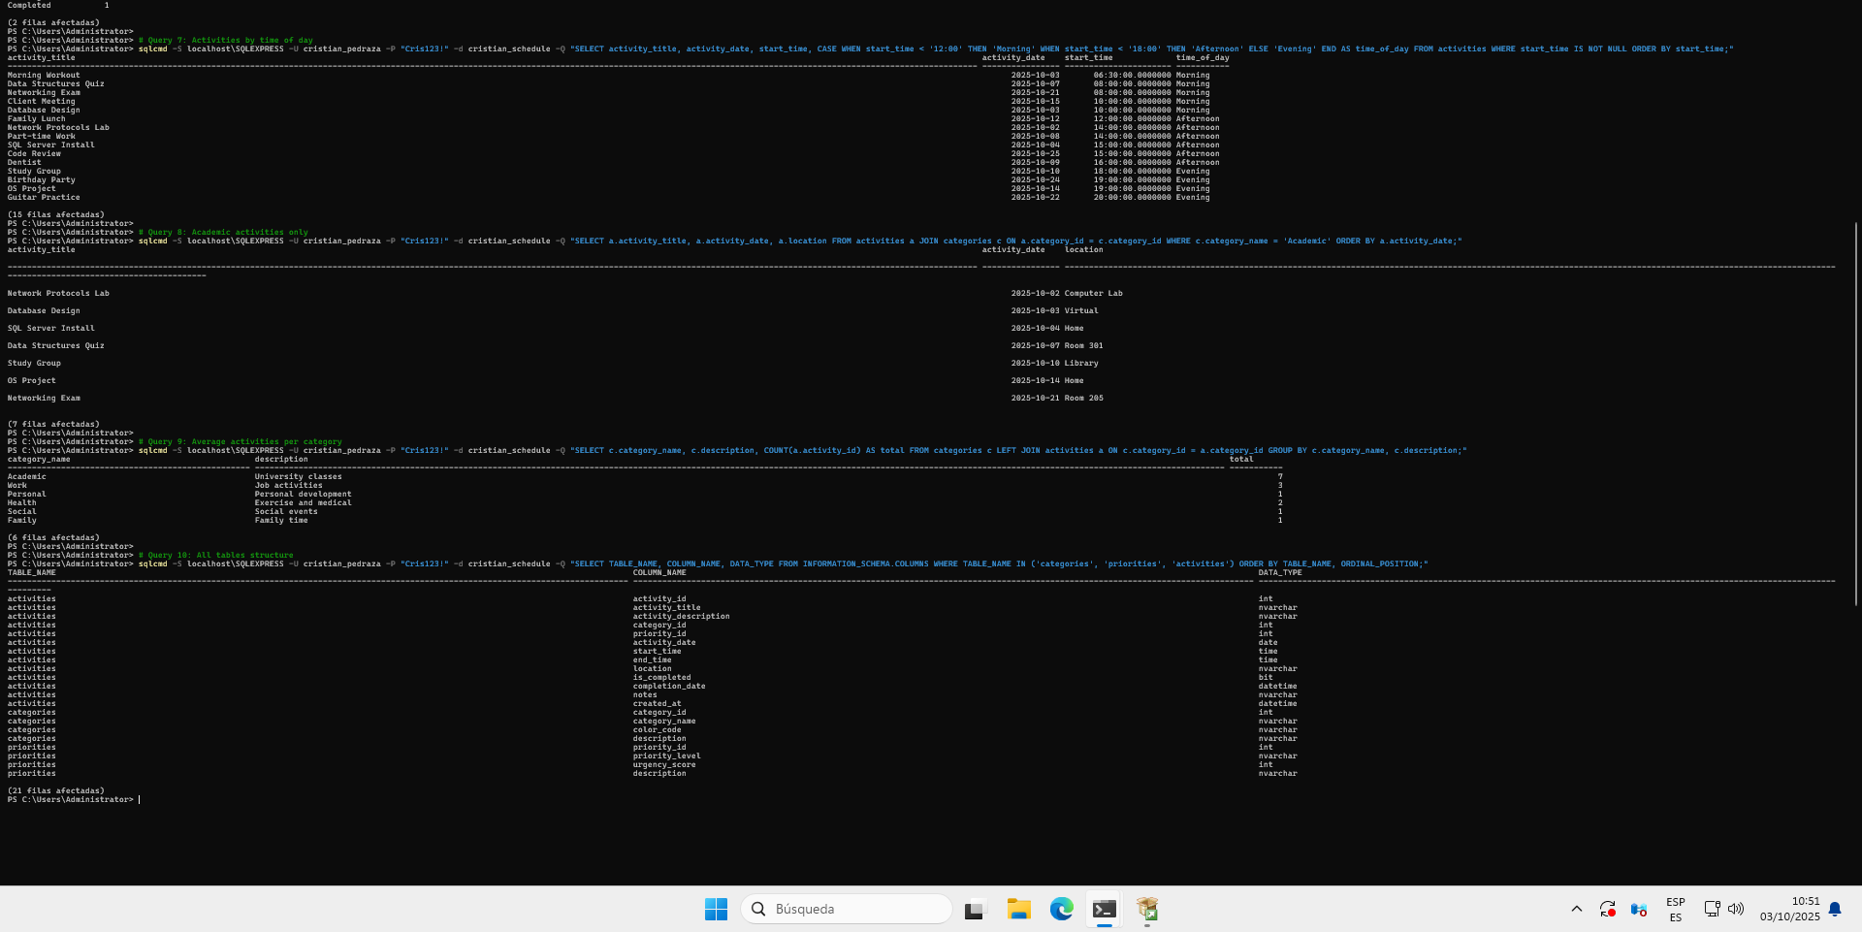

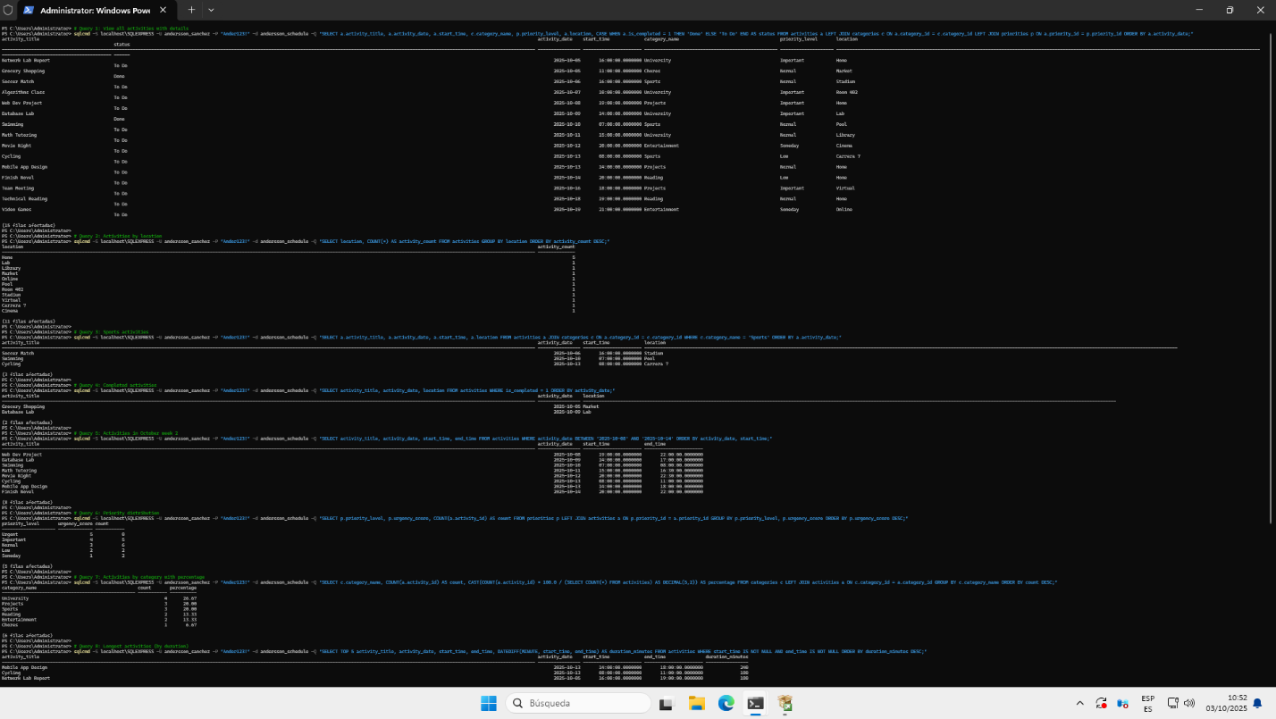

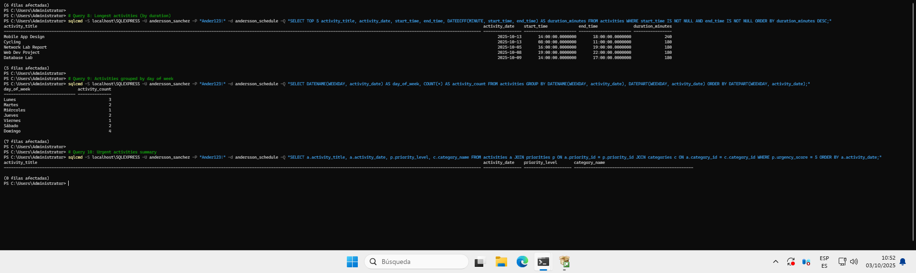

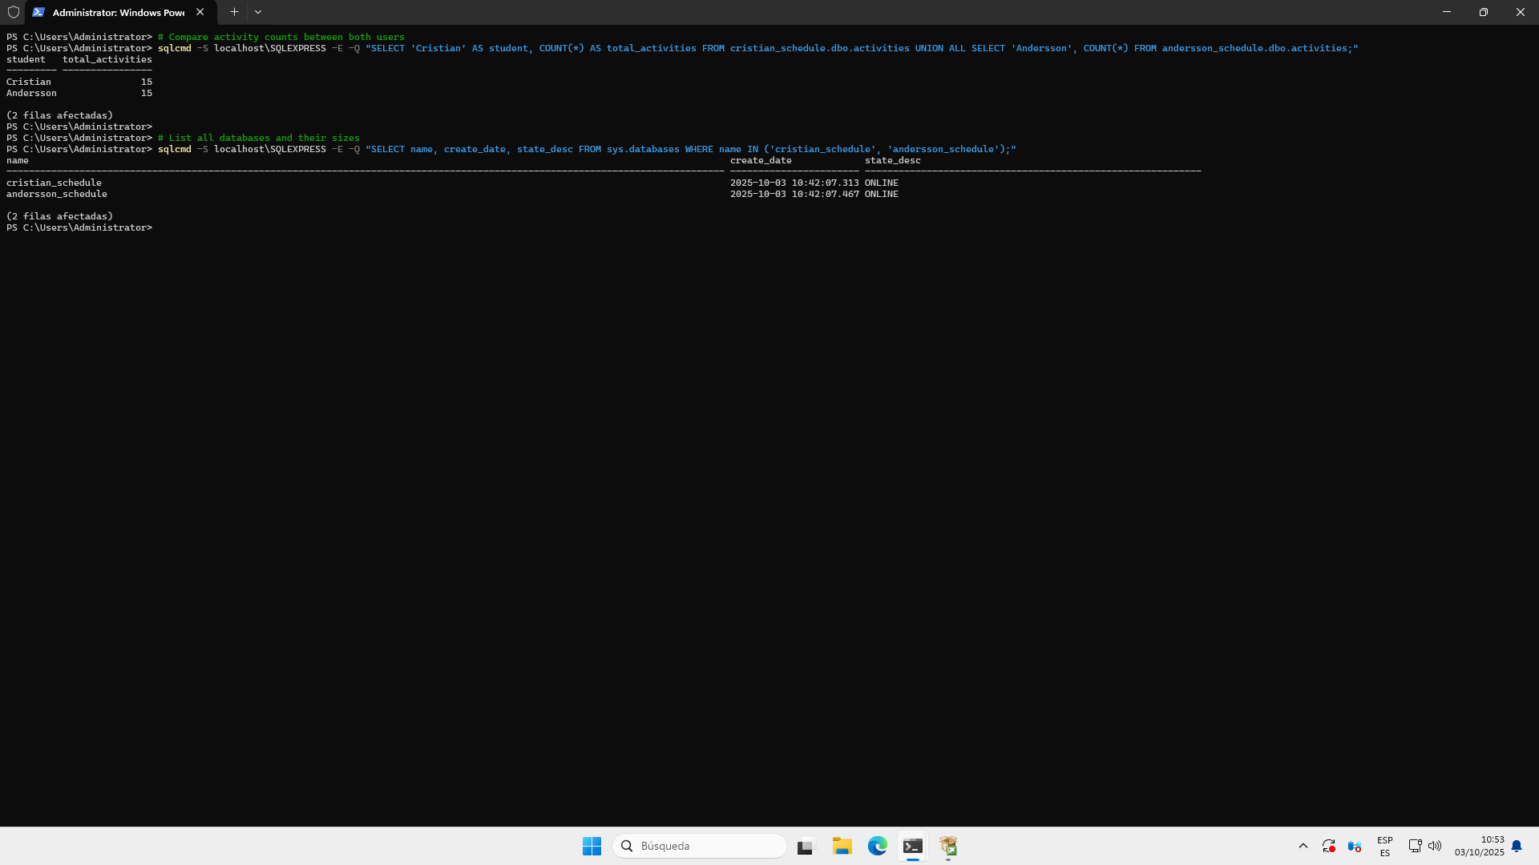

## SQL Database - Microsoft Azure

**[For groups of 1, 2, and 3 students]**

* 1. Go to <https://azure.microsoft.com/en-us/pricing/purchase-options/azure-account/> and log in with your institutional email.

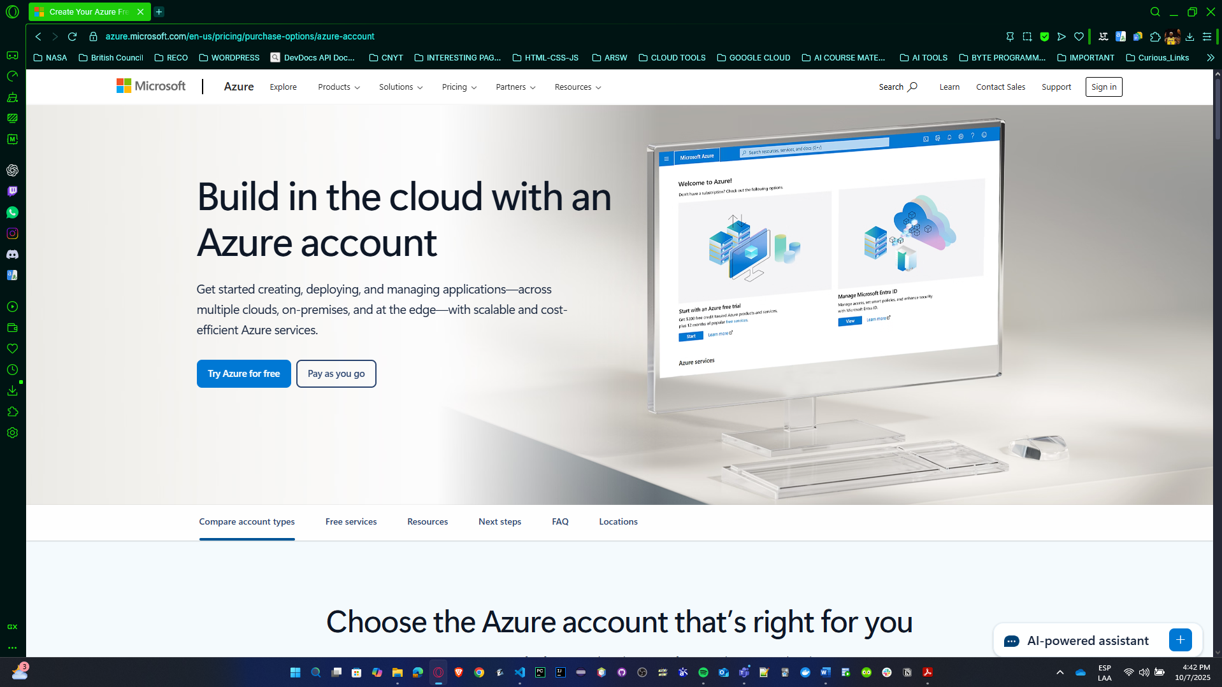

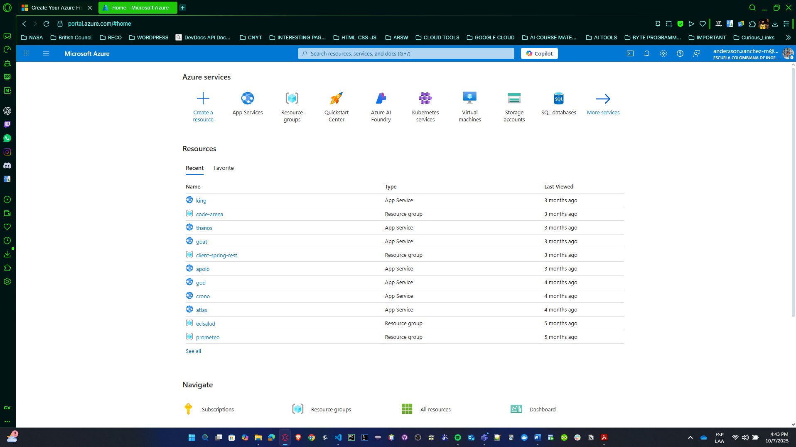

* 1. Once logged into the **Azure** portal, explore the available services.
* What is cloud computing, and what are some of the advantages of using a platform like Microsoft Azure compared to an on-premise infrastructure?

**Cloud Computing:** Delivery of computing services (servers, storage, databases, networking, software) over the internet ("the cloud") on a pay-as-you-go basis.

**Advantages of Azure over On-Premise:**

* **Cost Efficiency:** No upfront hardware costs, pay only for what you use
* **Scalability:** Easily scale up or down based on demand
* **High Availability:** 99.99% uptime SLA with automatic backups
* **Global Reach:** Data centers in multiple regions worldwide
* **Maintenance:** Microsoft handles hardware, updates, and security patches
* **Disaster Recovery:** Built-in backup and geo-replication
* **Faster Deployment:** Provision resources in minutes vs weeks
* **Automatic Updates:** Always have latest features and security
* What types of services does Microsoft Azure offer (IaaS, PaaS, SaaS), and how do they differ from one another?

• **IaaS (Infrastructure as a Service):**

* Examples: Virtual Machines, Virtual Networks, Storage
* You manage: OS, middleware, runtime, applications, data
* Azure manages: Physical hardware, networking, storage
* Use case: Migration of existing apps, full control needed

• **PaaS (Platform as a Service):**

* Examples: Azure SQL Database, App Service, Azure Functions
* You manage: Applications and data
* Azure manages: Infrastructure, OS, middleware, runtime
* Use case: Focus on development, not infrastructure

• **SaaS (Software as a Service):**

* Examples: Microsoft 365, Dynamics 365, Office 365
* You manage: Your data and user access
* Azure manages: Everything else (application, platform, infrastructure)
* Use case: Ready-to-use applications
* What is the importance of regions and availability zones in Azure, and how do they affect service availability?

**Regions:** Geographic areas containing one or more data centers

* Examples: East US, West Europe, Southeast Asia
* Choose based on: User location, data residency laws, latency

**Availability Zones:** Physically separate locations within a region

* Each zone has independent power, cooling, and networking
* Protect against data center failures
* Provide 99.99% uptime SLA

**Importance:**

* **Disaster Recovery:** Data replication across zones
* **Low Latency:** Deploy close to users
* **Compliance:** Meet data sovereignty requirements
* **High Availability:** Automatic failover
* What is the difference between vertical scaling and horizontal scaling in Azure, and when would you choose one over the other?

**Vertical Scaling (Scale Up/Down):**

* Increase/decrease resources of existing instance
* Example: Change from 2 cores to 8 cores
* **When to use:** Single instance with more power needed, simpler architecture
* **Limitations:** Hardware limits, downtime during scaling

**Horizontal Scaling (Scale Out/In):**

* Add/remove more instances
* Example: Change from 2 servers to 10 servers
* **When to use:** Distribute load, need high availability, elastic demand
* **Advantages:** No limits, no downtime, better redundancy
* How does using technologies like TLS (Transport Layer Security) on the transport layer affect accessing Azure SQL Database compared to a local virtual machine database?

**Azure SQL Database:**

* **Enforced encryption:** TLS 1.2+ always enabled by default
* **Certificate management:** Microsoft handles SSL certificates
* **Connection string:** Requires Encrypt=True
* **Security:** All data encrypted in transit automatically
* **Compliance:** Meets industry standards (PCI-DSS, HIPAA)

**Local VM Database:**

* **Optional encryption:** Must manually configure TLS
* **Certificate management:** You install and maintain certificates
* **Configuration:** Must edit server config files
* **Overhead:** Additional setup and maintenance
* **Risk:** Can accidentally disable encryption

**Impact:** Azure SQL Database provides stronger security by default with less administrative overhead.

* From a transport layer perspective, how does the handling of TCP connections differ between a SQL database hosted on a local virtual machine and Azure SQL Database?

**Local VM SQL Database:**

* **Direct TCP connection:** Client → VM IP:1433
* **Persistent connections:** Long-lived connections
* **Connection pooling:** Managed by application
* **Firewall:** You configure VM and network firewalls
* **Static IP:** VM has fixed IP address
* **Port management:** You open/close ports

**Azure SQL Database:**

* **Gateway architecture:** Client → Azure Gateway → Database
* **Connection proxy:** Azure SQL Gateway intermediates
* **Automatic failover:** Transparent to client if database moves
* **Built-in retry logic:** Handles transient failures
* **Dynamic routing:** Can redirect to different physical servers
* **Firewall rules:** Managed through Azure Portal
* **Connection limits:** Enforced based on service tier

**Key Differences:**

* Azure uses **connection pooling at gateway level**
* Azure has **idle connection timeout** (30 minutes default)
* Azure handles **automatic load balancing**
* Local VM gives **more control over TCP settings**
  1. Use the [Azure SQL Database](https://azure.microsoft.com/en-us/products/azure-sql/database/?&ef_id=_k_Cj0KCQjwurS3BhCGARIsADdUH52qK4ZVDy7_d4Wfli7m6jUsxb-yvW71V48ZmGcQ-M7H1TFlEQhCJNYaAnwoEALw_wcB_k_&OCID=AIDcmm3804ythc_SEM__k_Cj0KCQjwurS3BhCGARIsADdUH52qK4ZVDy7_d4Wfli7m6jUsxb-yvW71V48ZmGcQ-M7H1TFlEQhCJNYaAnwoEALw_wcB_k_&gad_source=1&gclid=Cj0KCQjwurS3BhCGARIsADdUH52qK4ZVDy7_d4Wfli7m6jUsxb-yvW71V48ZmGcQ-M7H1TFlEQhCJNYaAnwoEALw_wcB) service to manage records of books and scientific articles. The database must have at least 3 tables.

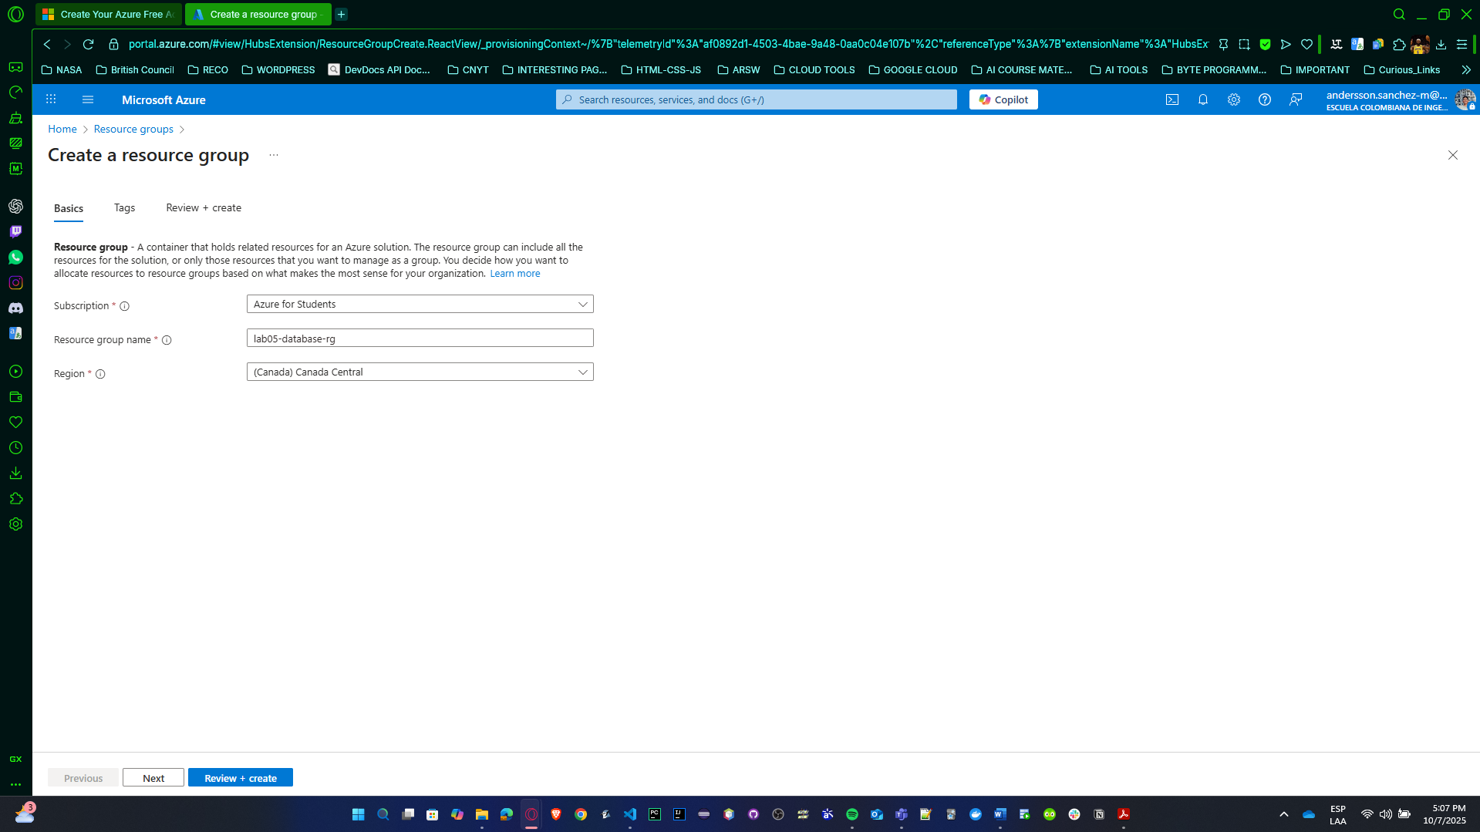

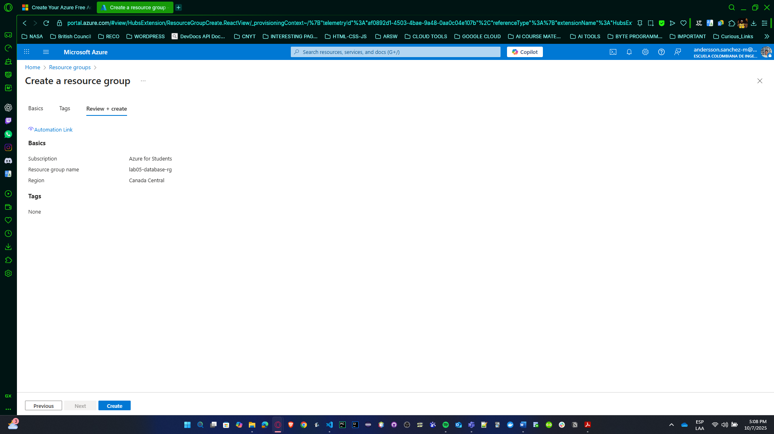

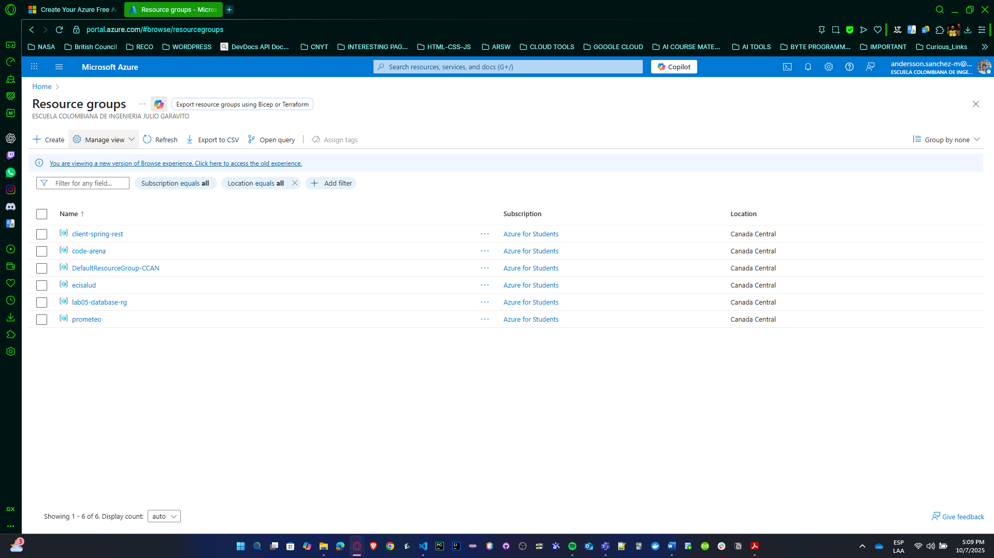

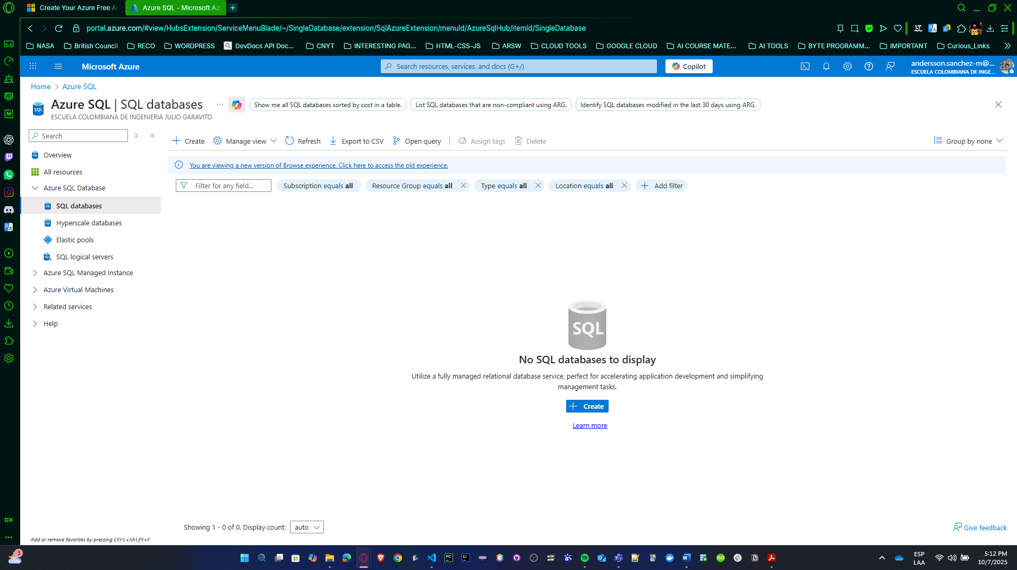

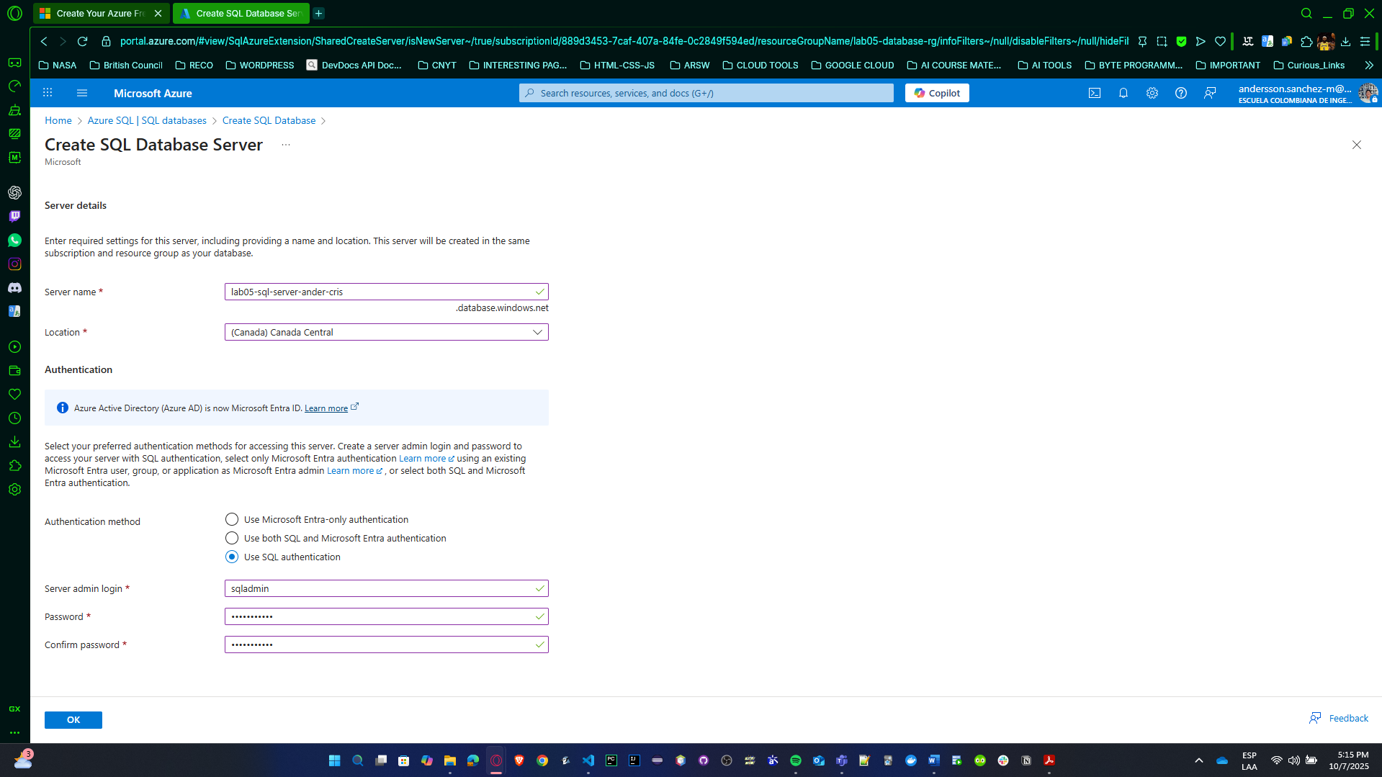

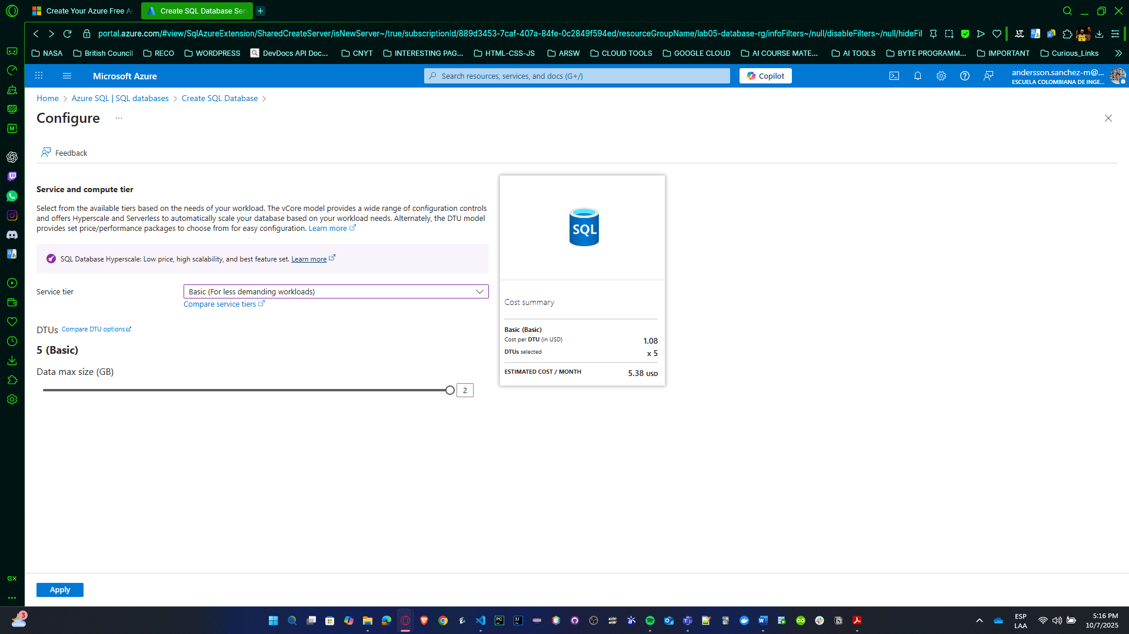

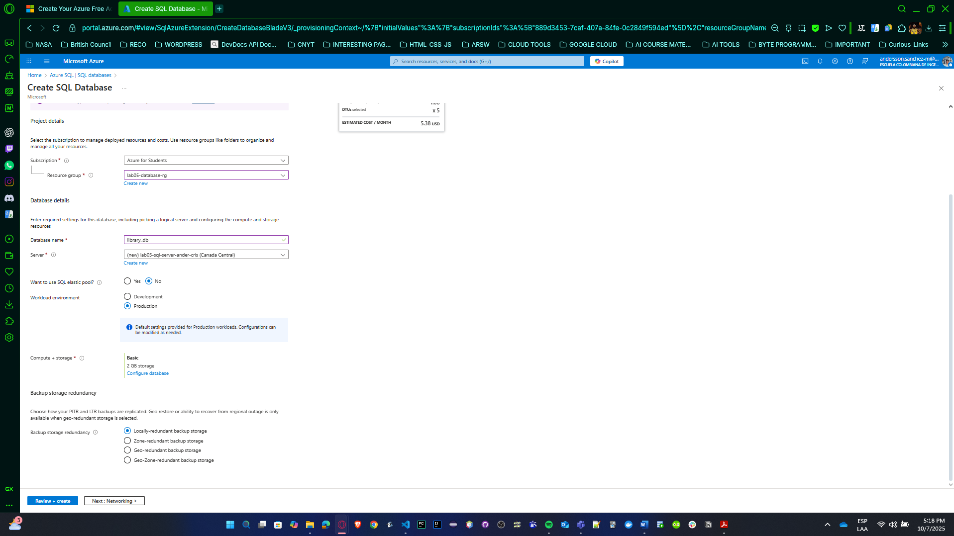

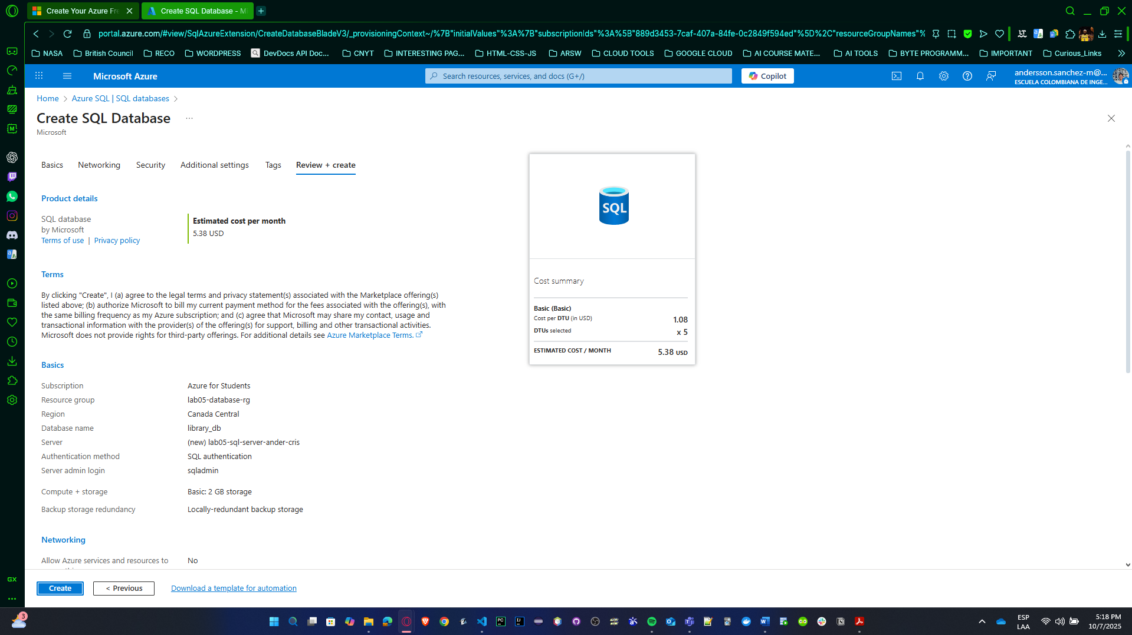

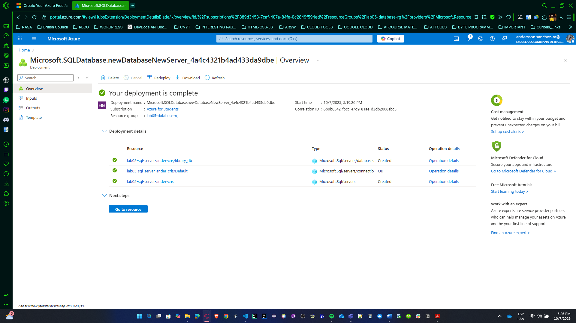

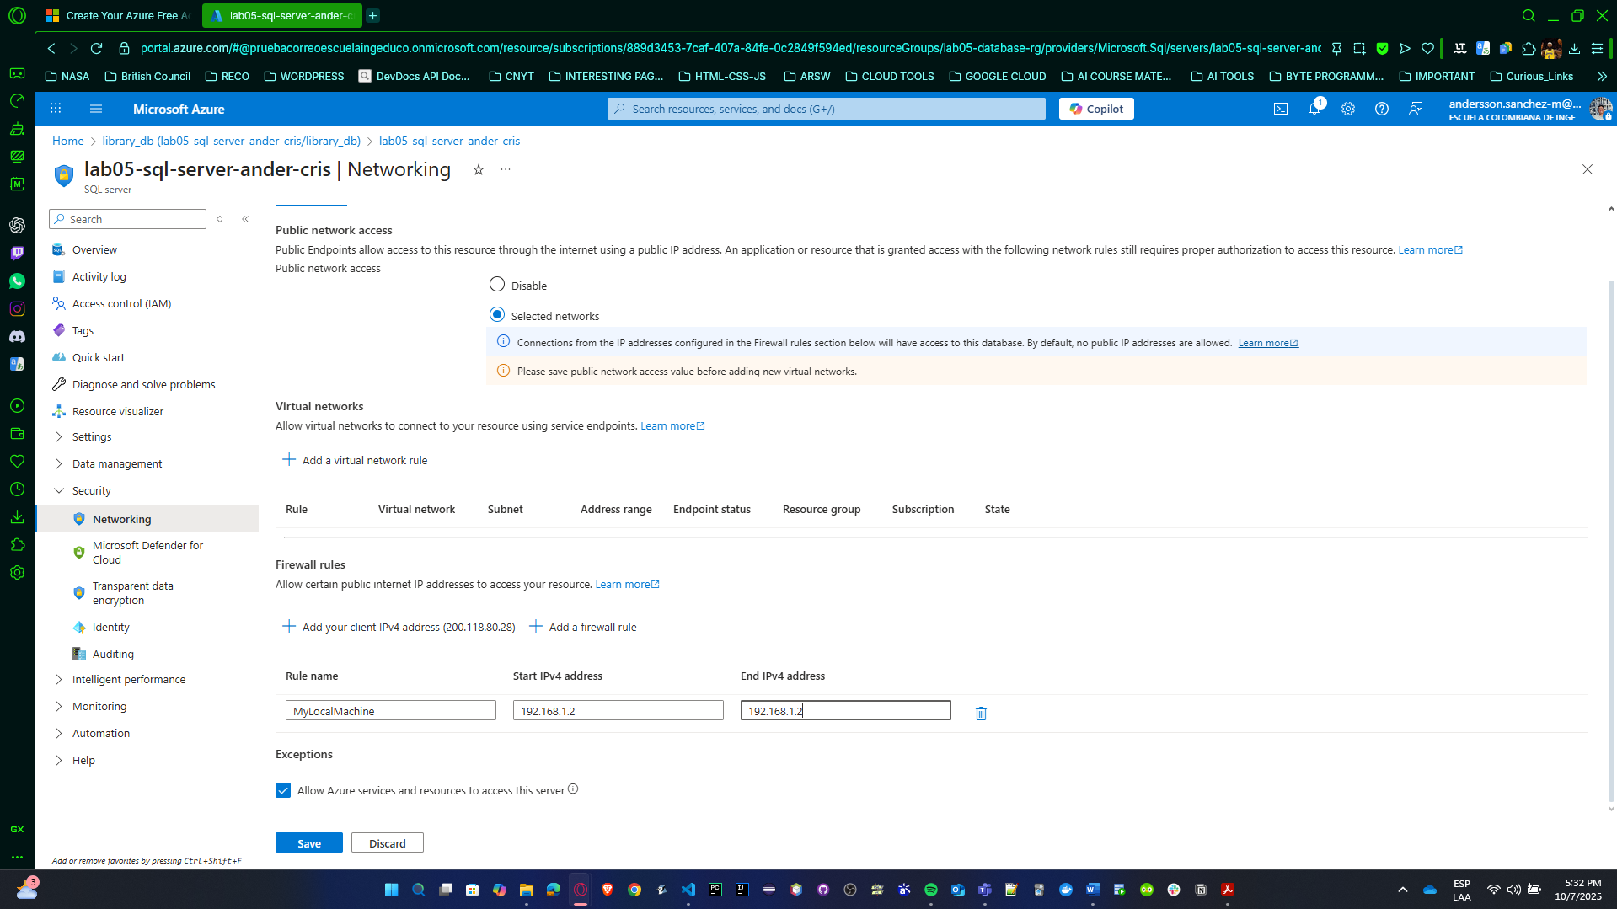

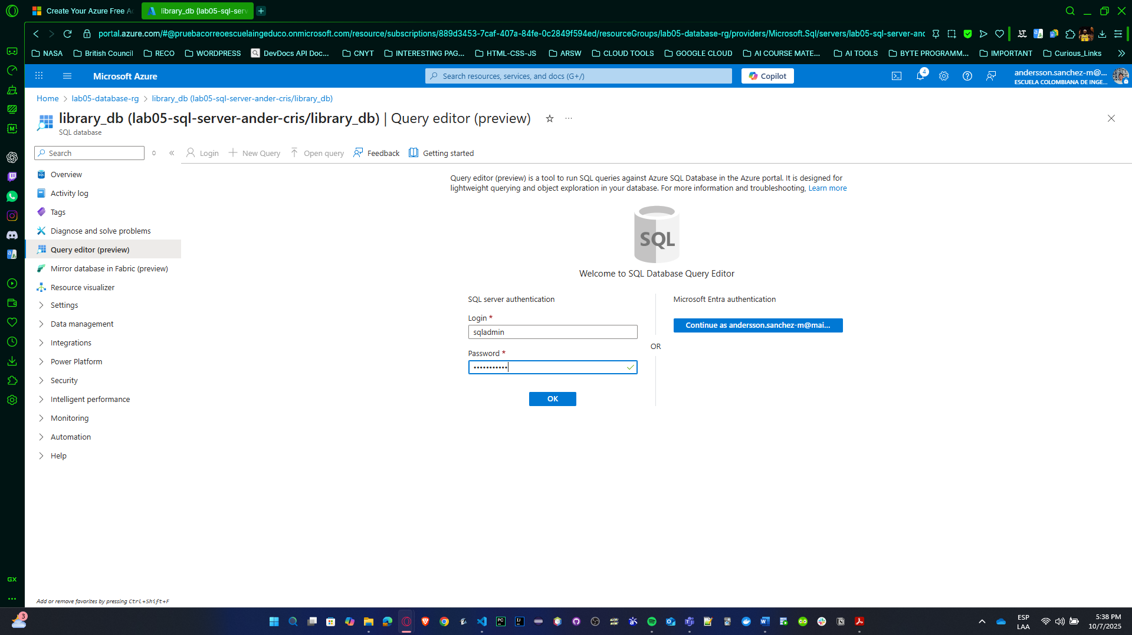

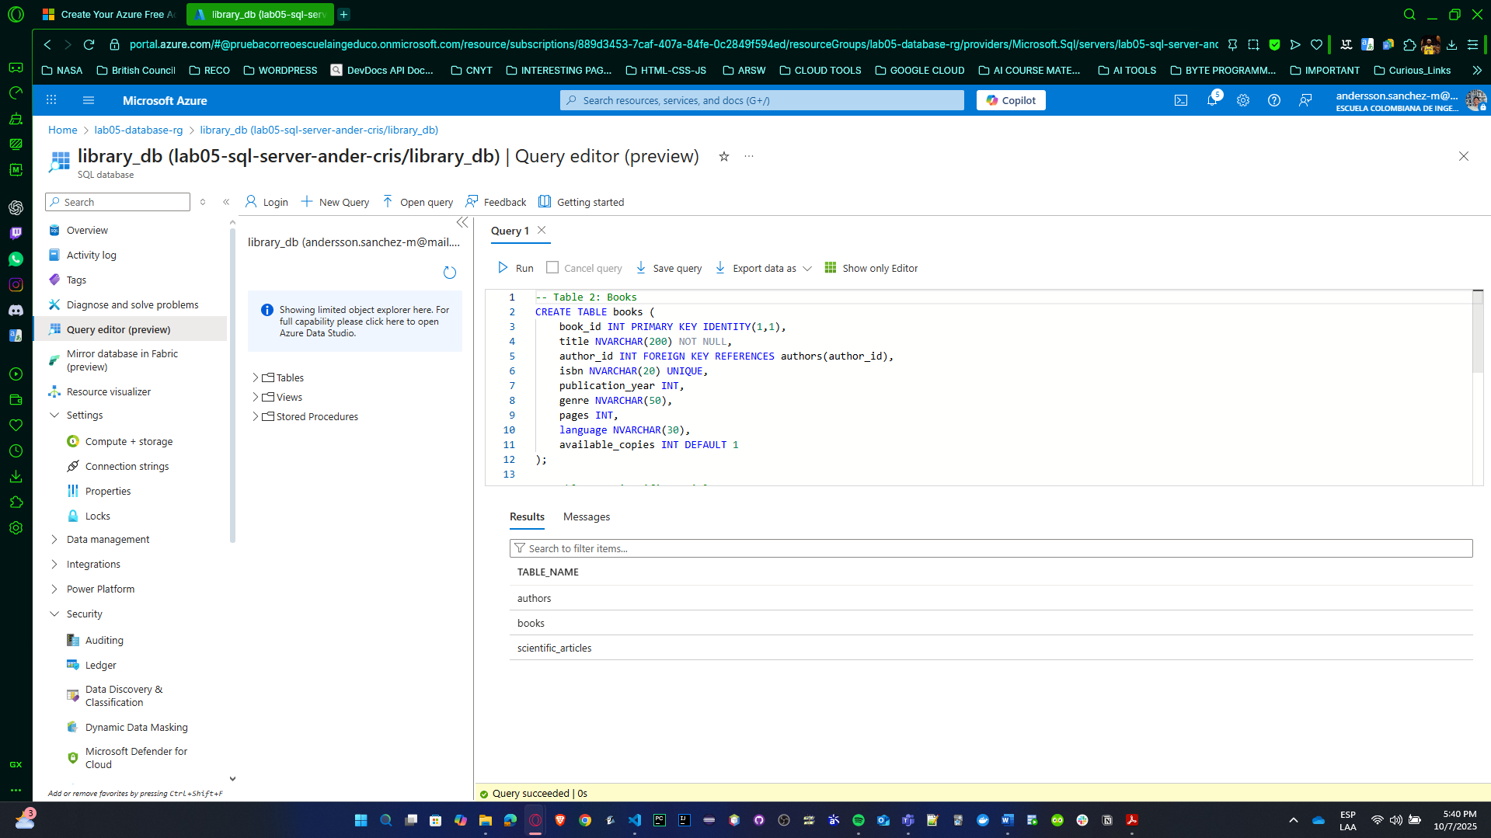

* 1. Insert data into the database.

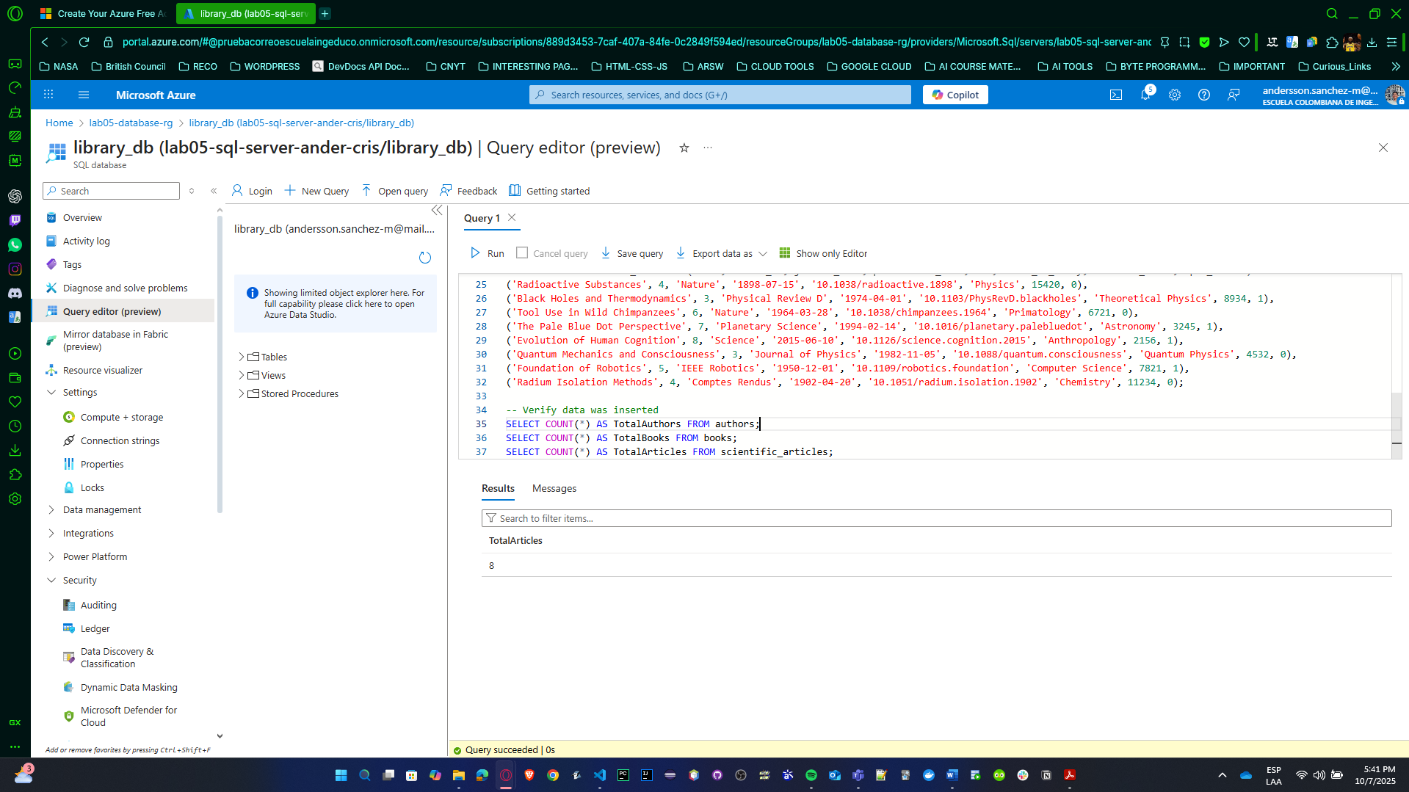

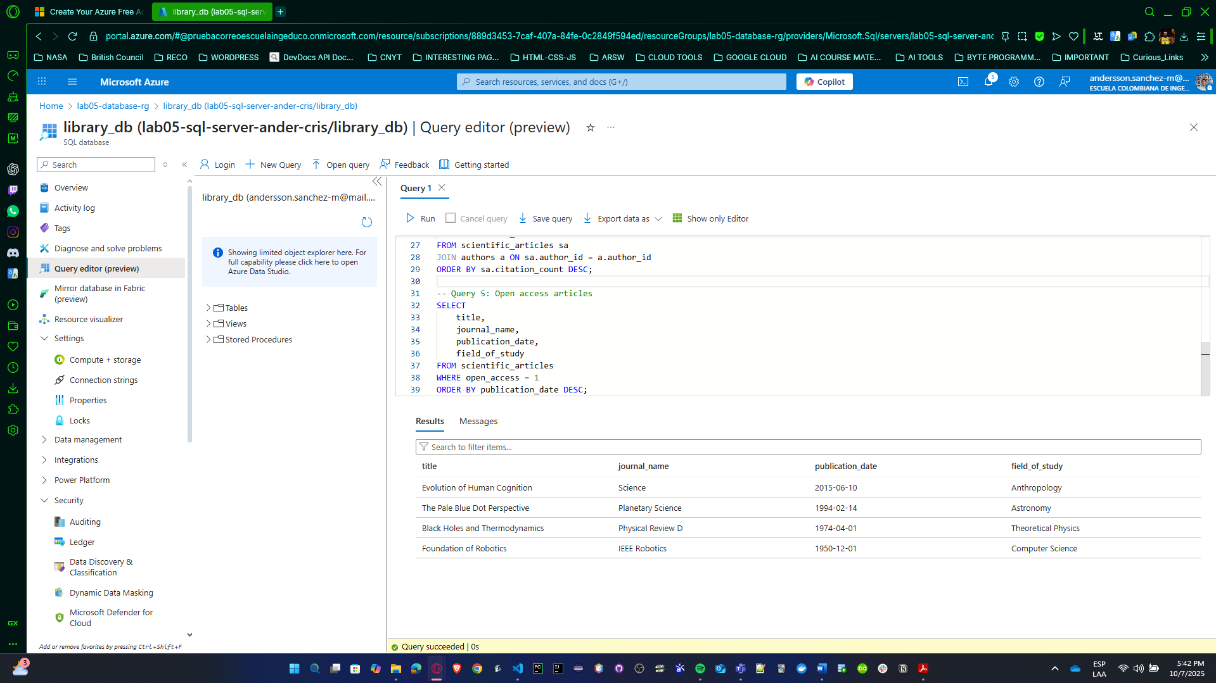

* 1. Record a video (no longer than 5 minutes) demonstrating the connection to the database, the created tables, and the inserted data.

<https://youtu.be/Ye6jw5p2mKk>, here we demonstrate DBeaver for Azure SQL Database, so, we will not include information about that in 4 Point

* 1. Delete all resources created for the database (including the database itself) to avoid additional costs and depletion of available credits.

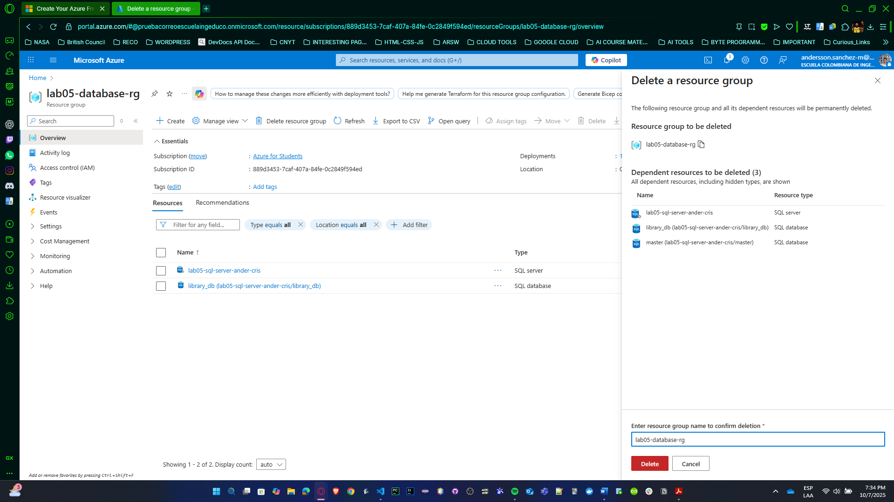

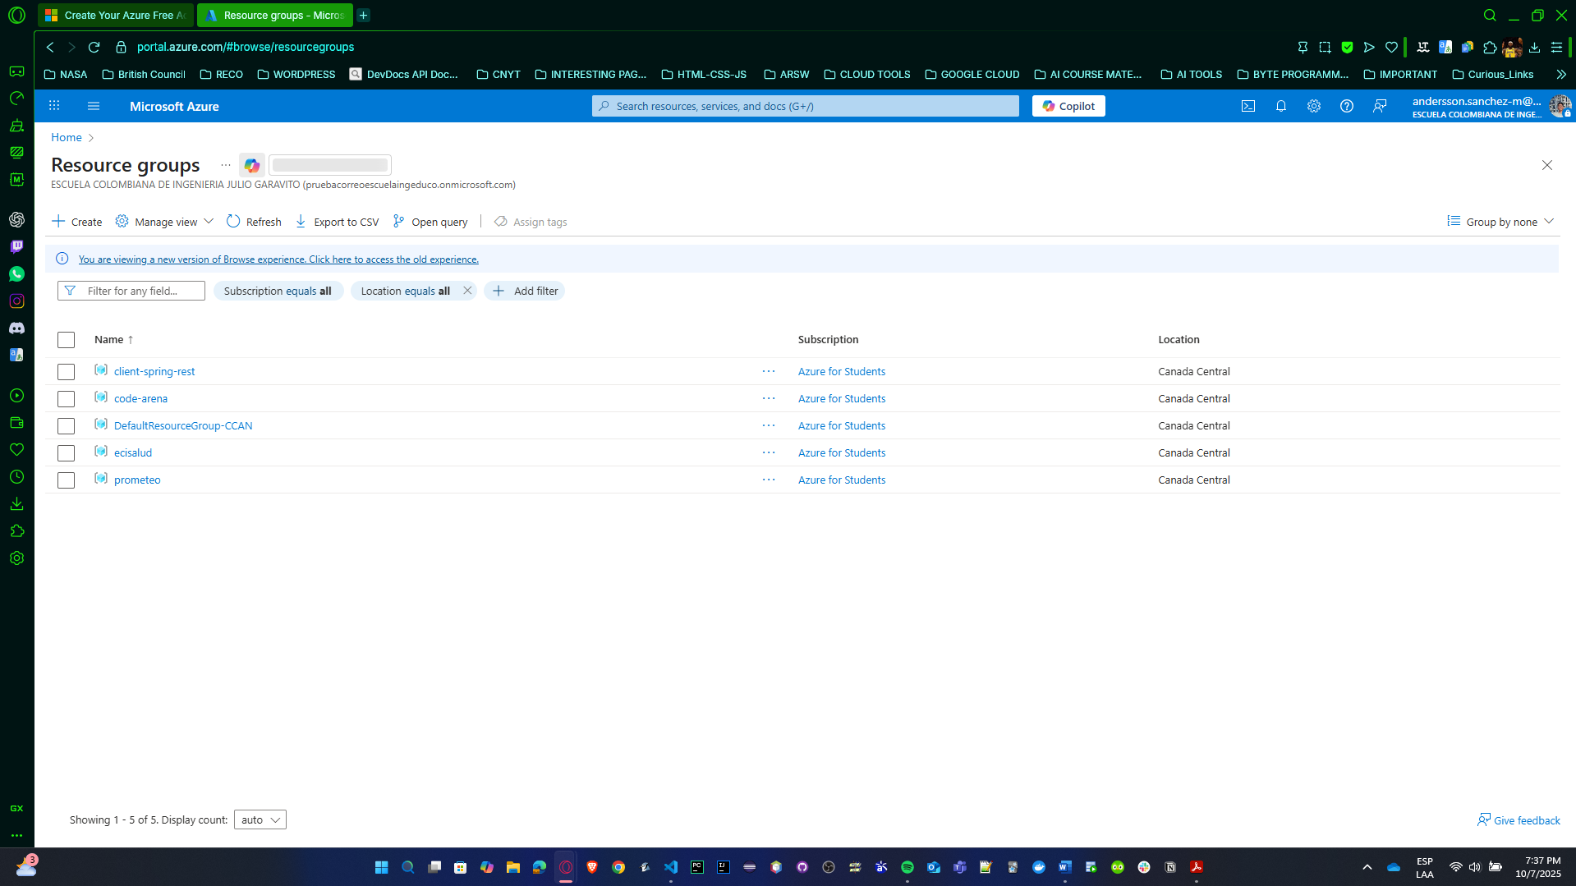

## Other Database Engine Configurations

**[For groups of 1, 2, and 3 students]**

1. On the servers where you installed the database engines, configure the operating system so that the database engines automatically start when the OS boots.

POSTGRESQL SLACKWARE

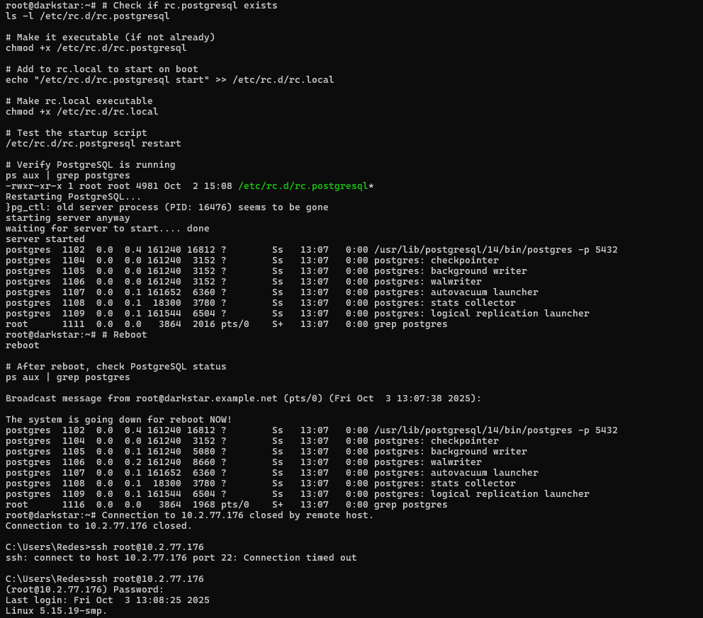

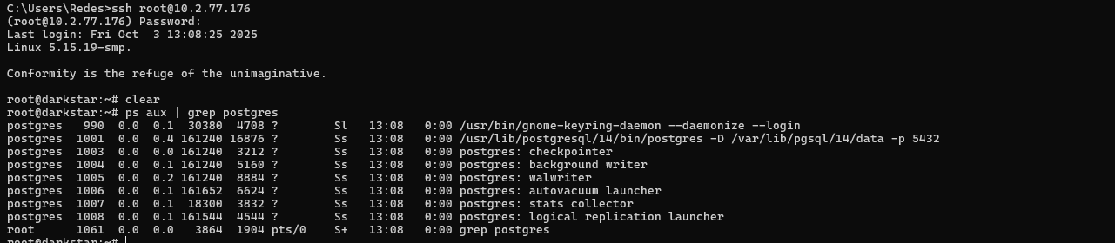

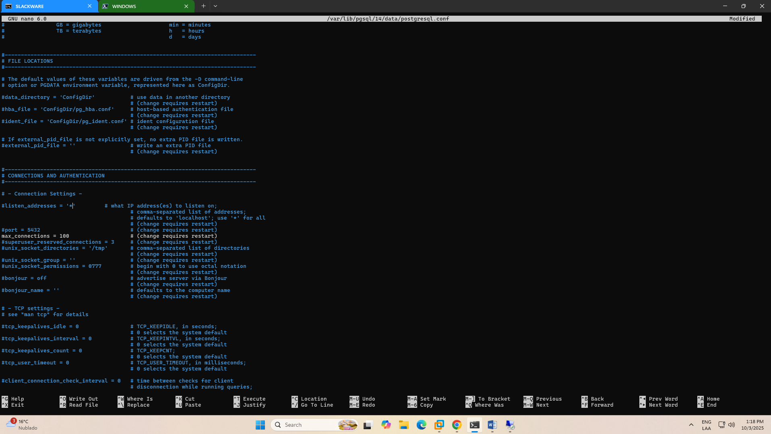

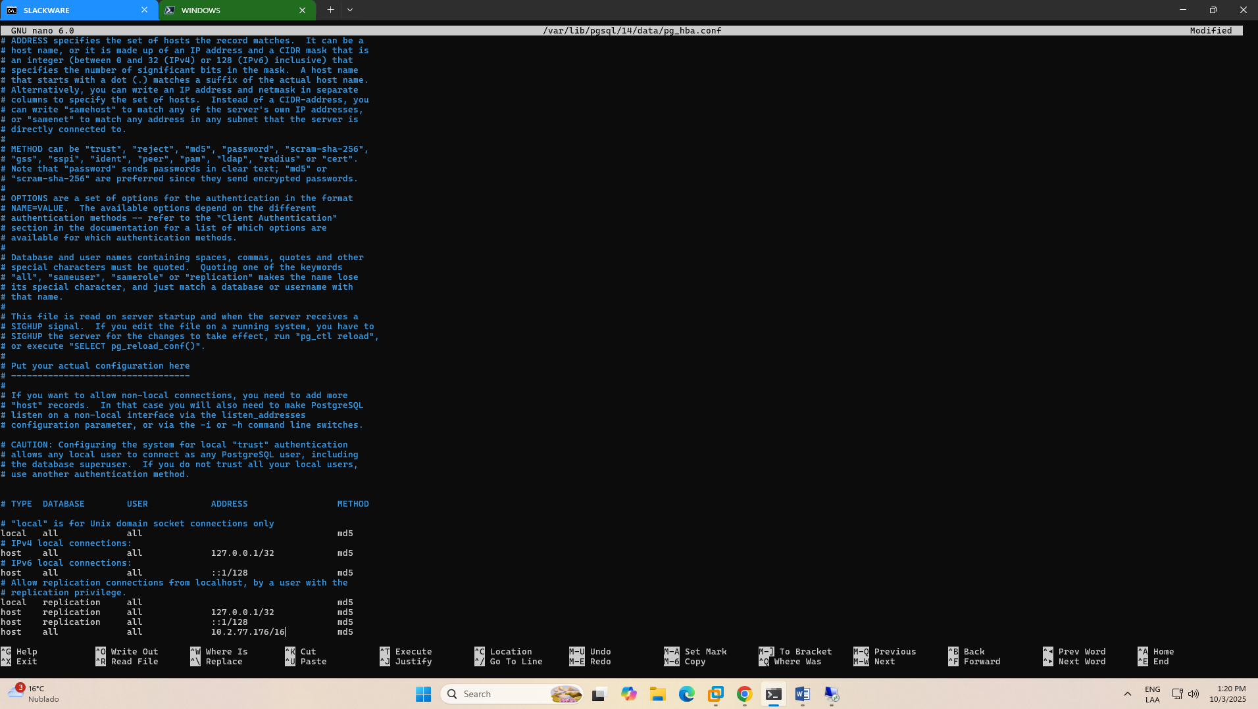

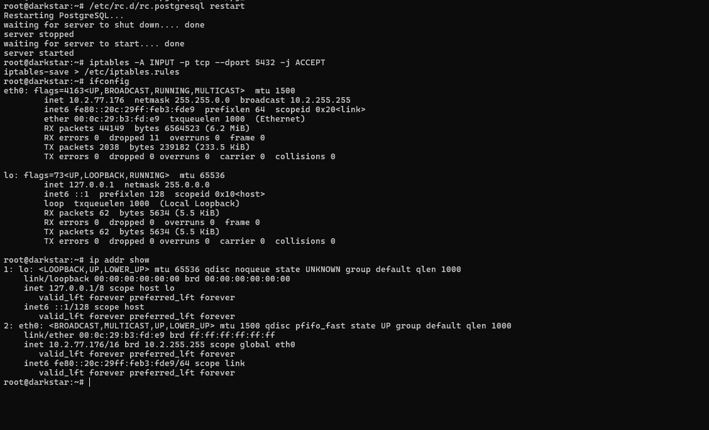

SQL SERVER WINDOWS SERVER GUI

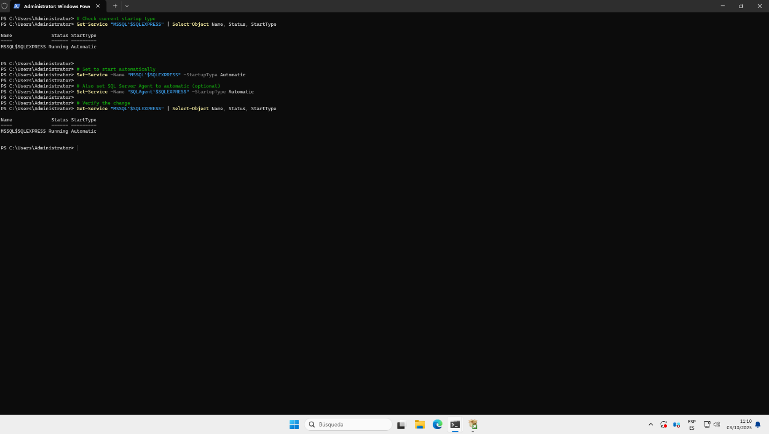

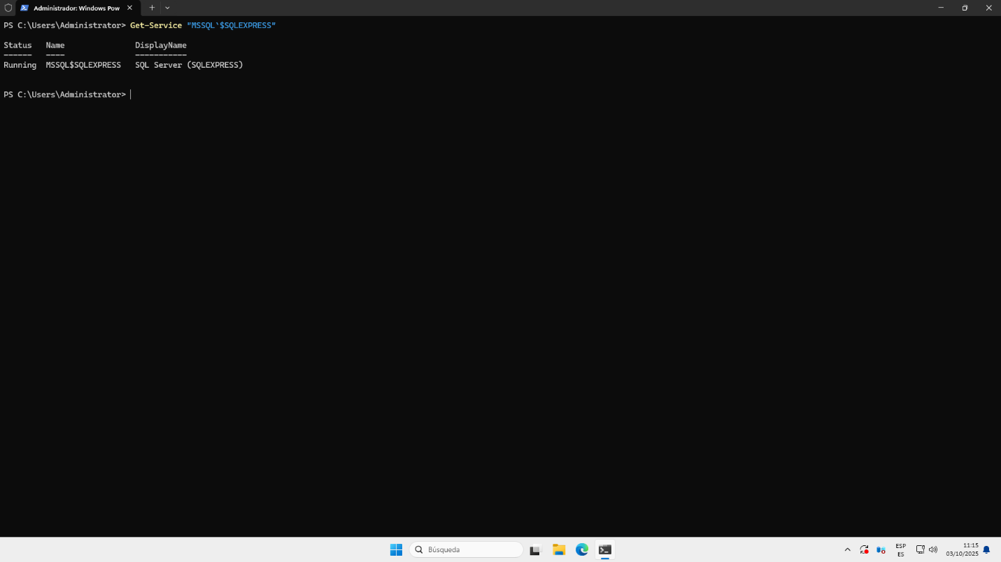

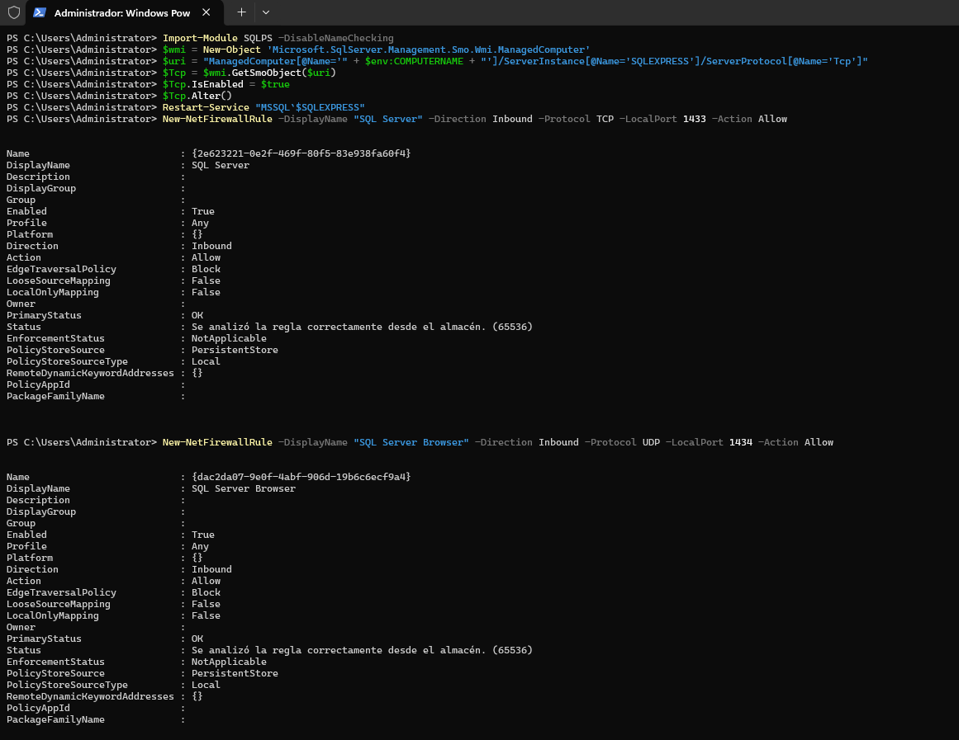

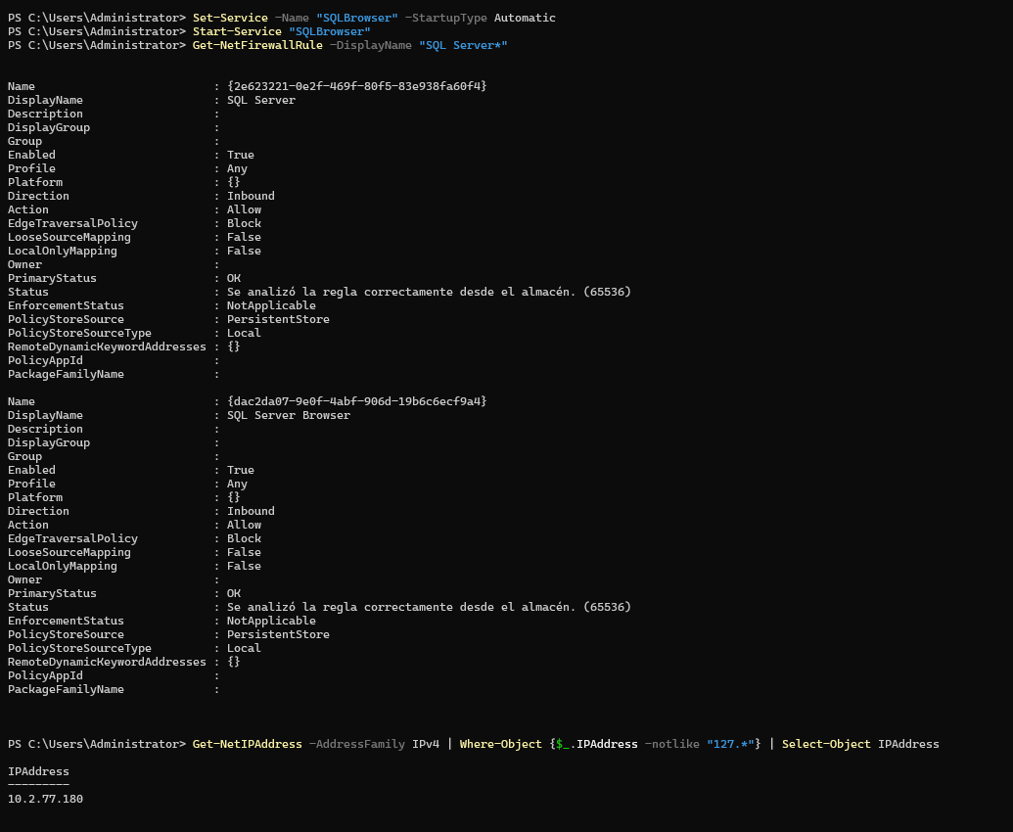

1. Using a database connection client (e.g., DBeaver), connect to your databases from a remote machine and view the table contents.

DBeaver

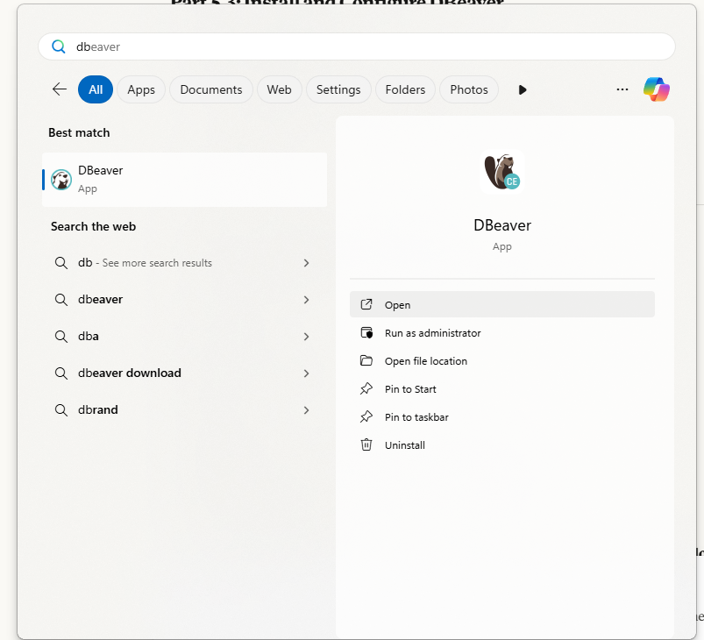

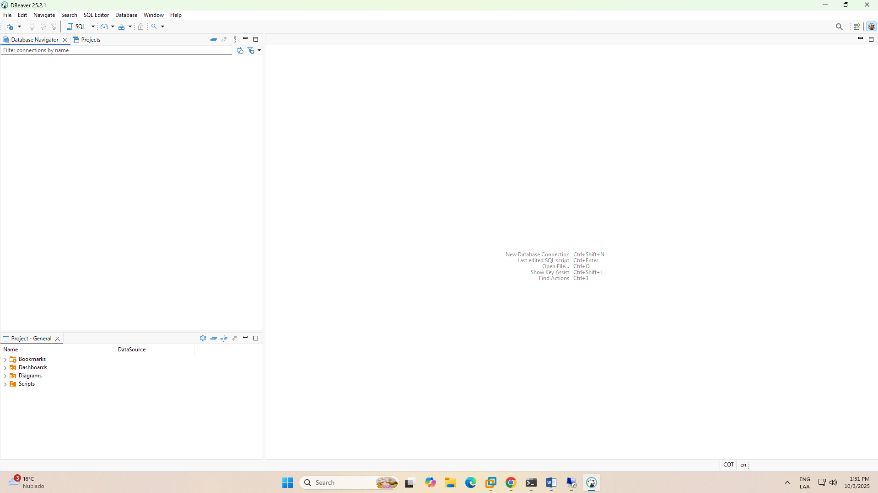

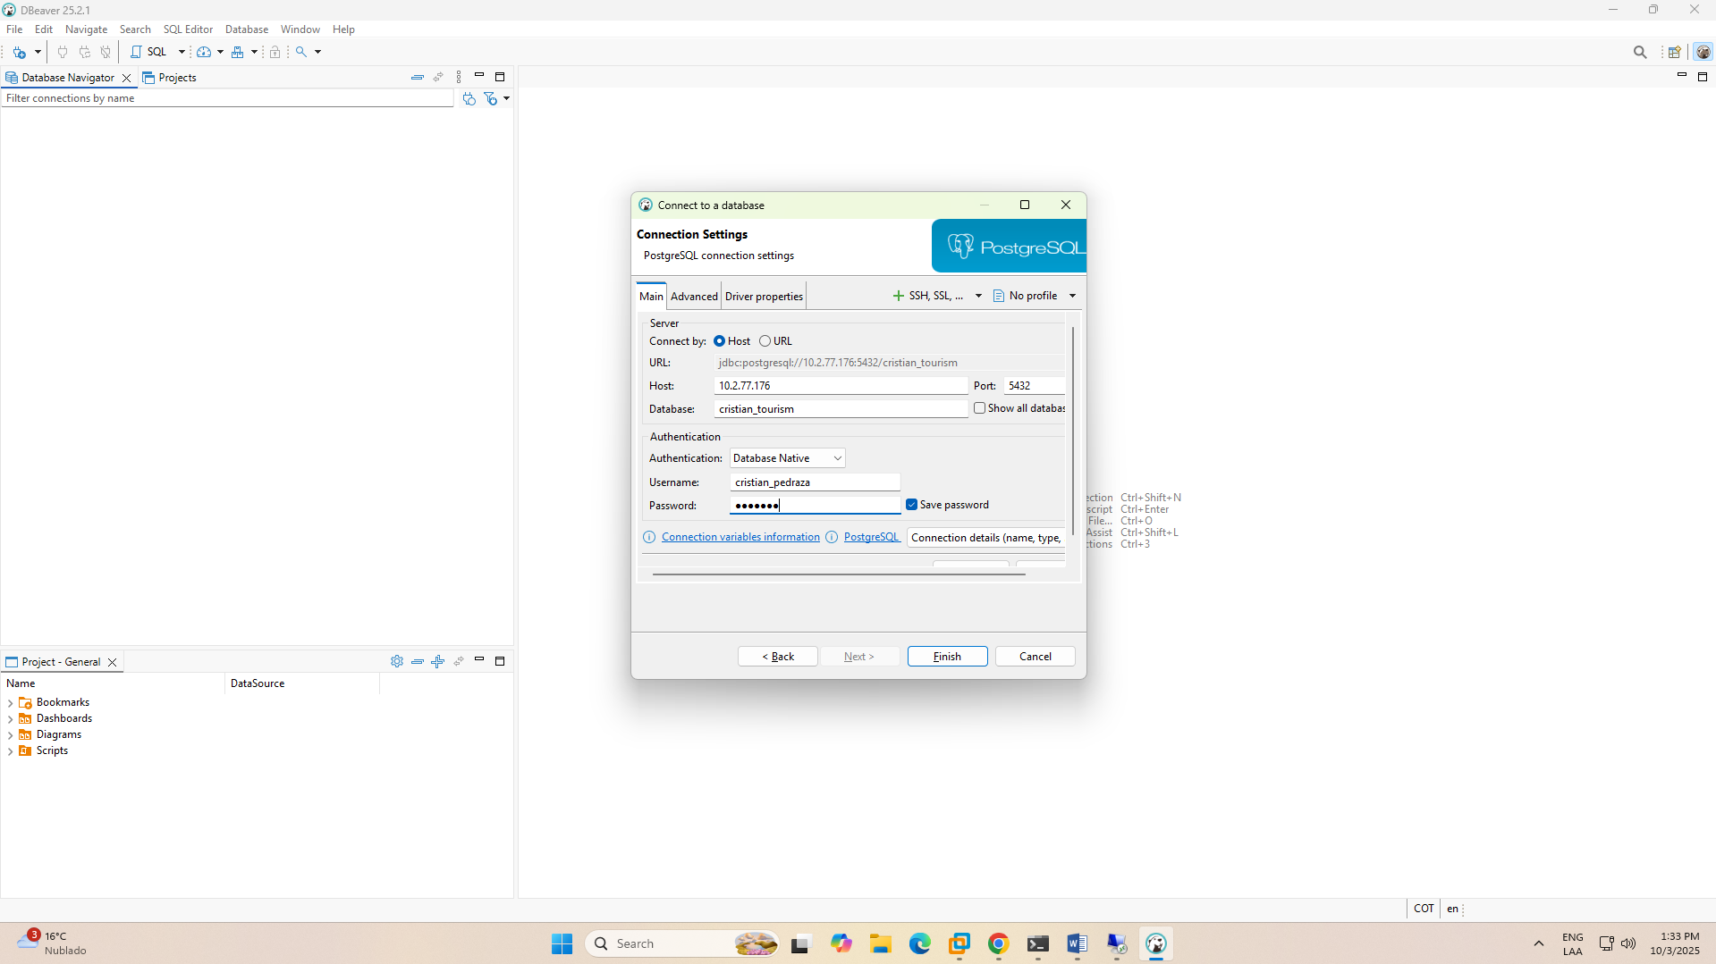

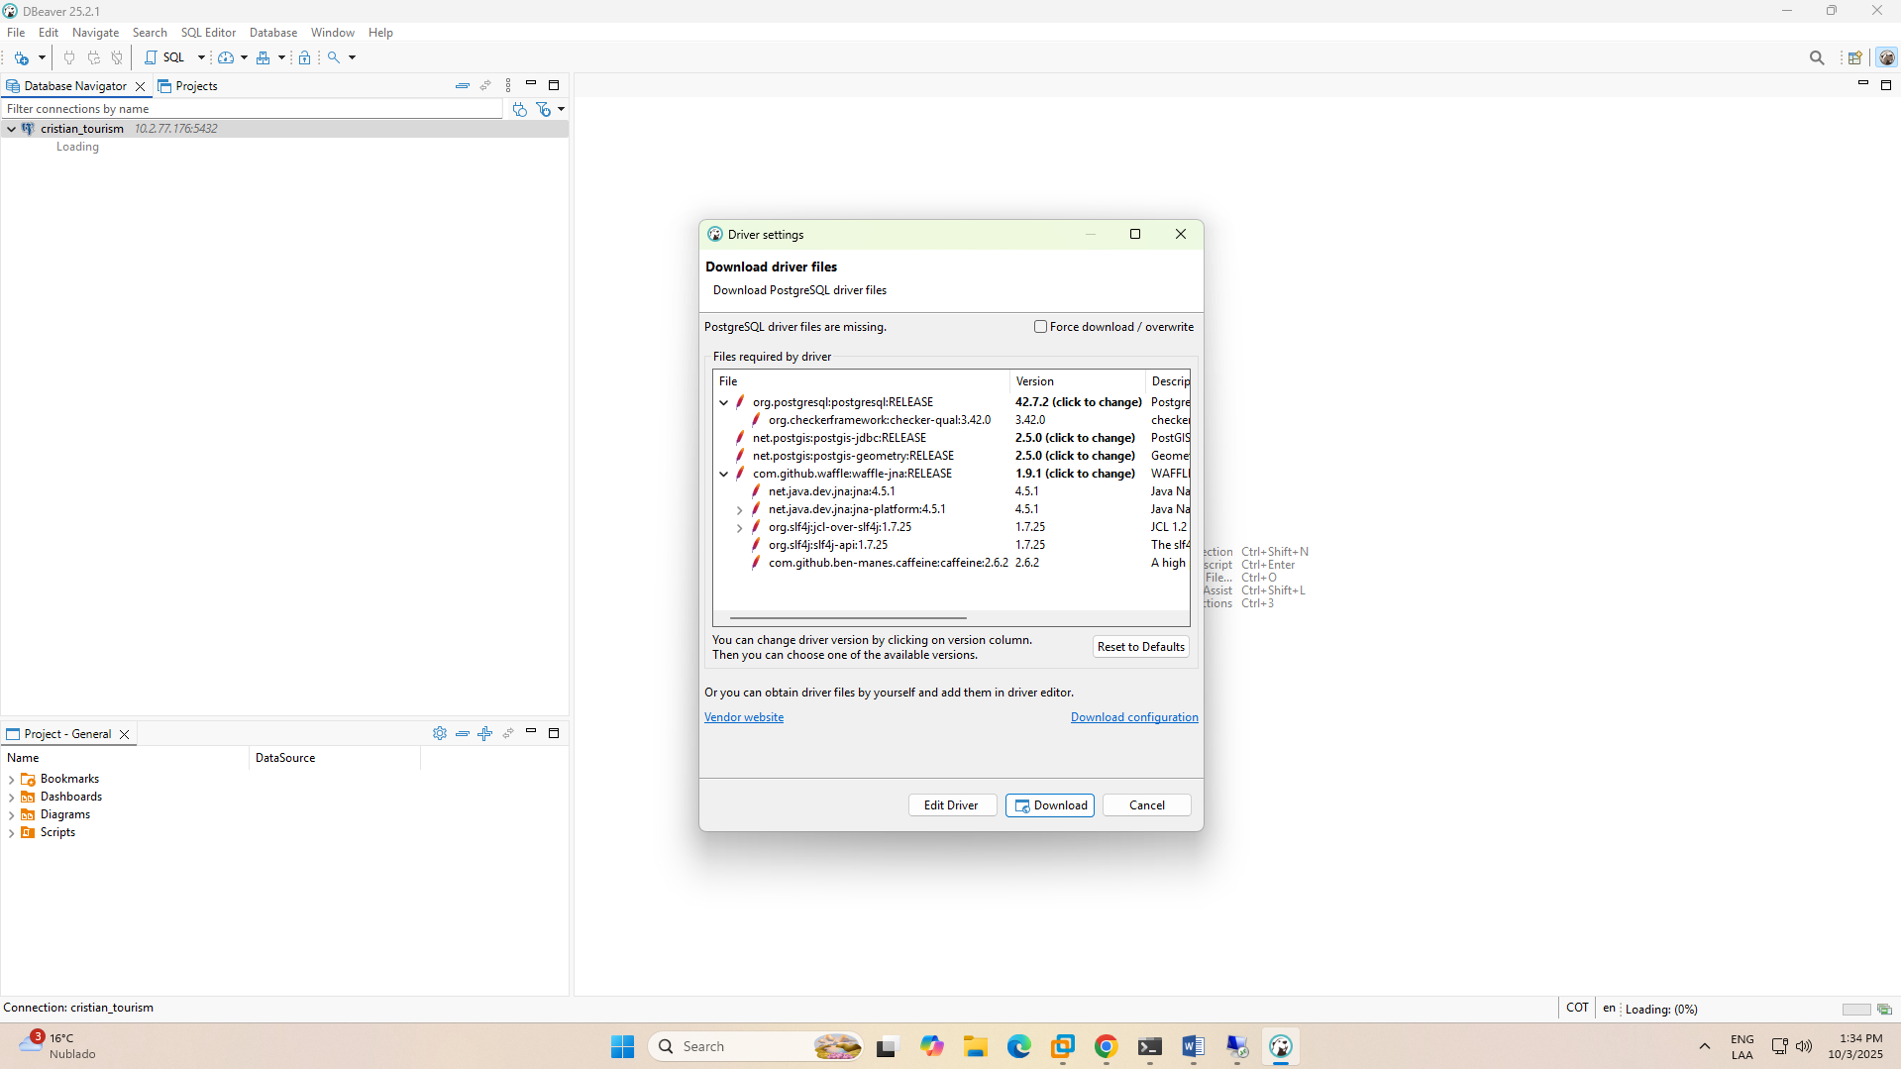

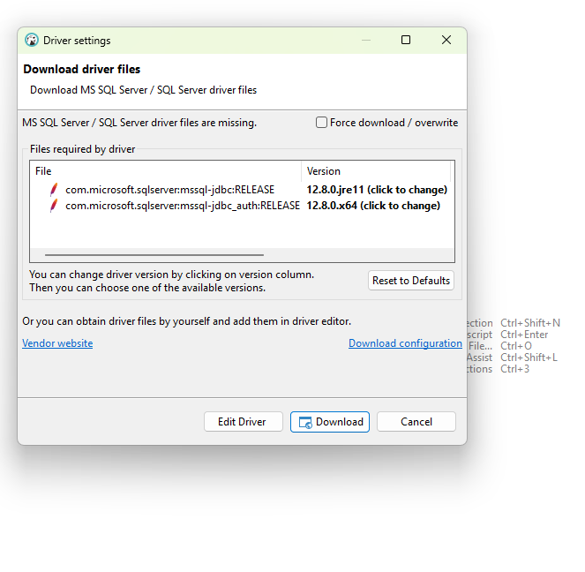

SLACWARE CRISTIAN DB

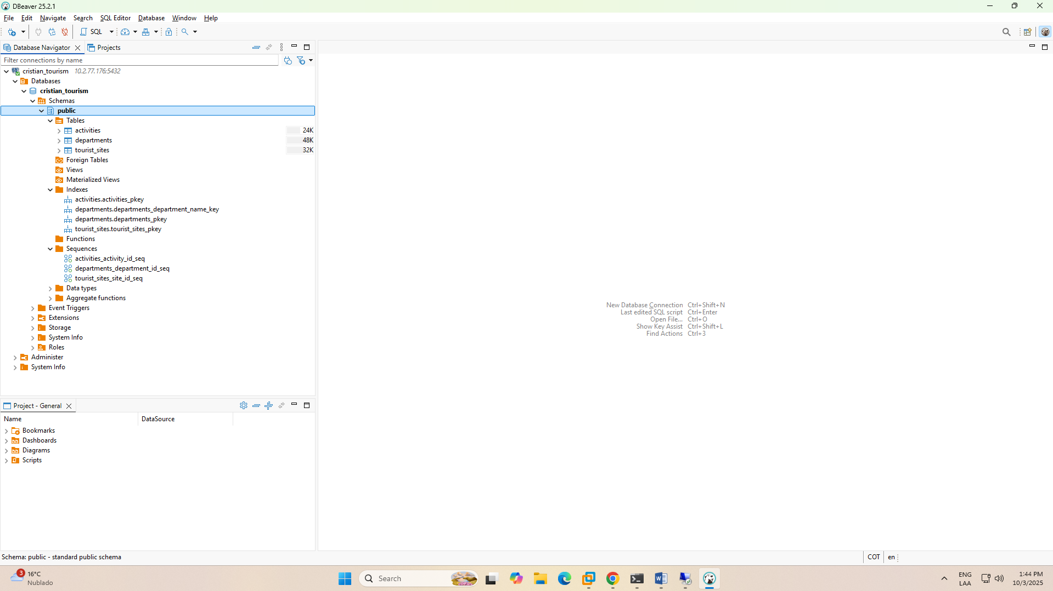

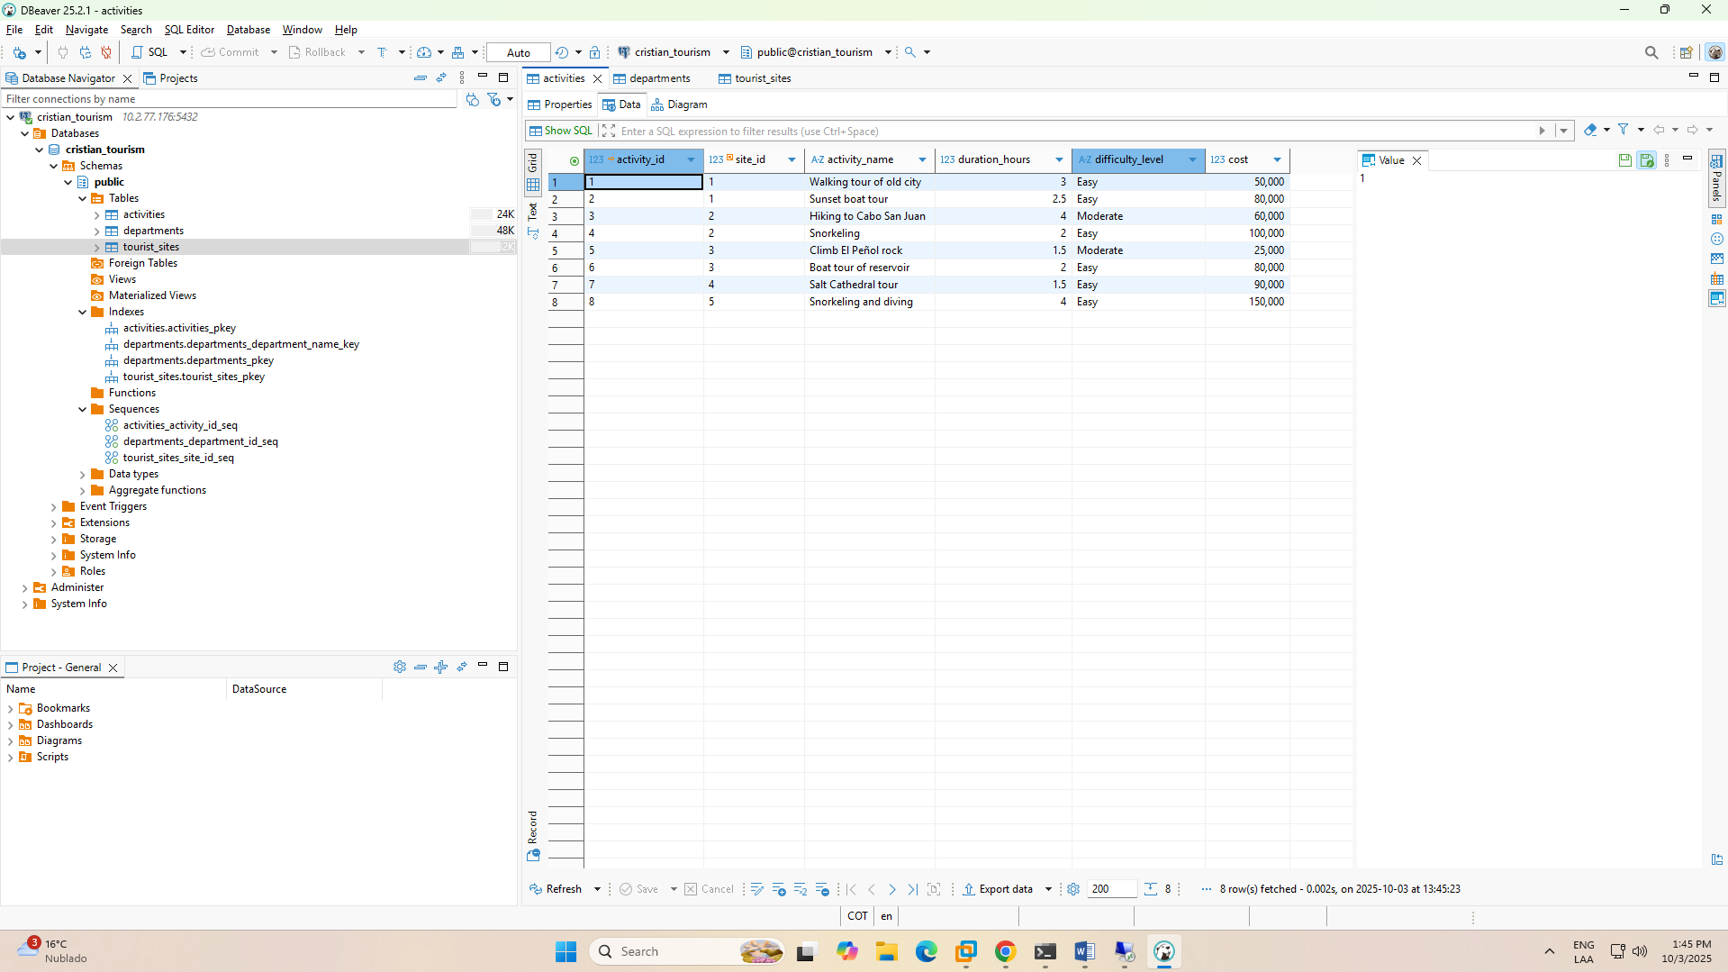

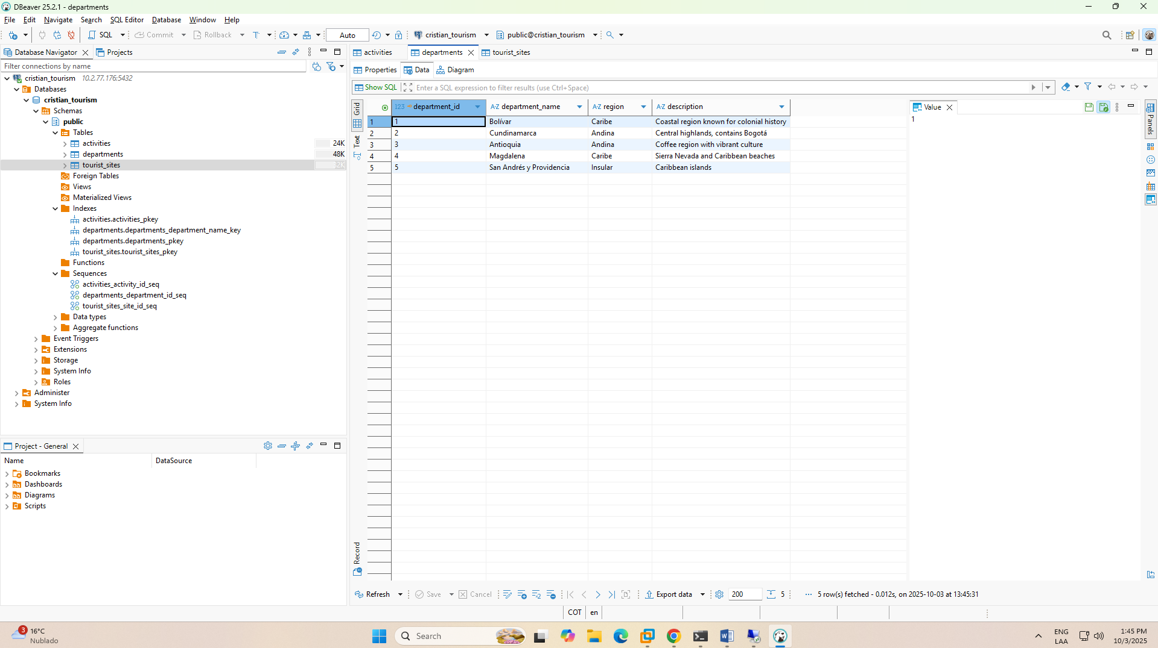

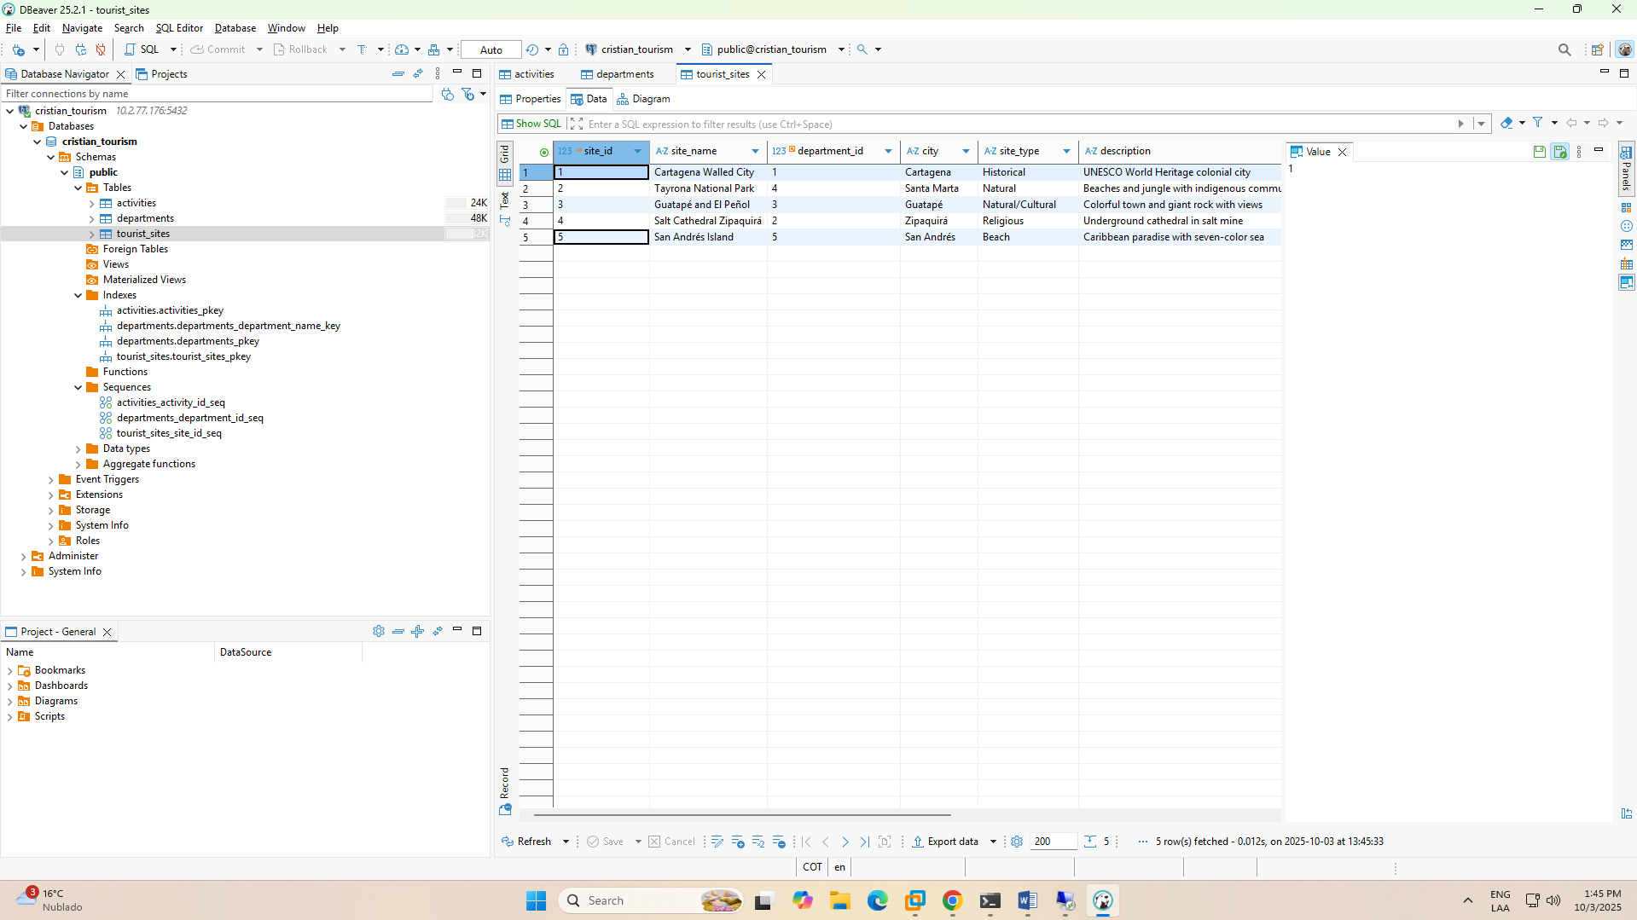

SLACKWARE ANDERSSON DB

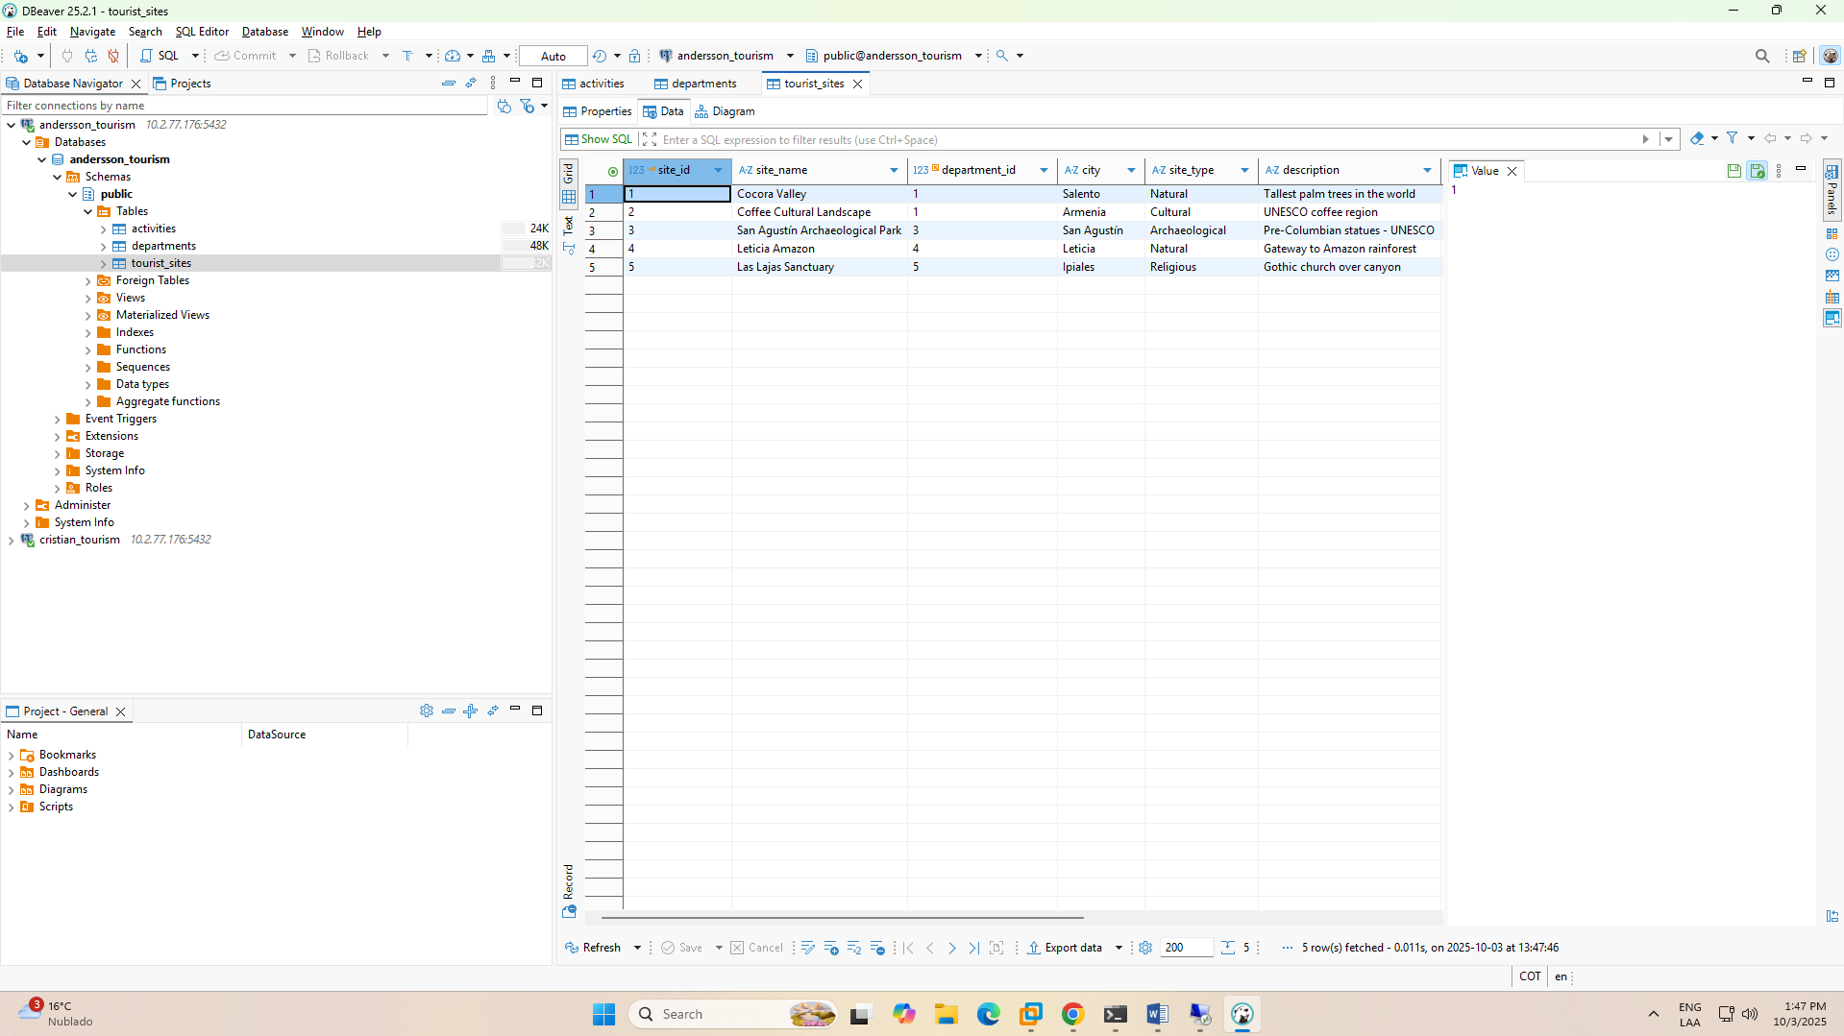

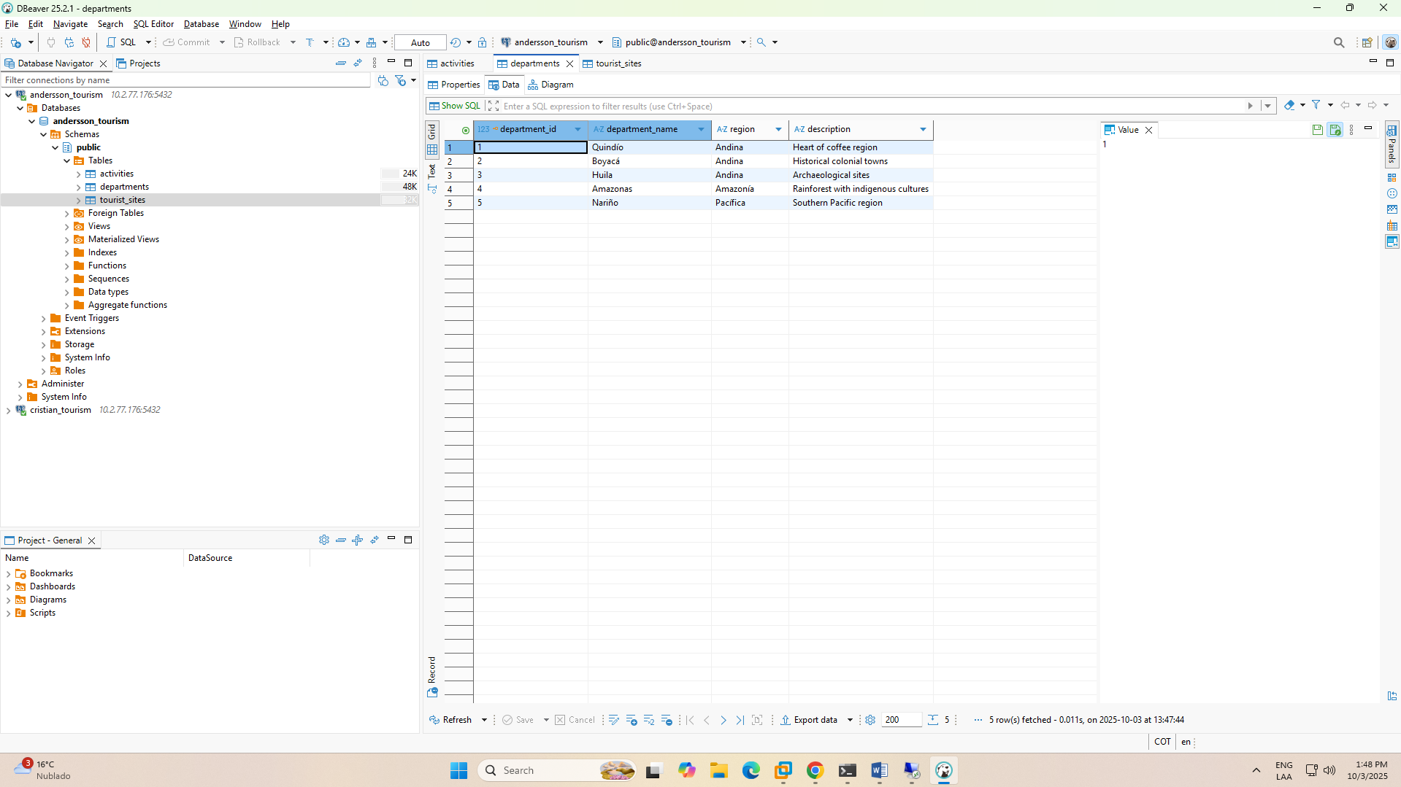

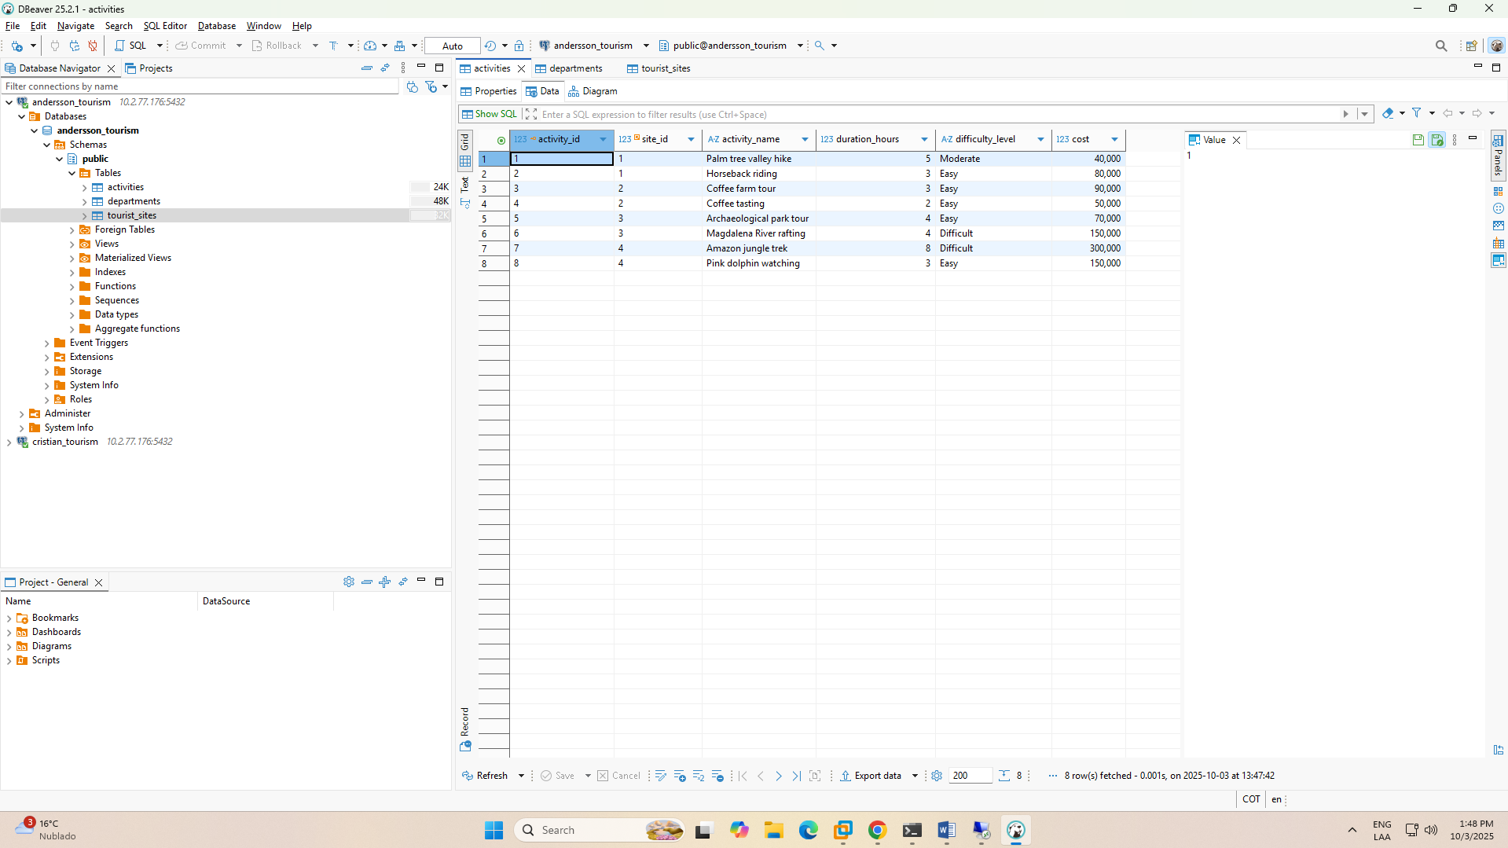

WINDOWS SERVER

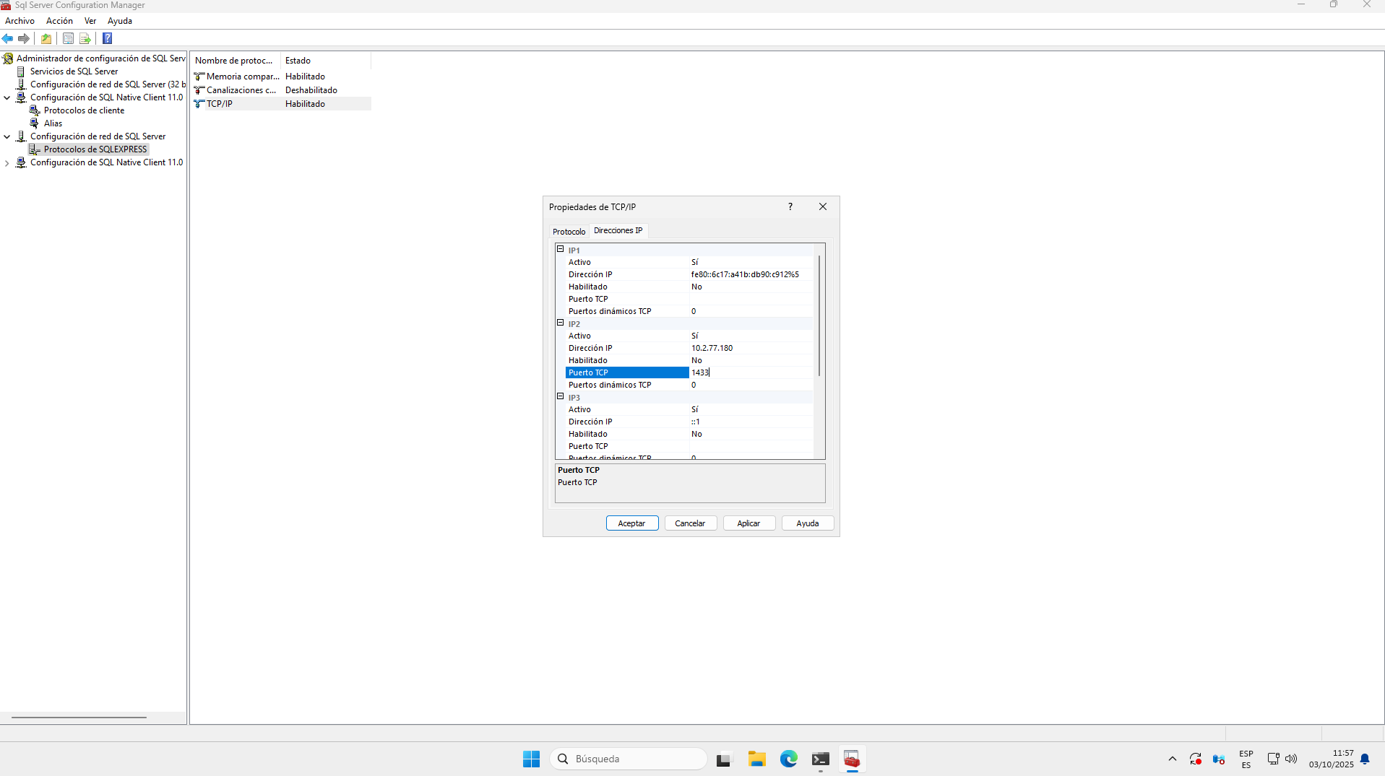

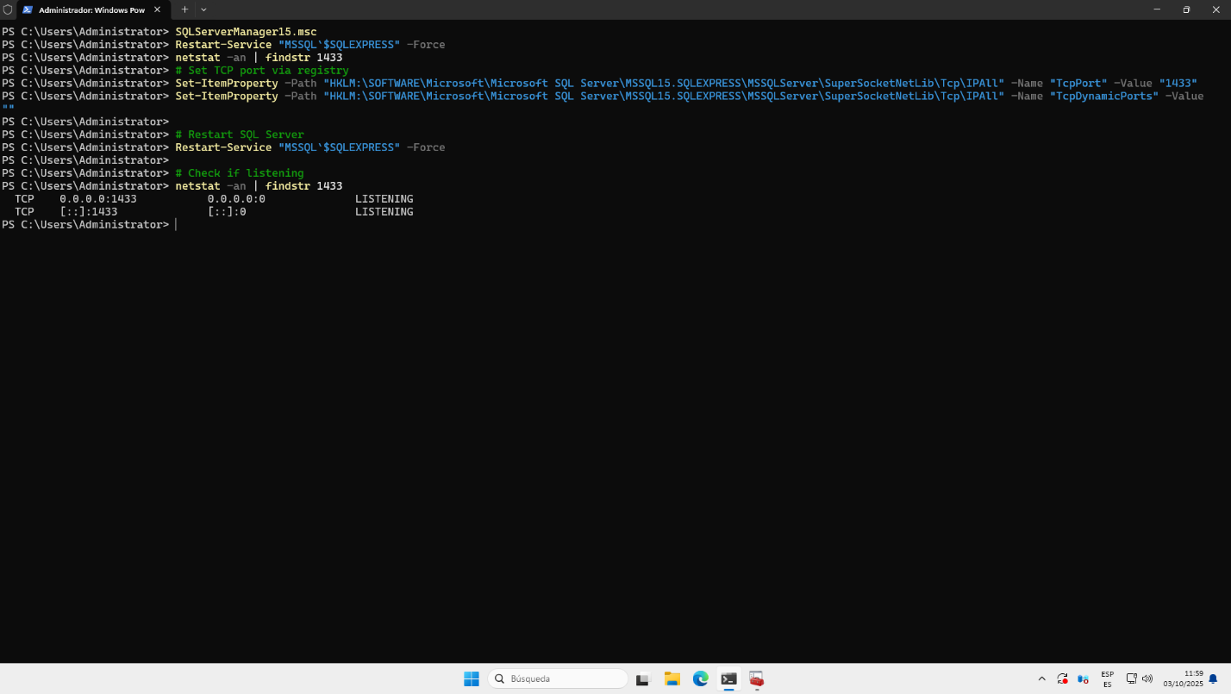

WINDOWS SERVER CRISTIAN DB

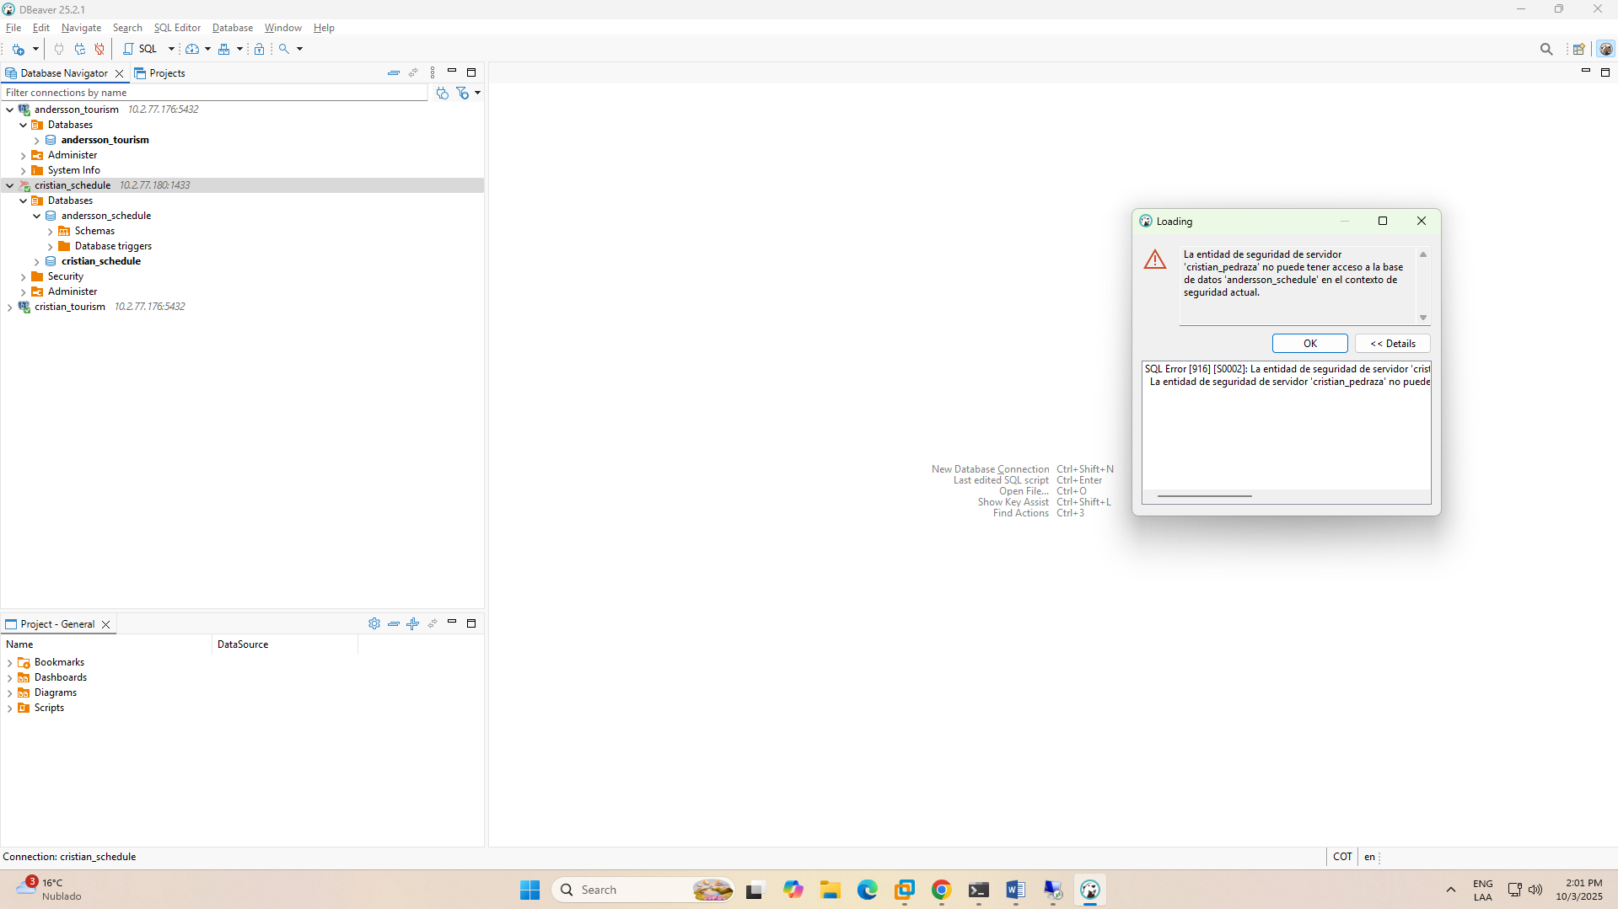

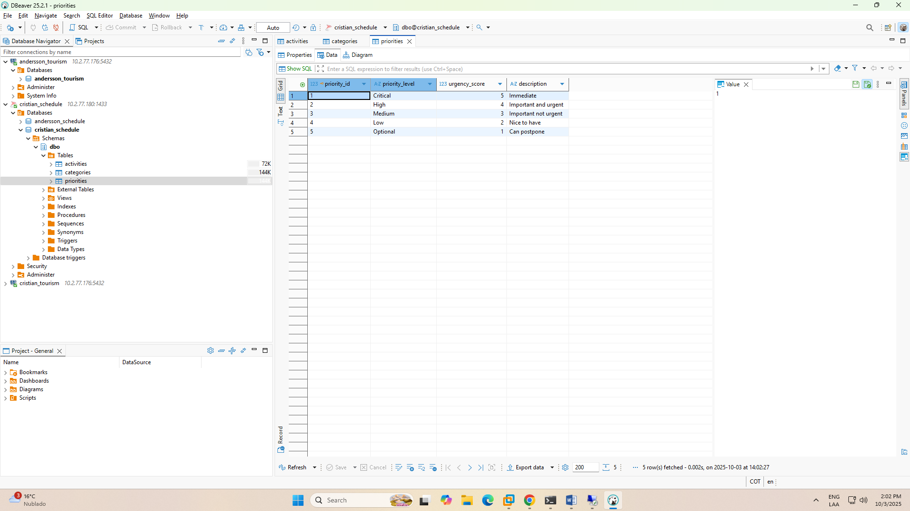

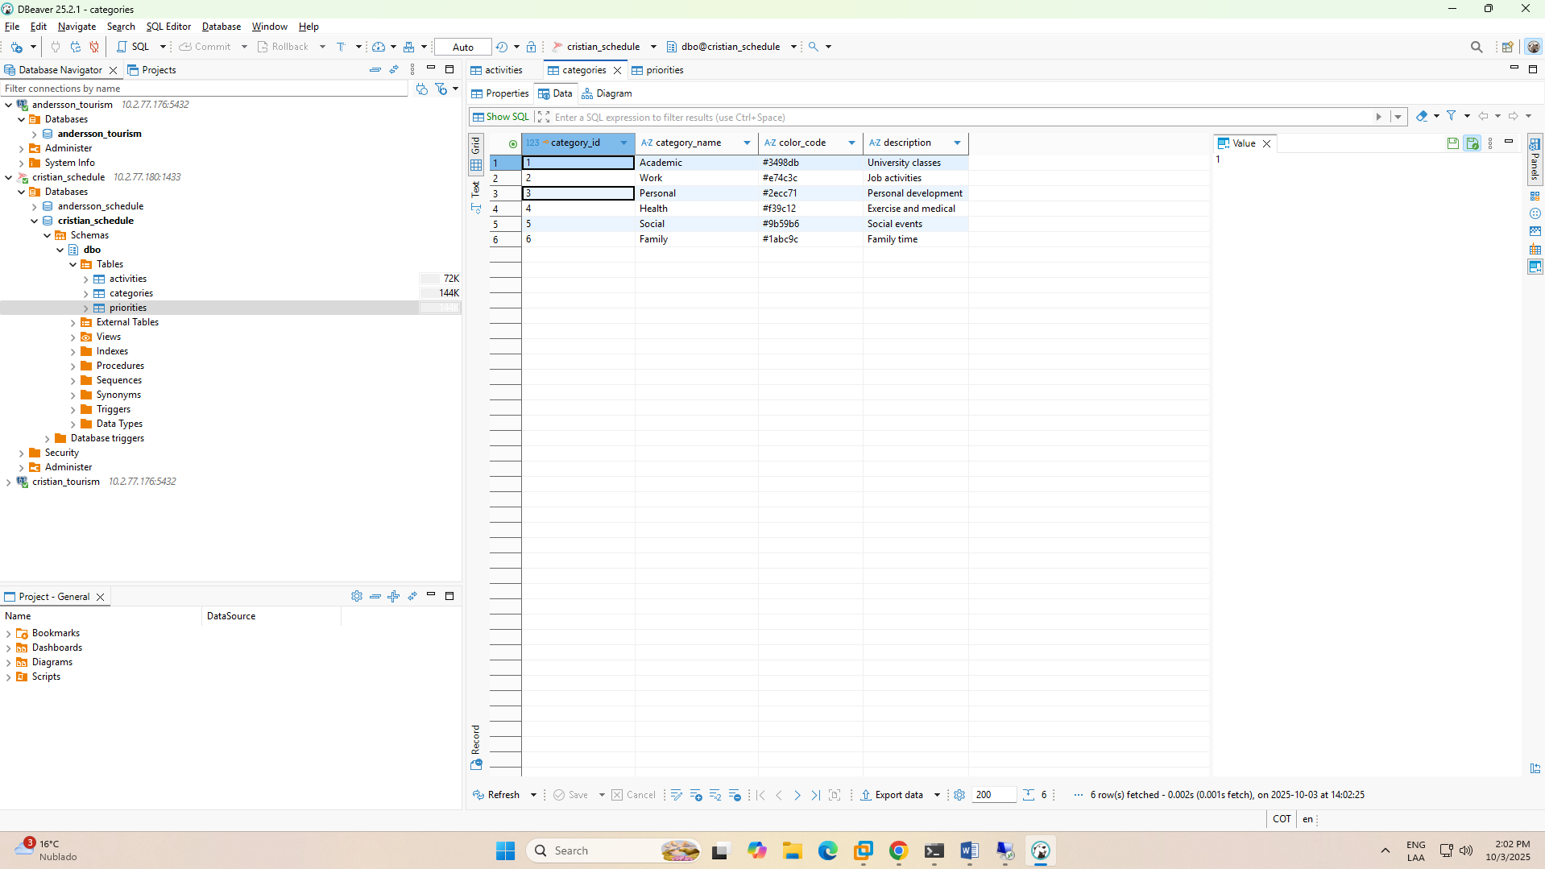

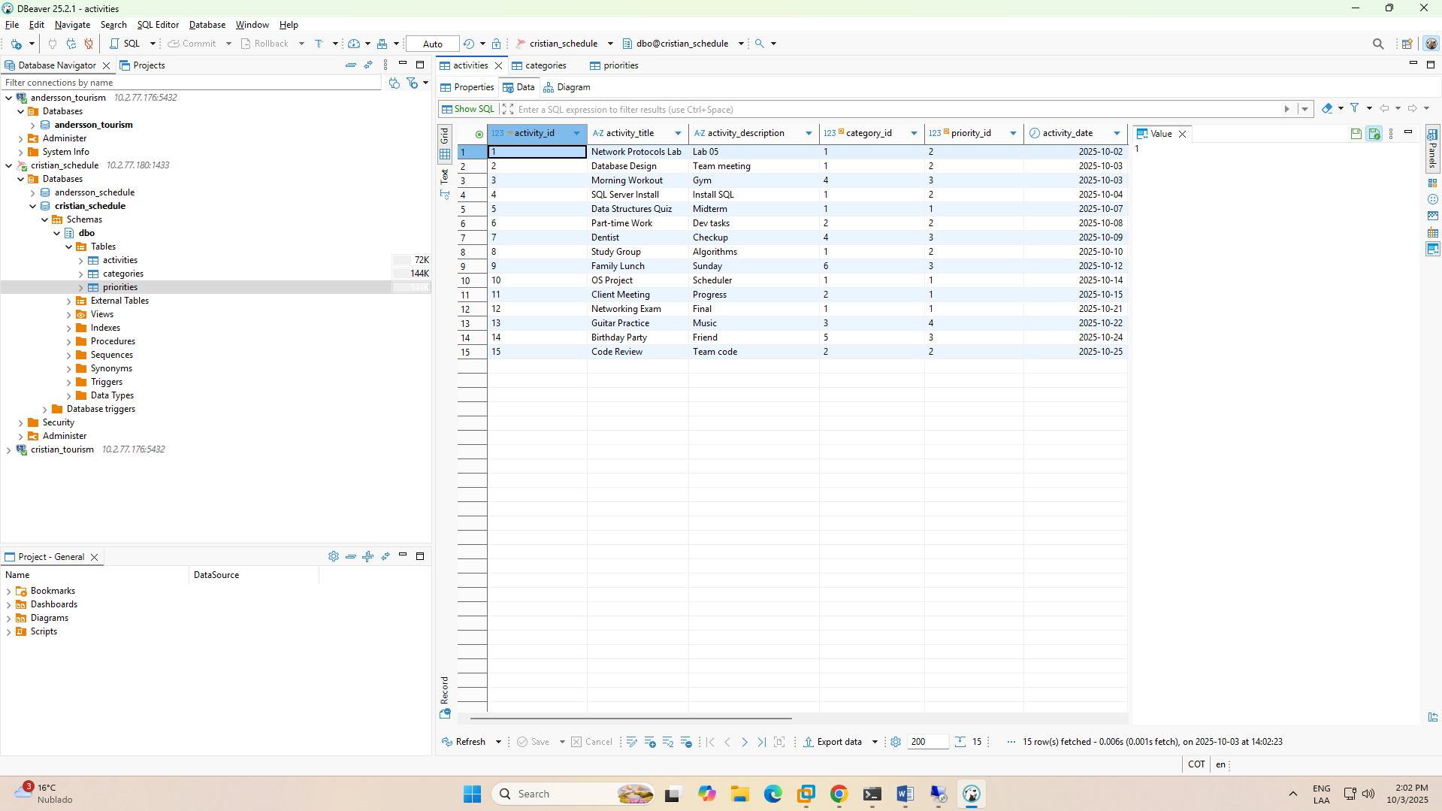

WINDOWS SERVER ANDERSSON DB

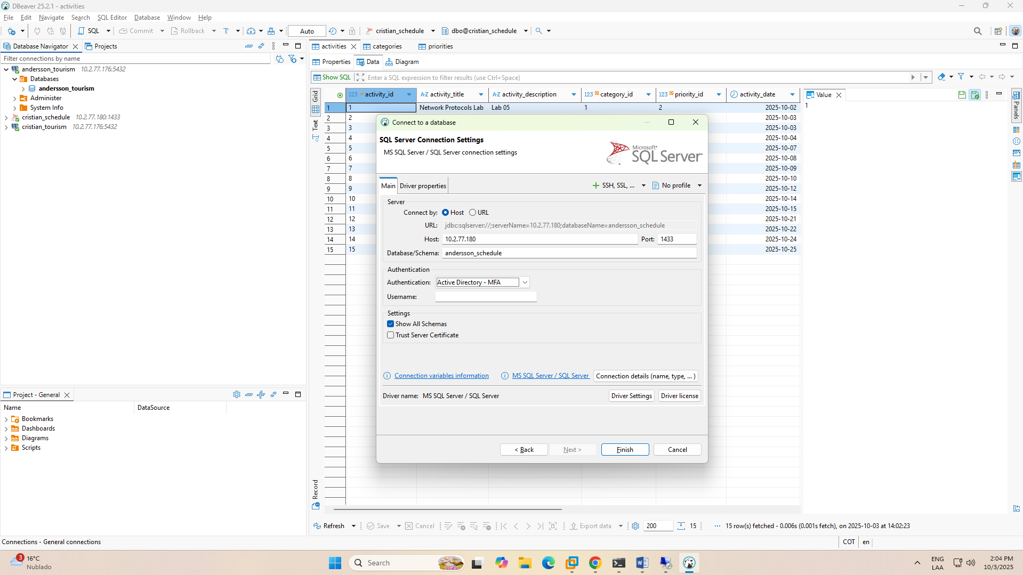

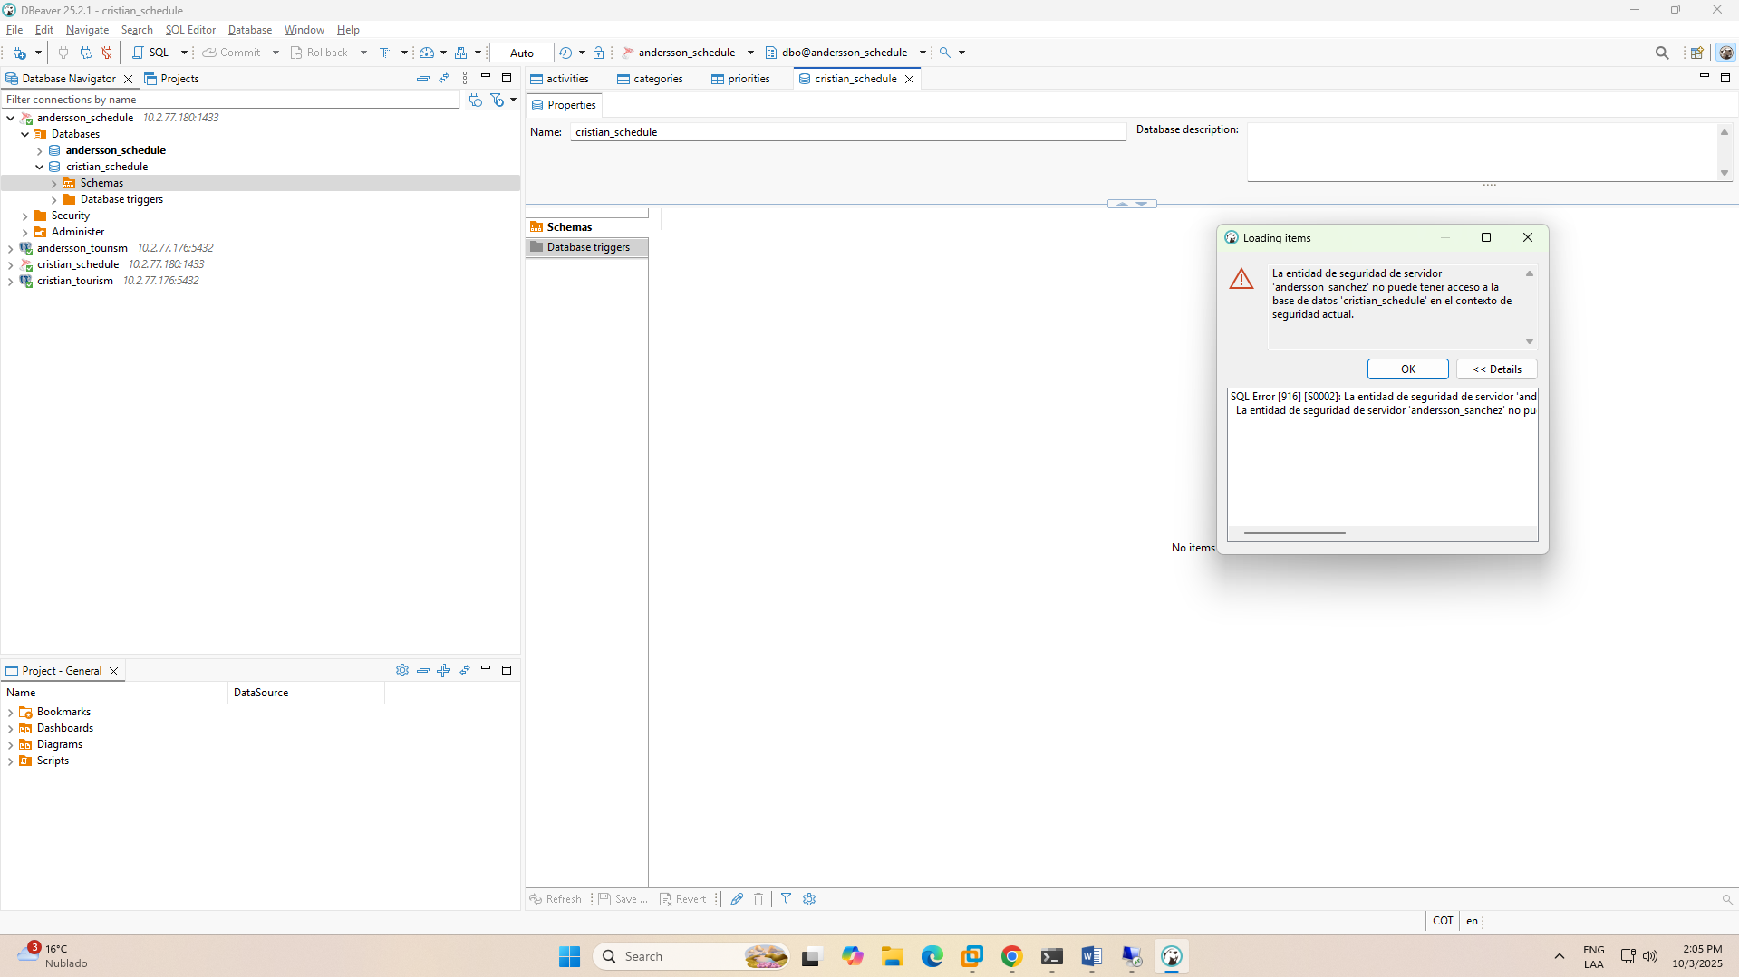

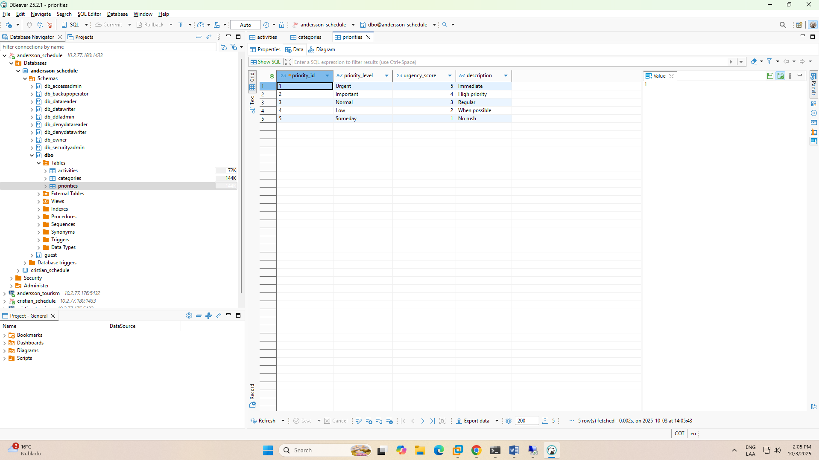

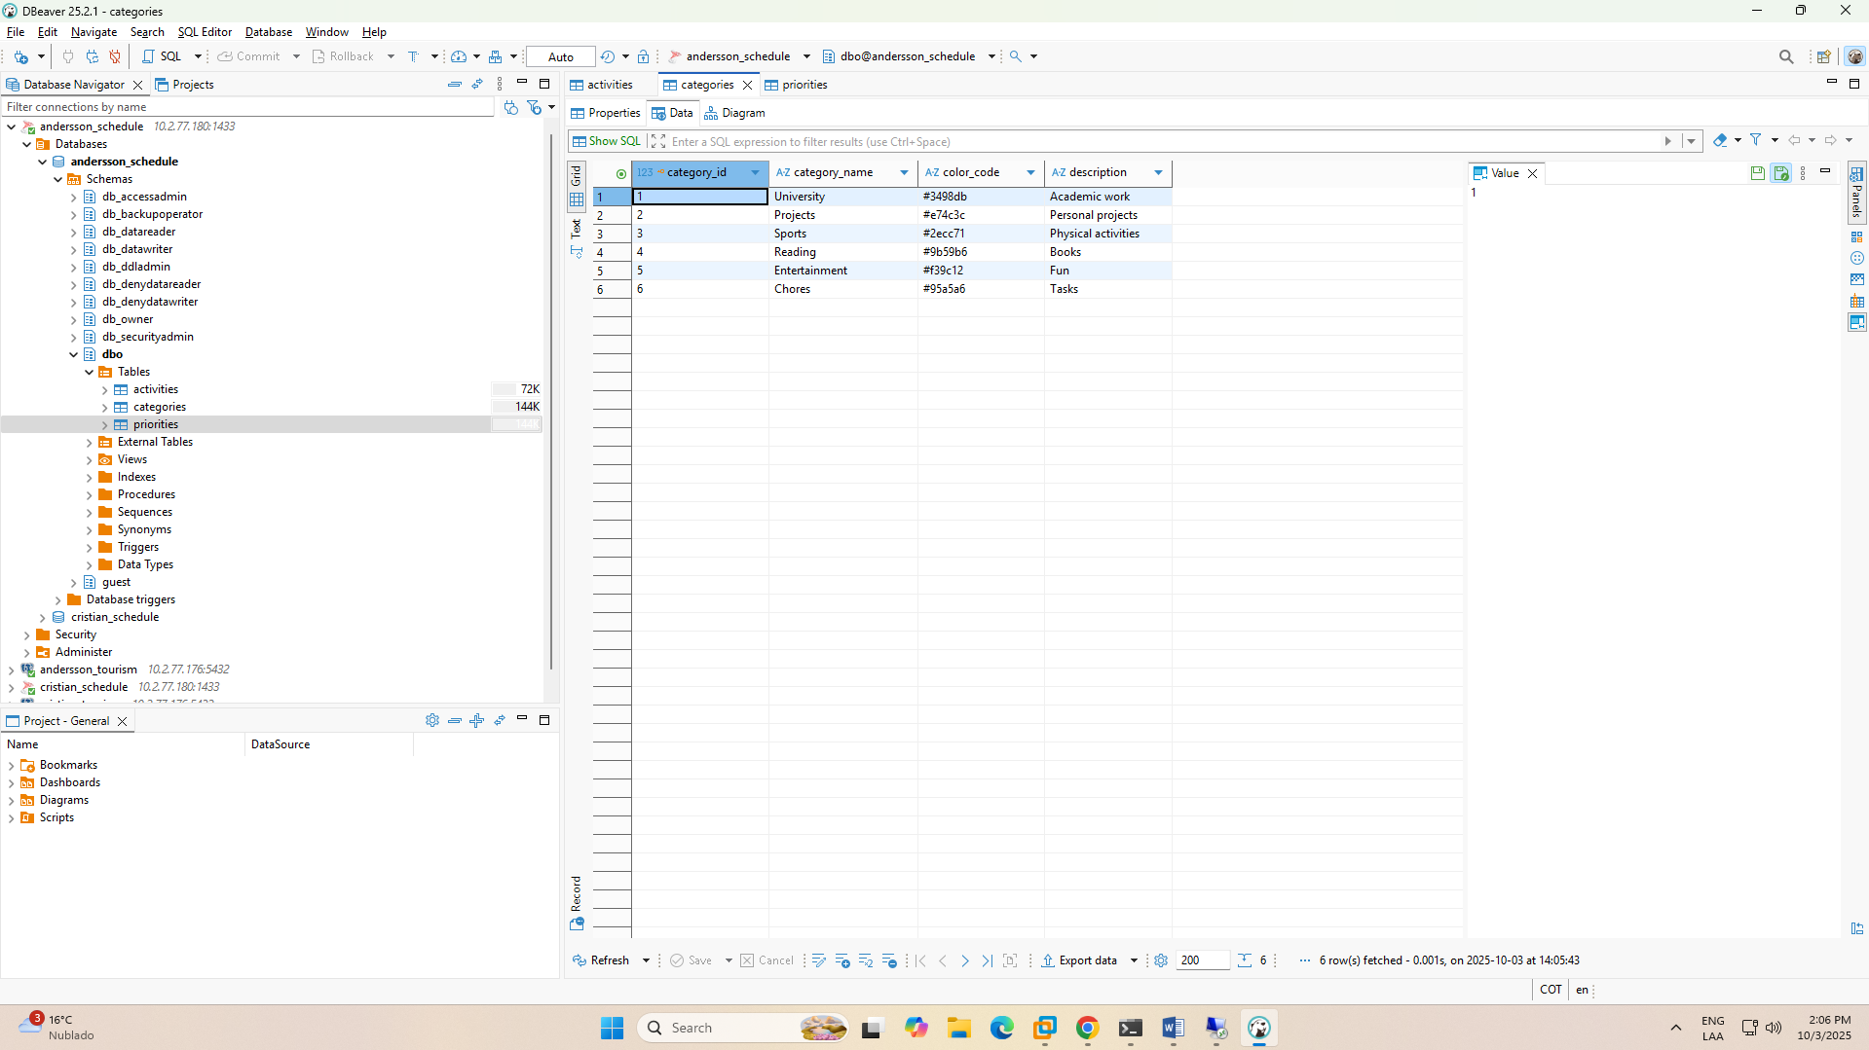

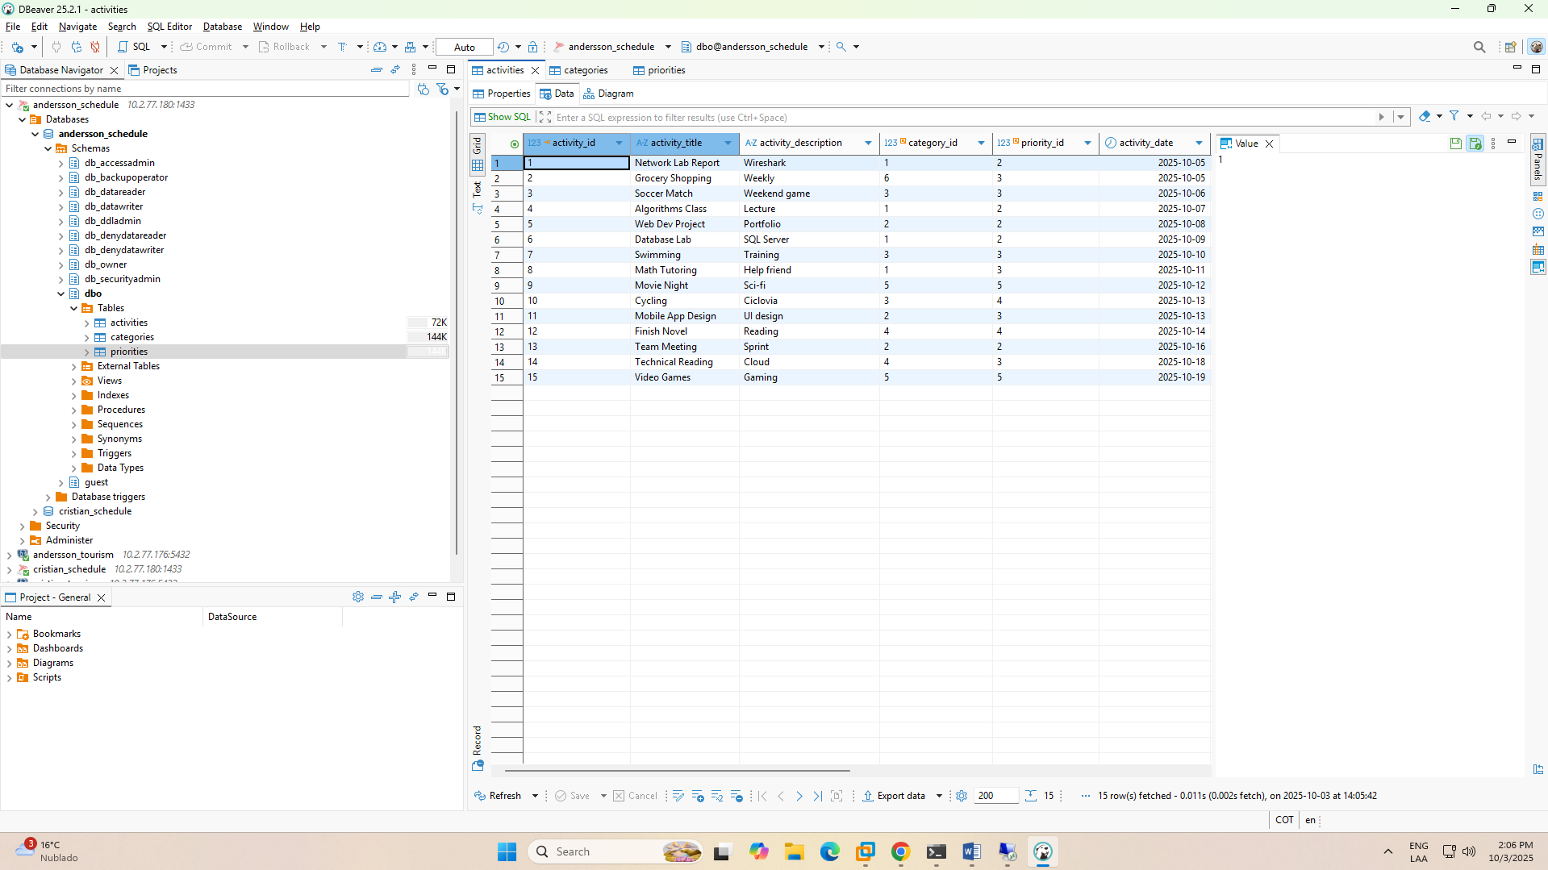

SUMMARY

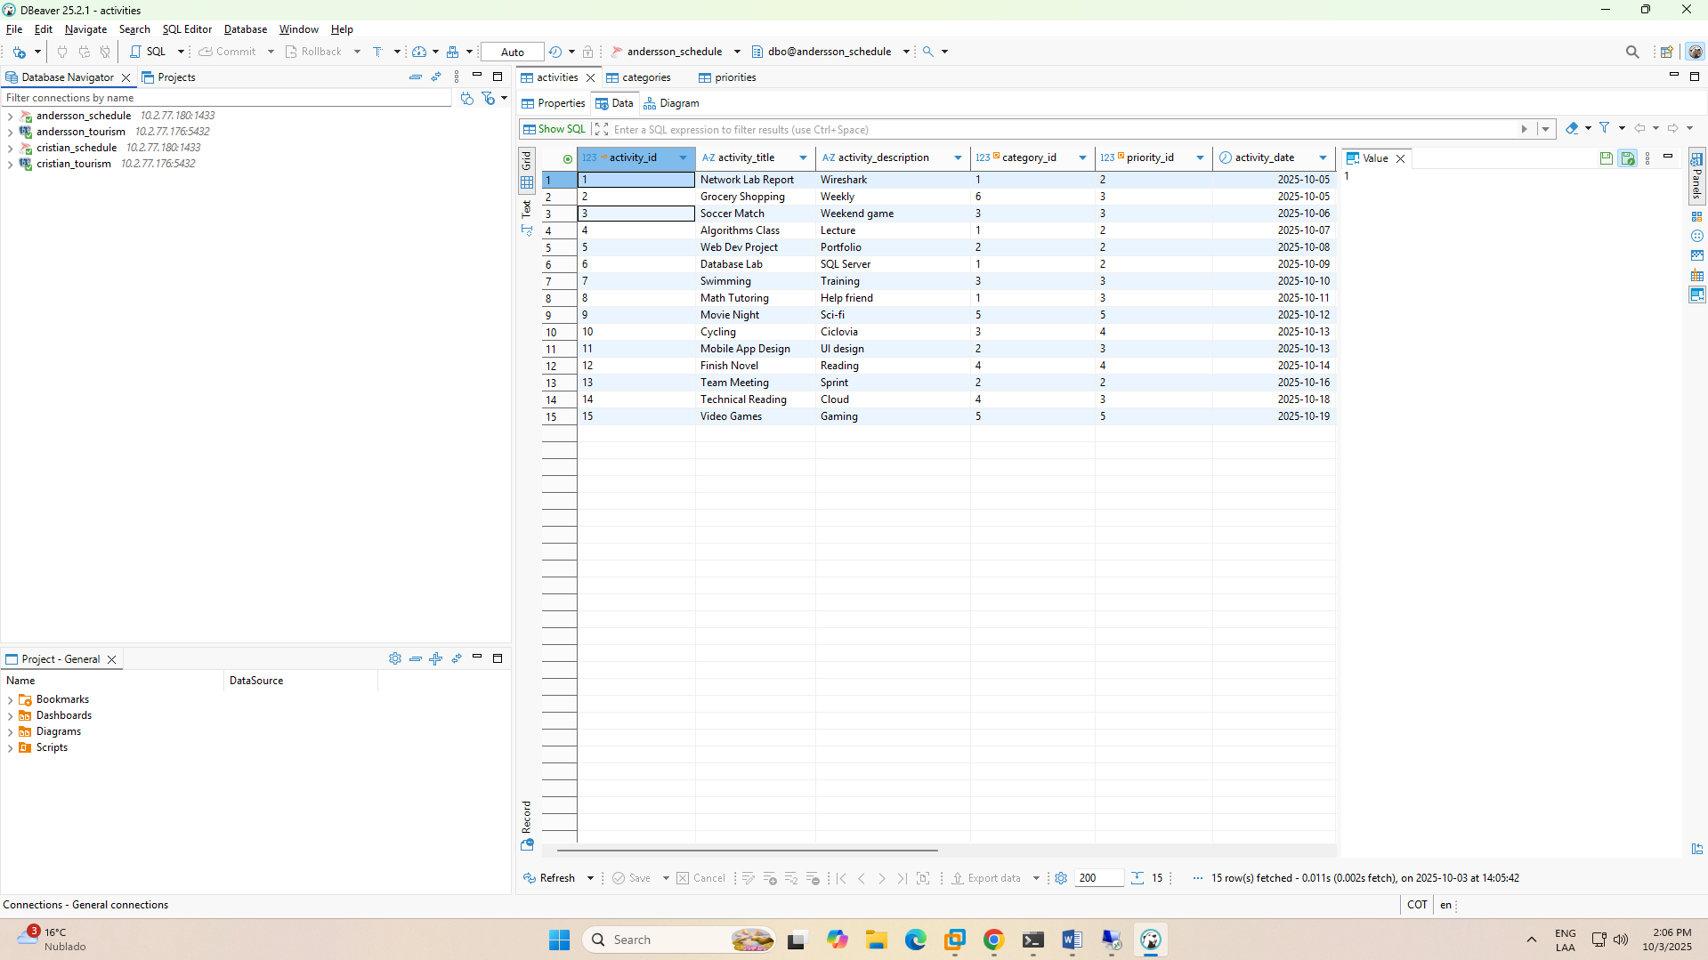

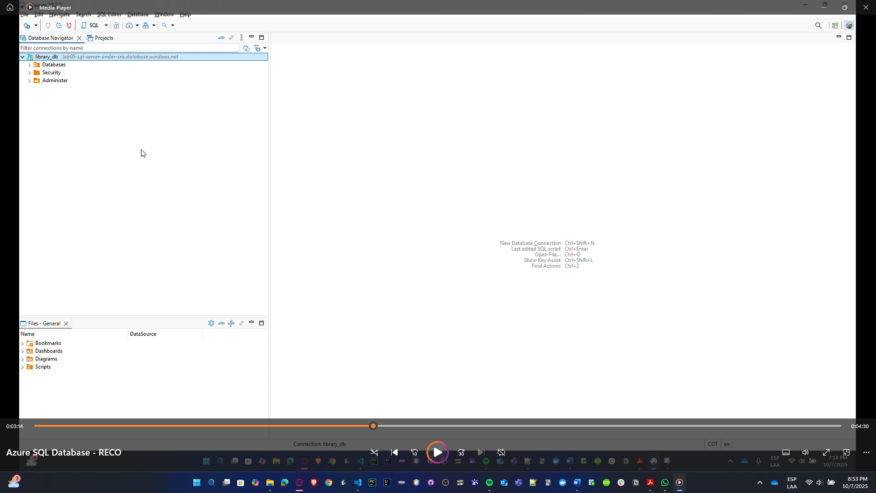

Present your results to your professor.